How to Skateboard
Skateboarding is exhilarating - you can move quickly and fly through the air! Before you can do amazing tricks in the air, though, you need to learn the basics of skateboarding, and be prepared for a lot of trial and error.
The first thing you need to do is get a skateboard. It’s probably best to talk with a skateboarder to find a store that sells good quality skateboards, not just toys. Many skateboarders create their own “setup,” but for your first board, someone at a skate shop should be able to help you. A helmet, elbow pads, knee pads, and wrist guards are important to get, as well. It is better to wear all of those than to hurt yourself! Once you are ready to learn tricks, you might also need to buy some skate shoes.
Then you’ll need to find a place to skateboard. An empty parking lot (with a safe adult around) or your driveway are good places to start. Skate parks are popping up in many towns now, so try to find one near you! Wherever you go, though, make sure it’s a place where skateboarding is allowed.
There are some basic movements you’ll need to learn in order to skateboard. The first movement is to find your stance. Most skateboarders put their left foot towards the front of the board and use their right foot to push themselves. If you’re left-handed, you might want to try standing in a
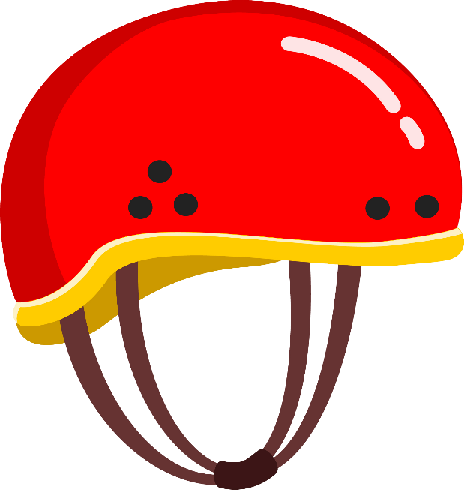
“goofy” stance, with your right foot towards the front of the board and using your left foot to push. Make sure your foot isn’t all the way at the front of the board, or it will tip forward. Next, you’ll want to practice how to push off the ground and glide along on the board. Make sure most of your weight is over your front foot so that you can balance as your back foot pushes. Push off of your back foot and balance as the board moves. Balancing on the board as it’s moving might take some time to get used to, so make sure you’re comfortable balancing before you move on!
Once you get used to balancing with your weight over your front foot, you can practice shifting your weight while you’re on the moving skateboard. After you push off, practice putting your back foot on the board and shifting your weight so that you have equal weight in each foot. Then practice shifting your weight back over your front foot so that you can push with your back foot again.
Braking is another important movement. You use your back foot to brake, just like you use it to push. Let the bottom of your back foot drag along the ground to slowly bring you to a stop. Make sure you are moving slowly at first so that you get better at judging how much force you need to put on your back foot to brake.
Last, practice how to get off the board. Once your board is stopped, with your back foot on the ground, transfer your weight to your back foot and take your front foot off the board. Ta-da! You took your first ride on a skateboard! Keep practicing all of these basic movements slowly, until you’re very comfortable doing them. Then, try them at a faster speed. Once you’re confident in these basic moves, then you can start to learn cool tricks! Make sure that you’re always wearing your protective gear, and that there is an adult nearby in case you fall. Happy skateboarding!
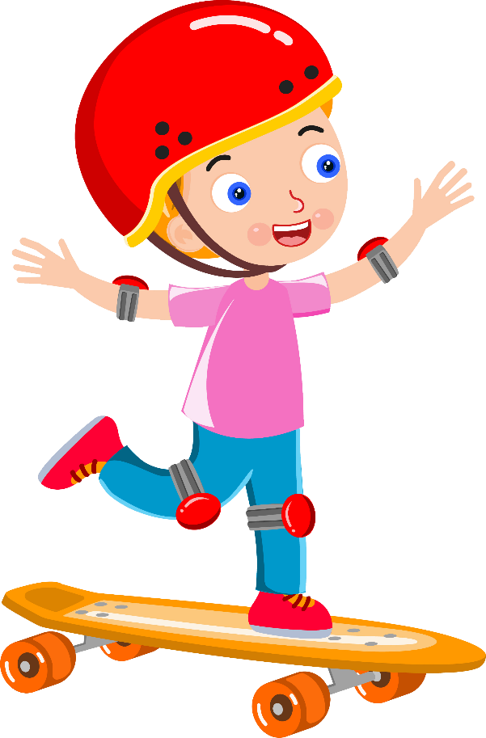

Questions:
- What are the basic movements for skateboarding?
_______________________________________________________
_______________________________________________________
- Name another sport that is similar to skateboarding. How are they similar?
_______________________________________________________
_______________________________________________________
- What does “exhilarating” mean in the 1st paragraph? How do you know?
_______________________________________________________
_______________________________________________________
- Look at the 1st paragraph. Why do you think it says “be prepared for a lot of trial and error”?
_______________________________________________________
_______________________________________________________
- Do you think skateboarding would be an activity you’d like to try? Why or why not?
_______________________________________________________
_______________________________________________________

