History of Transport
Did you know that a very important invention happened a very long time ago? In 3500BC, a wheel was attached to a cart for the first time.
This invention meant that people could use a cart to carry food that they had gathered instead of having to carry it by hand. People could use the cart to carry items for longer distances.
In 1783, a man called Jean-François Pilâtre de Rozier flew in a hot air balloon for the first time.
This is a hot air balloon.
Jean-François worked as a French chemistry and physics teacher. He knew that the people who flew in the hot air balloon for the first time
would be remembered forever. King Louis XVI thought that two criminals should be put into the hot air balloon, but Jean-François disagreed. He managed to convince King Louis XVI to let him be the first person to fly.
In 1785, Jean-François tried to cross the English Channel in a hot air balloon. The balloon deflated during the flight and crashed. Jean-François was killed in this accident.
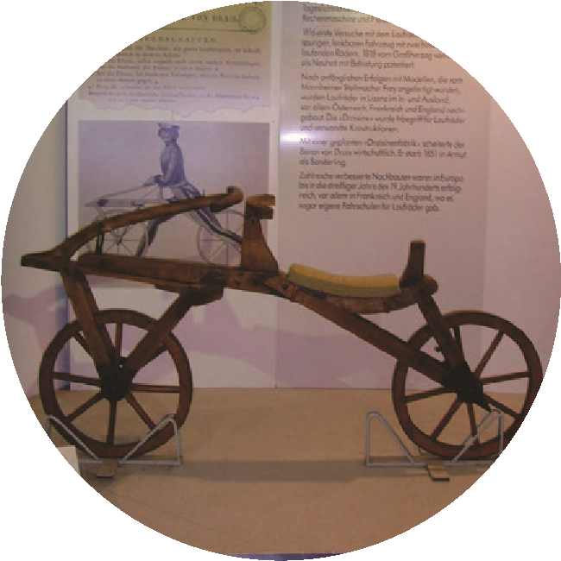
A man called George Stephenson invented the first steam-powered engine in 1814. He called the engine ‘Blucher’. Blucher’s first job was to carry eight coal wagons along an uphill track. Blucher was so successful that Stephenson ended up building another sixteen engines.
German inventor Karl von Drais invented something that he called the
‘Laufmaschine’, which means ‘running machine’. It looked a lot like a bicycle, but something was missing! Can you see what is missing from this bicycle invention?
This invention had two wheels and handles at the front of it for steering, but it had no pedals. Instead, the rider pushed along the ground with his feet.
Karl von Drais’ ‘Laufmaschine’, or ‘running machine’.

History of Transport
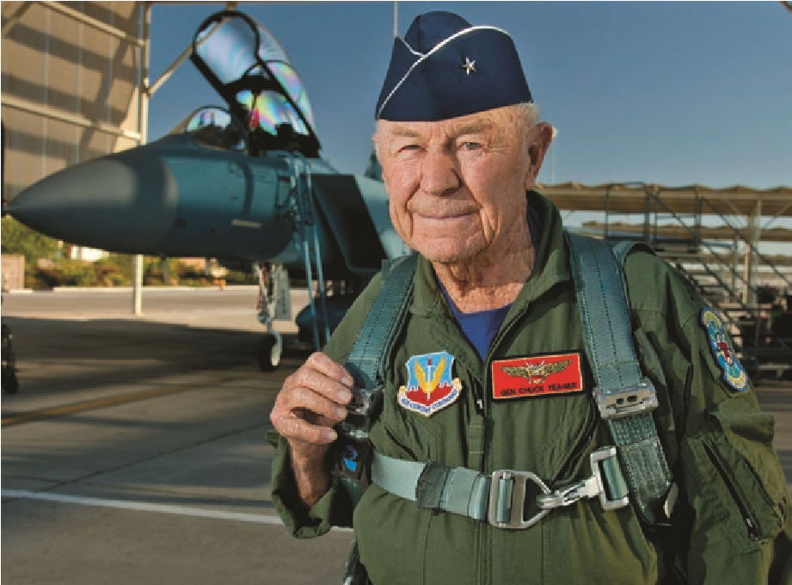
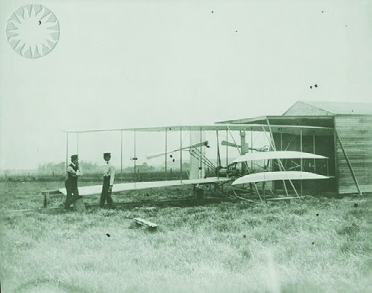
In 1903, brothers Orville and Wilbur Wright flew the first powered aeroplane in North Carolina in America. When they were building their plane, they watched birds to see how they used their wings and they used what they saw to help them design the wings for their plane. When it was time for them to test the plane for the first time, they couldn’t decide which brother was going to fly it first. They flipped a coin. Wilbur won the coin toss so he flew the plane first. This flight only lasted 12 seconds.
Orville and Wilbur Wright
The word ‘supersonic’ means ‘faster than the speed of sound’, which is very, very fast! The first supersonic flight took place in 1947. During the flight, the plane flew at 700mph. The pilot’s name was Charles Yeager and he was an Air Force general officer. His plane was called ‘Glamorous Glennis’.
Air Force general officer Charles ‘Chuck’ Yeager
In 1994, the Channel Tunnel opened. High-speed trains take people from the UK to France. The tunnel is just over 31 miles long and it takes trains about 35 minutes to get from one side to the other. This has made the journey between England and France a lot quicker. The ferry between Dover and Calais takes around 90 minutes.
Some people think that the next big thing to happen in transport will be regular trips into space! What do you think the next big transport invention will be?
Photo courtesy of Sheila Sund, Klaus Nahr, Public.Resource.Org, DVIDSHUB (@flickr.com) - granted under creative commons licence - attribution

Questions
Read carefully and complete the answers to the questions below.
- What was added to carts in 3500BC?

- What did people use the carts for?

- What did Jean-François Pilâtre de Rozier do?

- What caused the accident that killed Jean-François Pilâtre de Rozier?

- What was ‘Blucher’?

- How many steam engines did George Stephenson make after he tested the first one?

- What was missing from Karl von Drais’ bicycle invention?

- Which of the Wright brothers flew the plane first?

- How did the Wright brothers decide who was going to fly the plane first?

- Why did the Wright brothers study birds?

- How fast did Charles Yeager’s plane travel?

- What was Charles Yeager’s plane called?

Answers
- What was added to carts in 3500BC? Wheels were added to carts.
- What did people use the carts for?
They used the carts to help them carry food that they had gathered.
- What did Jean-François Pilâtre de Rozier do?
He flew in a hot air balloon for the first time.
- What caused the accident that killed Jean-François Pilâtre de Rozier? The hot air balloon that he was in deflated and crashed.
- What was ‘Blucher’?
Blucher was the name of the steam engine that George Stephenson invented.
- How many steam engines did George Stephenson make after he tested the first one? George Stephenson made 16 more engines after he made Blucher.
- What was missing from Karl von Drais’ bicycle invention? Karl von Drais’ invention didn’t have pedals.
- Which of the Wright brothers first flew the plane? Wilbur Wright flew the plane first.
- How did the Wright brothers decide who was going to fly the plane first?
Orville and Wilbur tossed a coin to decide who was going to fly the plane first.
- Why did the Wright brothers study birds?
They looked at their wings to help them design the wings for their plane.
- How fast did Charles Yeager’s plane travel? The plane travelled at 700mph.
- What was Charles Yeager’s plane called?
His plane was called ‘Glamorous Glennis’.

