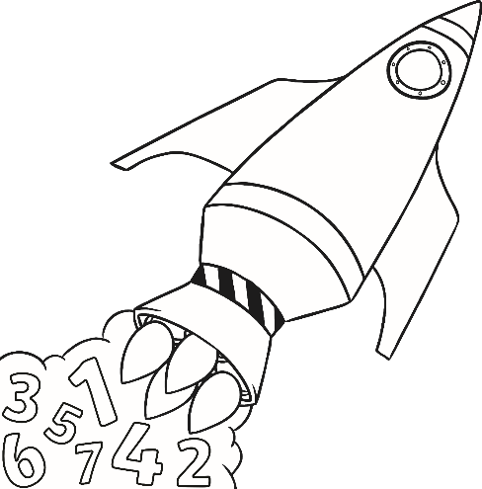**Number Bonds to 10**

10)

11)

+ ? =

+ ? =

1 + = 10

0 + = 10

7)

8)

9)

+ ? =

+ ? =

+ ? =

4 + = 10

3 + = 10

2 + = 10



4)

5)

6)

+ ? =

+ ? =



+ ? =

7 + = 10

6 + = 10

5 + = 10



1)

2)

3)

+ ? =



+ ? =



+ ? =

10 + = 10

9 + = 10

8 + = 10