Insert Daily Timetable/Schedule
- Staff Share > 2020-2021 > Remote Learning > Daily Timetable
- Save Daily Timetable as a JPEG once edited
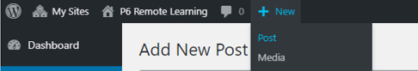
- Glow Blog: Click ‘ + New’ then ‘Post’

- Click ‘Add Media’
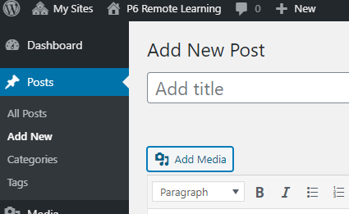

- Click ‘Upload Files’ then ‘Select Files’ (Find JPEG Daily Timetable in your saved files)
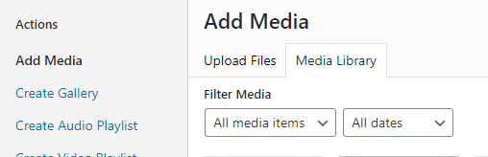

- Click ‘Insert Post Now’ (You may wish to resize this by dragging out the corners to enlarge image)
