Percentages

Colour, then write the fractions:

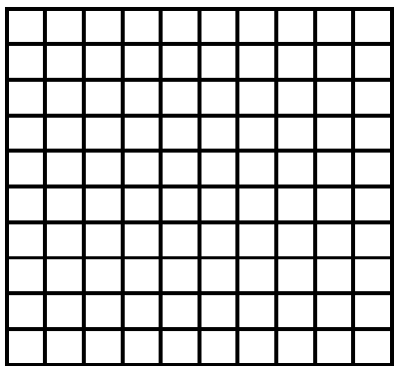1. Colour 25% 2. Colour 65% 3. Colour 45%

4. Colour 100% 5. Colour 7% 6. Colour 47%

What percentage is coloured?

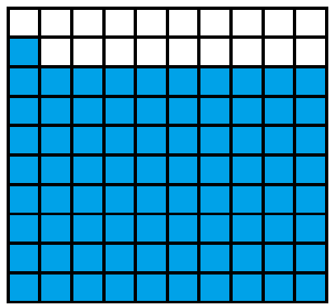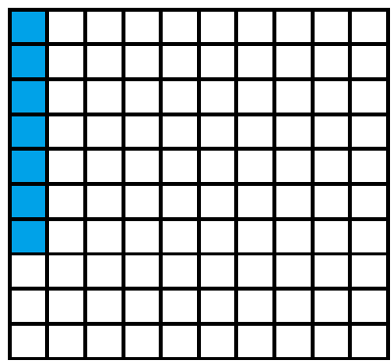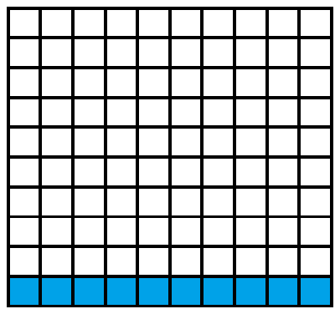1. _____% 2. _____% 3. _____%

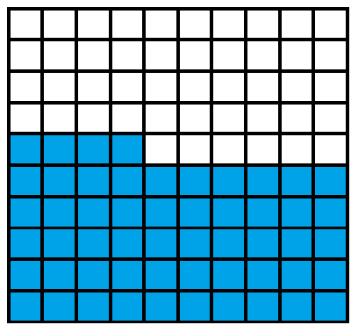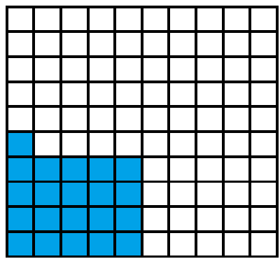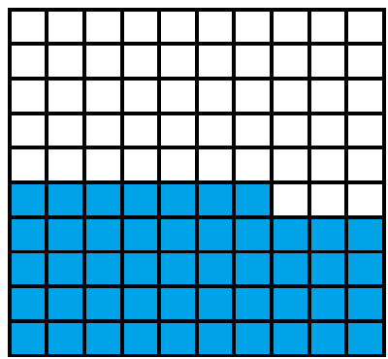4. _____% 5. _____% 6. _____%