- Write out what fraction of these shapes is shaded.  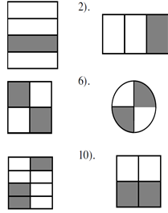  - Copy this diagram and shade the following fractions in.  - $\frac{1}{4}$ b) $\frac{1}{2}$ c) $\frac{1}{12}$ d) $\frac{3}{4}$  - Find $\frac{1}{4}$ of these amounts  - 20 b) 40 c) 36  - Find the following fractions of 100.  $a) \frac{1}{2}$ b) $\frac{1}{4}$ c) $\frac{1}{10}$ | - I have £180 find:  $a)\frac{1}{6}$ of £180  - Which is bigger? Find the fractions of the amounts to find out.  - $\frac{3}{5}$ of 25 or $\frac{2}{3}$ of 18?  - Which is bigger? $\frac{6}{10}$of 70 or $\frac{3}{5}$ of 70? Explain your answer.  - In a school $\frac{2}{5}$ of the students go to an afterschool club. There are 500 students in the school, how many students go to afterschool clubs?  - In a year group of 60 pupils, $\frac{3}{4}$ like coke. How many children like coke?  - Sam has a bag of 320 sweets. He eats $\frac{3}{5}$ of them. How many does he have left?

