The Perfect Planet Trailer Comprehension 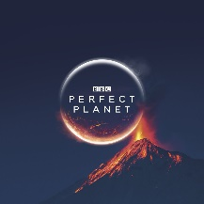

<https://www.youtube.com/watch?v=635uup08DLU>

1. “Life flourishes here thanks to powerful natural forces.” Which definition most closely fits the word ‘flourishes’?
2. Exists only in this place.
3. Grows and develops in a healthy, vigorous way.
4. Is being destroyed rapidly.
5. Will never be very successful.
6. How long does it take for light from the Sun to reach Earth?
7. What does Sir David Attenborough say is the effect of the daily and yearly rhythms of the Sun?
8. Find and copy two adjectives the Sir David Attenborough uses to describe volcanoes.
9. What percentage of the Earth’s surface has been created by volcanoes?
10. Why is it surprising to hear that life could not exist on Earth without volcanoes?
11. How long does a drop of seawater take to complete a circuit of Earth?
12. What weather carries freshwater around the globe?
13. 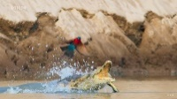Pause at 2.58 – Explain how you think the bird and the crocodile feel in this moment.
14. Has this trailer successfully made you want to watch the TV show? Why?
15. Order the following from 1 – 5. One has been done for you.

* Humans are revealed as a new force. _
* A volcano is shown erupting. _
* A crocodile lunges at some birds. _
* We are shown a close-up image of the Sun. 1
* A baby elephant is loaded onto a trailer.