Name: _____________________________________ Date: _______________
We are learning the meaning of some Scottish words.
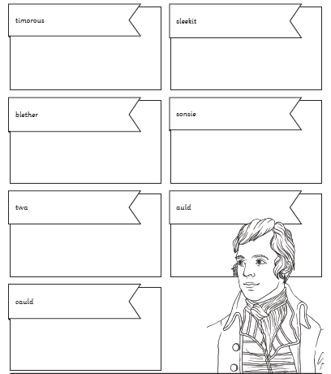
Fill in the boxes and use an educated guess to what these words mean. If you are really unsure, you may use the internet. Send me back your finished work at: ddrpetrie598@glow.sch.uk
