Me llamo es: ___________________________________ Hoy es: ________________________
L.I. I can recall my previous understanding of different Spanish terms.
1. Write the English and Spanish names for these numbers.
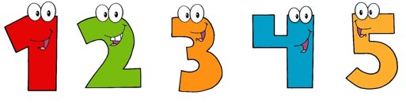

2. Complete the boxes with the matching Spanish phrase.
Hello |  | Hello |  | How are you? |  | How are you?
goodbye |  | And you? |  | Yes/No |  | What is your name?
My name is |  | Please |  | Thank you |  | I’m good
I’m sad |  | I’m so so |  | How old are you? |  | I’m 11 years old
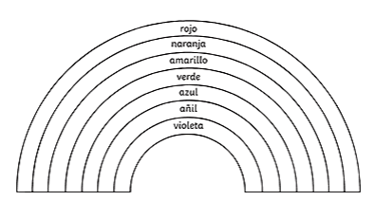
3. Colour the rainbow to match the words written in Spanish.

4. Draw lines to match the days of the week in English and in Spanish.
Thursday
Wednesday
Tuesday
Sunday
Saturday
Friday
Monday

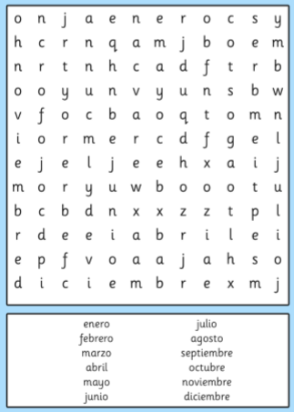
5.

Complete the word search to find the Spanish months of the year. Then write them out 3 times on the back of this worksheet in your neatest handwriting.

6. Draw a picture of the fruit that matches the Spanish word.
plátano | manzana | pera | fresas
ciruela | naranja | coco | sandía
uva | piña | limón | aguacate

Songs for if you are finished or if you need help:
On YouTube, search:
Happy Sunshine Friends – Spanish fruits and you should find a Spanish/English song
Basho and Friends – numbers to 20
Basho Mosko – Spanish alphabet
Jack Hartmann – 7 days of the week in Spanish

