**Activity 2 – The Roman Army – Weapons**

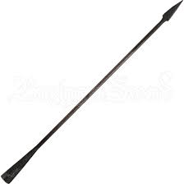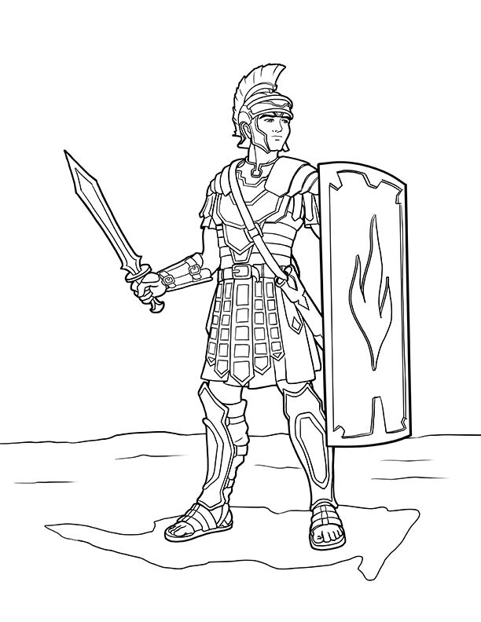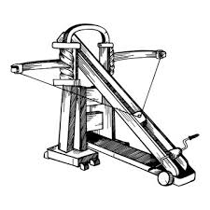

|  |  |  |  |
| --- | --- | --- | --- |
| Pilum | Gladius | Scutum | Ballista |