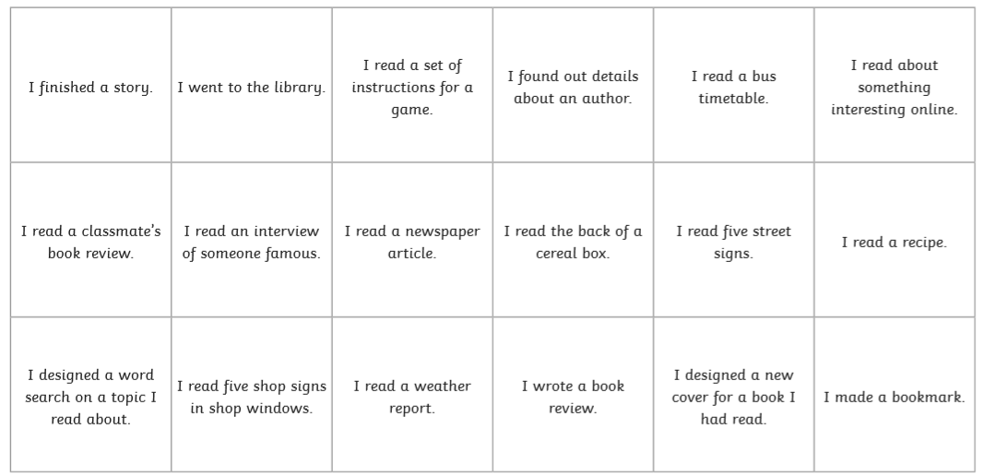

Colour in the box when you complete the activity. How many of the challenges can you complete by the end of the week? Some may be tricky due to lockdown but try as many as you can! You can complete the challenges in any order you like! (If you cannot print and colour the boxes, just take a note of the challenges you complete).