Art Activity
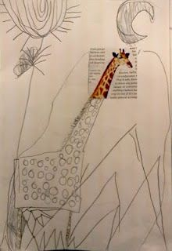
Expand an image- cut out a square from a magazine or newspaper and finish the picture. See the example below. You can add some colour to your picture too!

