Time | Activity | Looks like | Activity ideas
Before 9am | Wake up | 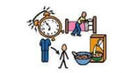 | - Have breakfast  - Get dressed  - Brush your teeth  - Make your bed
9am-10am | Exercise Time | 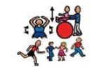 | - If possible- morning walk or indoor exercise  - Try PE with Joe Wicks or Yoga  - See Health and Wellbeing activities on Learning Grid
10am-11am | Learning Time | 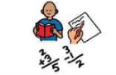 | - Try to do some schoolwork and learning activities  - Reading  - Sharing a book
11-12pm | Creative Time |  | - Lego  - Drawing  - Colouring  - Crafts  - Singing/dancing  - Music  - Cooking/baking together  - See Other activities on Learning Grid
12pm-1pm | Lunch/Relax |  | - Help make lunch  - Eat lunch  - Have some ‘Electronics Time’ (iPad/tablet/computer/games console).  - Relax!
1pm-1:30pm | Exercise Time |  | - See Health and Wellbeing activities on Learning Grid  - Joe Wicks  - Go Noodle  - Just Dance  - Outdoor exercises (if possible)  - Daily Walk (if possible)
1:30pm-2:30pm | Learning Time |  | - Try to do some schoolwork and learning activities  - Reading  - Sharing a book
2:30pm-3pm | Quiet Time |  | - Relax with a book  - Watch TV  - Play a board game  - See Health and Wellbeing or Other activities on Learning Grid
3pm-4pm | Play | 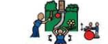 | - Outdoor play (if possible)  - Indoor play  - Play with a sibling  - Play with toys
4pm-5pm | Free Time |  | - Family Time  - Chat with friends  - Electronics Time  - Watch TV  - Play a game  - Read  - Listen to Music
5pm-6pm | Tea Time/Free Time |  | - Help make tea  - Help tidy/do a chore  - Have tea and relax for the evening/prepare for bed.

