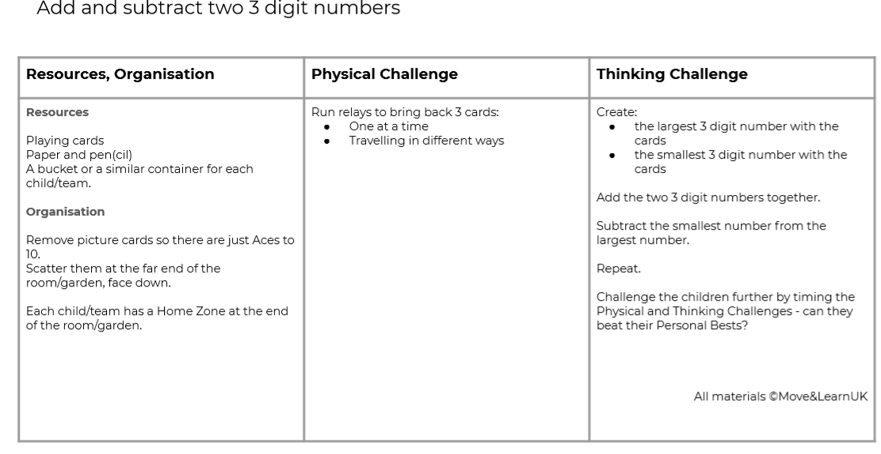

**Move and Learn Number Game**

[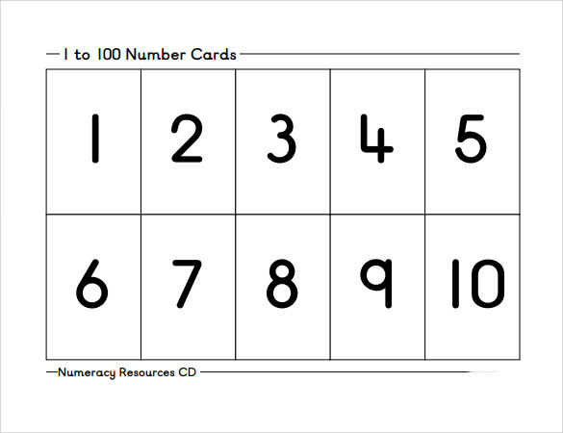](https://www.google.com/url?sa=i&url=https%3A%2F%2Fwww.sampletemplates.com%2Fbusiness-templates%2Fnumber-template.html&psig=AOvVaw0yAg2J8ib7tUAvaFRGaFXj&ust=1588930219154000&source=images&cd=vfe&ved=0CAIQjRxqFwoTCPDPsLy4oekCFQAAAAAdAAAAABAN)

You could also play this game with 2 or 4 digit numbers.

If you do not have playing cards, you could make your own number cards with paper. Cut up paper into smaller rectangles and write numbers from 1-10 on each card.