Framing Nature
You will need:
- Cereal box (or other cardboard)
- Scissors
- Camera
- Cut out a cardboard frame from a cereal box (or other cardboard). Ask an adult to help you with the centre.
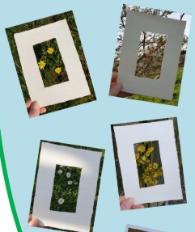
- On a walk or in the garden, use your frame to capture nature.
- Take a photograph and create a nature collage.
Extension
Why don’t you draw or paint what you have captured in your frame?
Use your images to create a book about nature. Label each flower, plant or tree and add a description.
Start a project about cloud formations. Use your frame to capture different cloud formations in the sky. Research the different cloud formations and what they mean.

Take time to look around and appreciate the beauty of nature around you!

