[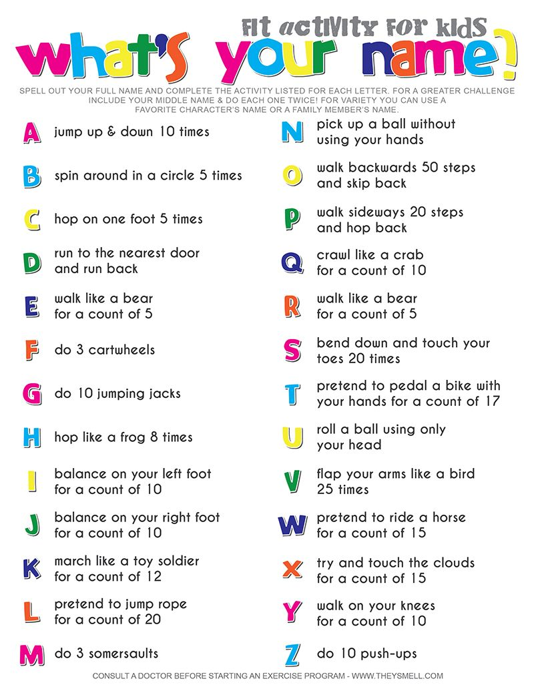](https://www.google.com/url?sa=i&url=https%3A%2F%2Fwww.pinterest.com%2Fpin%2F136163588713223713%2F&psig=AOvVaw3GZzog_mUVbplHGPKsATW3&ust=1588429115087000&source=images&cd=vfe&ved=0CAIQjRxqFwoTCMiIstvtkukCFQAAAAAdAAAAABAJ)w