Name: __________________________________
The Skeleton Key
by Kelly Hashway
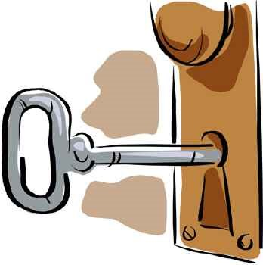
Erik rang his grandparents’ doorbell and silently wished
the next four hours would go by quickly. He didn’t want to give up his entire Saturday afternoon at his grandparents’ house where there were no kids in the neighborhood.
“You’re right on time,” Grandma Bethany said, opening
the door. “There’s tea and cake in the dining room.”
Cake? At least the first ten minutes would go by quickly. Erik hung his coat on the rack by
the door and saw a strange looking key hanging on a hook. “Grandpa Bill, what’s this funny key for?”
“That’s a skeleton key. It opens the best room in this house,” Grandpa Bill whispered so no
one else could hear. “It’s the room I go to when your grandmother tries to make me help with the dishes.”
“What’s so special about the room?” Erik asked.
“It’s a game room,” Grandpa Bill said. “Take the key and see if you can find the room by
the time I finish my tea.”
Erik grabbed the key and stared at it. “A skeleton key? It looks old.” Erik decided the oldest
things in the house were probably upstairs in the walk-up attic. He headed past the dining room and to the stairs.
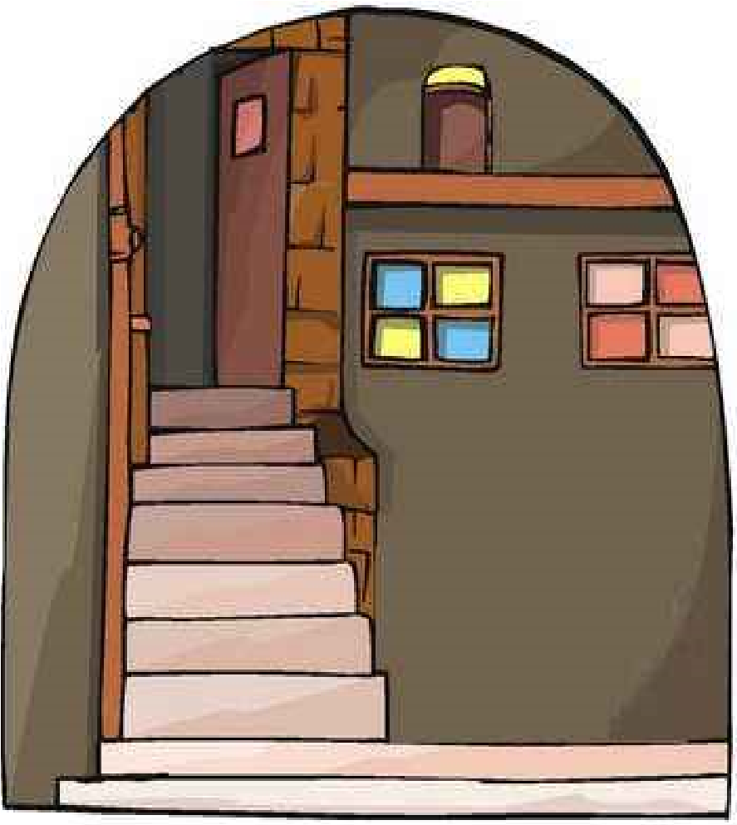
Grandpa Bill sipped his tea and shook his head.
Erik knew that meant he was going the wrong way. He headed back to the front

door where he’d found the key.
Erik thought about the oldest part of a house. “The basement! It’s the first part that’s

built.” He rushed to the basement door and looked at the lock. It was different from a

normal lock. He slid the key inside and turned it. With a click, the door opened.
Erik switched on the light and walked down the stairs. The basement was one giant

room with a pool table in the middle and a dartboard on the far wall.
“Awesome!” Erik said.
“Ever learn to play pool?” Grandpa Bill

asked, coming down the stairs.
“No,” Erik said.
“Well then, grab a cue from the rack and I’ll

teach you.”
Erik smiled. The next four hours were going to

fly by.
The Skeleton Key
by Kelly Hashway
- What is the setting of this story?
(Tell where and when the story takes place.)
_____________________________________________________________________________
_____________________________________________________________________________
- Why didn't Erik want to visit his grandparents' house at the beginning of the story?
_____________________________________________________________________________
_____________________________________________________________________________
- Grandpa told Erik that the skeleton key opened...
  - a trunk with secrets
  - the basement door
  - the attic door
  - a game room
- Why did Erik think the key would open the attic door?
_____________________________________________________________________________
_____________________________________________________________________________
Now try this: On a sheet of lined paper, write a continuation of this story. Tell what happens from the time Erik starts playing pool to the time he leaves.
Name: __________________________________
Name: __________________________________
The Skeleton Key
Vocabulary
Choose the best definition for the underlined word in each sentence.
- Erik and his grandfather played a game of pool.
  - a hole in the ground filled with water
  - a game where a large ball is shot into a goal
  - a game where a stick is used to shoot balls across a table
- Grandpa Bill grabbed a cue from the rack.
  - a ball used to play pool
  - a stick used to play pool
  - a storage container for pool equipment
- Erik noticed a dartboard on the wall in Grandpa Bill's game room.
  - a square box where darts are kept
  - a piece of wood use to keep score while playing darts
  - a target made of cork that is used in a game of darts
In the space below, draw a pencil sketch of Erik and Grandpa Bill playing pool. Label the pool table and cue. Draw a picture of a dartboard in the background and label it too.
The Skeleton Key
by Kelly Hashway
- What is the setting of this story?
(Tell where and when the story takes place.)
This story takes place at Erik's grandparents' house on a Saturday afternoon.
- Why didn't Erik want to visit his grandparents' house at the beginning of the story?
There were no kids in the neighborhood and he thought he would be bored.
- Grandpa told Erik that the skeleton key opened... d
  - a trunk with secrets
  - the basement door
  - the attic door
  - a game room
- Why did Erik think the key would open the attic door?
The key looked old and he thought the attic contained the oldest things in the house.
Now try this: On a sheet of lined paper, write a continuation of this story. Tell what happens from the time Erik starts playing pool to the time he leaves.
ANSWER KEY
Name: __________________________________
The Skeleton Key
Vocabulary
Choose the best definition for the underlined word in each sentence.
- Erik and his grandfather played a game of pool. c
  - a hole in the ground filled with water
  - a game where a large ball is shot into a goal
  - a game where a stick is used to shoot balls across a table
- Grandpa Bill grabbed a cue from the rack. b
  - a ball used to play pool
  - a stick used to play pool
  - a storage container for pool equipment
- Erik noticed a dartboard on the wall in Grandpa Bill's game room.
  - a square box where darts are kept
  - a piece of wood use to keep score while playing darts
  - a target made of cork that is used in a game of darts
In the space below, draw a pencil sketch of Erik and Grandpa Bill playing pool. Label the pool table and cue. Draw a picture of a dartboard in the background and label it too.

