Comprehension Worksheet.

Read the short story below with your child, then talk about each question.

Playing with Friends

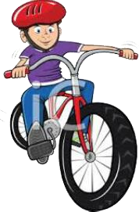
John went for a bike ride. He rode around the block. Then he met some girls he knew from school.
They all rode to the field to play. John had a great time playing games with his friends.

Questions:
- Where did John go for a ride?
- Who did he meet?
- Where did they go to play?
- Did John have fun playing with his friends?
- What do you like playing with your friends?

