Comprehension Worksheet.

Read the short story below with your child, then talk about each question.

My Pets

I have a dog, a cat and a hamster. I love them all. My dog’s name is Snoopy, my cat’s name is
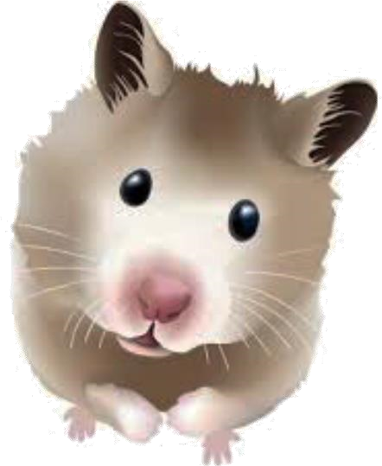
Whiskers and my hamster’s name is Nibbles. Snoopy is playful and he likes bones. Whiskers sleeps in my bed. Nibbles loves running in his wheel. They are all soft and furry.
Questions:
1. How many pets are there?
2. What is the hamster’s name?
3. Who sleeps in the bed?
4. What does Snoopy like?
5. Which pets are soft and furry?

