Comprehension Worksheet.

Read the short story below with your child, then talk about each question.

Making Pizza

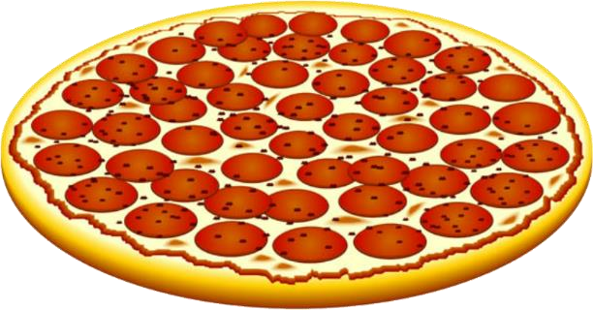
We are making a pizza. First, we make the dough with flour and eggs. We flatten the
dough into a round shape. Then we put tomato sauce and cheese on top. The pizza goes into the oven. In a few minutes, it is ready to eat.

Questions:
- What do you use to make pizza dough?
- What shape do we make the pizza?
- What do we put on top of the pizza?
- Where do we cook the pizza?
- How long does it take to cook?

