Comprehension Worksheet.

Read the short story below with your child, then talk about each question.

Making Pizza

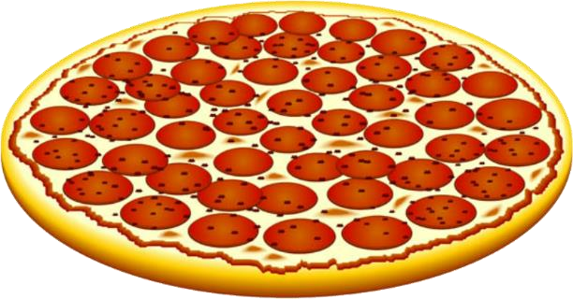
We are making a pizza. First, we make the dough with flour and eggs. We flatten the
dough into a round shape. Then we put tomato sauce and cheese on top. The pizza goes into the oven. In a few minutes, it is ready to eat.

Questions:
- What do you use to make pizza dough?
  - Flour and eggs
  - Rice and water
- What do we put on top of the pizza?
  - Milk and butter
  - Tomato sauce and cheese
- Where do we cook the pizza?
  - In the oven
  - On the stove

