The Bookshelf

The bookshelf in my house holds many books and some pictures and candles. It is a tall bookshelf. There are large books and small book. There are also books for kids and books for adults. There is a picture of my family. There are two blue candles and a yellow candle. I’m glad the books I like are on the lowest shelf.
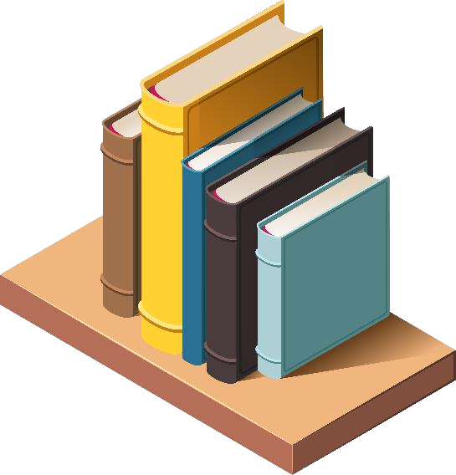

Questions:

1. Is the bookshelf short or tall?
2. What is on the bookshelf?
3. How many pictures are on the bookshelf?
4. What colours are the candles?
5. Where are the kids’ books?

