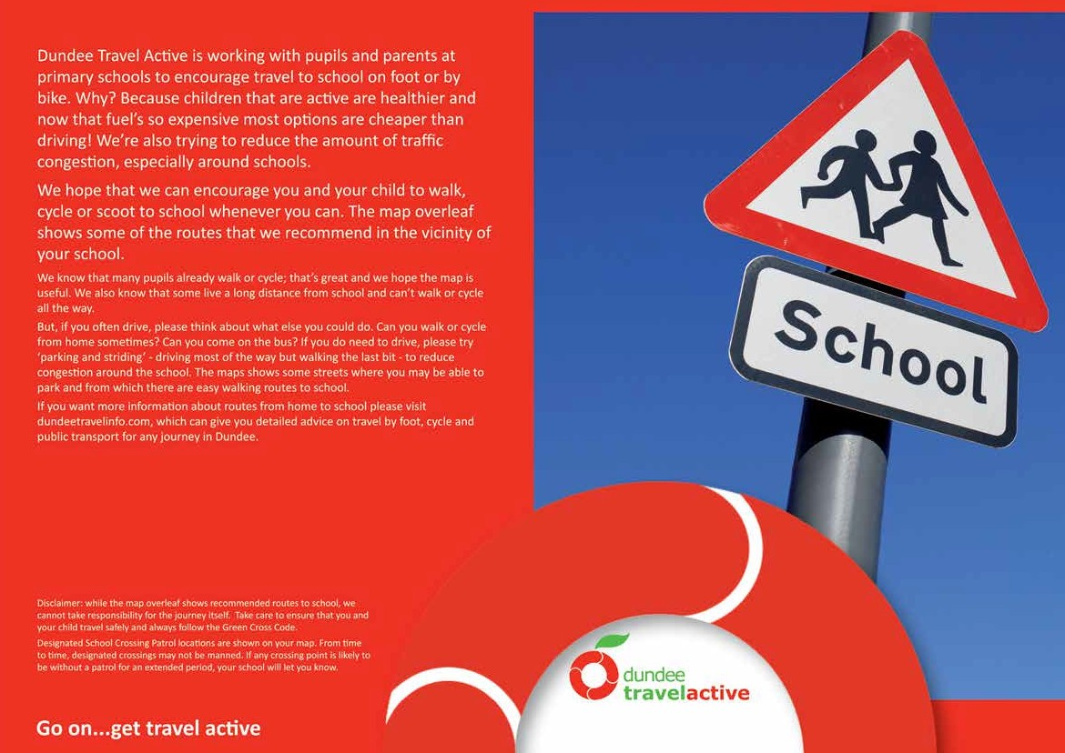Safer Routes to Balgarthno Campus

Camperdown
Primary School

St Clement’s RC Primary School

L

ON
Kingsb

Balgarthno
Campus
Craigmount Ave

Charleston
rr
Library
Recommended walking route

School crossing patrol

Signalled controlled crossing

Uncontrolled crossing

Park and Stride zone
Bus stops
School gates

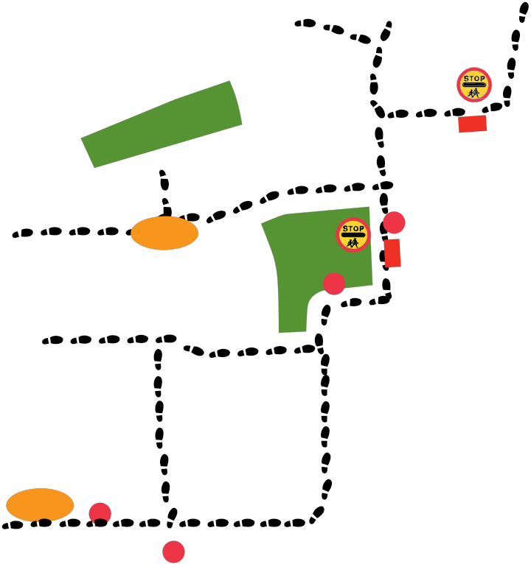
Elmwood

Rd

Safer Routes to Balgarthno Campus
e e
l
m o
o
B Greenlee
r

Broomlee Rd
Dr

South

Overto n Gd

