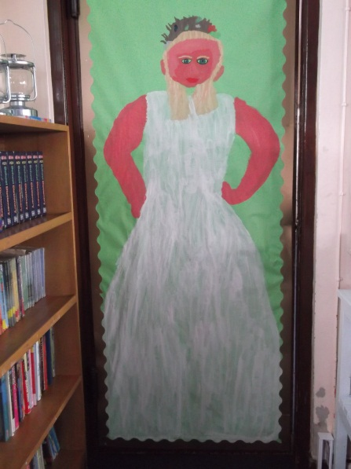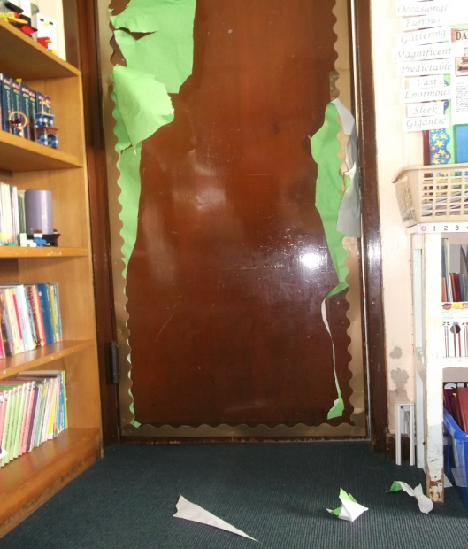

The Fat Lady before the attack

We don’t know how he got in. Is he after Harry Potter?

If you see Black please contact the Ministry of Magic immediately.

By Georgie Rice

On October 31st Sirius Black destroyed a portrait of the Fat Lady in Hogwarts, whilst all the students were having their Halloween feast.

The Fat Lady has hidden herself in the Map of Argyle on the second floor of Hogwarts.

No one knows how Black got in as the castle is heavily guarded with dementors and enchantments.

This horrible crime was witnessed by a poltergeist named Peeves. He said, “She ran and wouldn’t come out after Black attacked her.

The Destroyed Portrait of the Fat Lady

When Black was in Azkaban he kept saying the same thing, “He’s in Hogwarts.”

All the teachers had a search party but didn’t have any luck. Professor Dumbledore has no idea how he got in because you can’t apparate in Hogwatrs.

**Fat Lady Torn to Shreds**

1st November 1999 1939 3Knuts