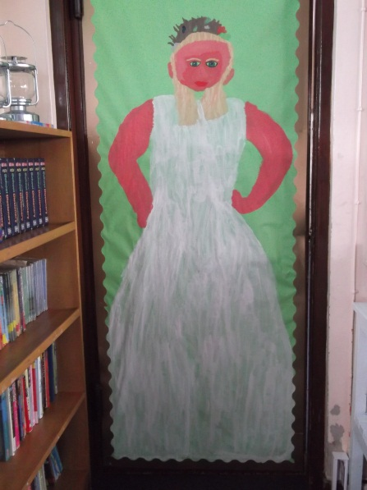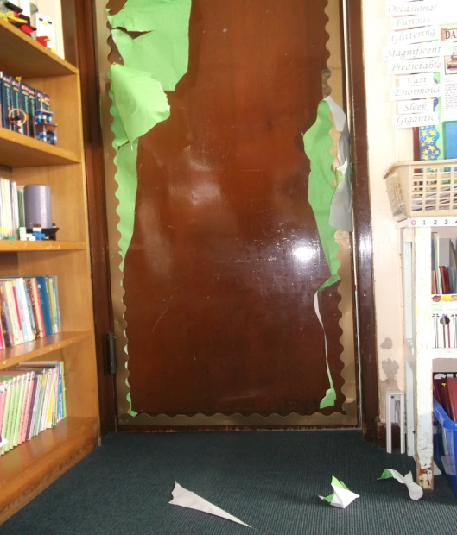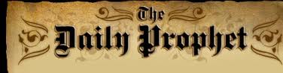

Hogwarts staff and pupils do not know how he could get past the dementors and enchantments. Sirius Black blew up half a street and killed 12 people. He was imprisoned in Azkaban 13 years ago and escaped.

By Bobby Douglas

On Halloween night during the Hogwarts big feast Hogwarts was attacked by Sirius Black. He attacked the Fat Lady at Gryffindor common room. The Fat Lady did not let him in so he decided to rip up the portrait. The Fat Lady ran away.

The Ministry of Magic do not know if he has got a relationship with anyone, or an enemy, in the castle.

After the delicious feast all the Gryffindors went back to their common room. The Fat Lady was torn to bits. Peeves the poltergeist told Professor Dumbledore, the Headmaster of Hogwarts what happened. He said it was good attack Sirius did.

The Fat Lady before the attack

The Destroyed Portrait of the Fat Lady

**Hogwarts has Been Attacked**

1st November 1999 1939 3Knuts