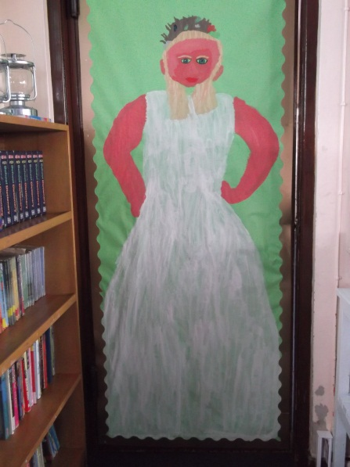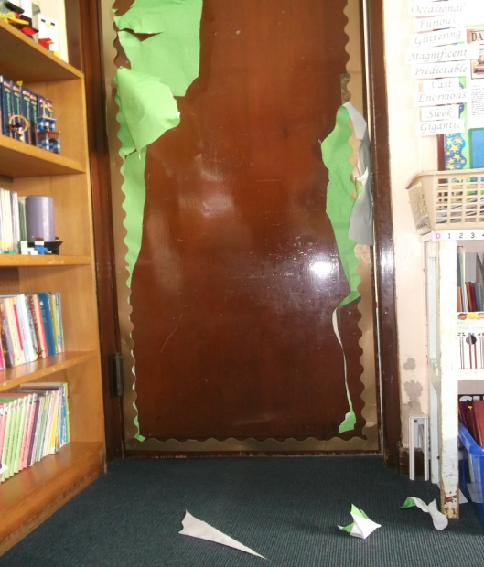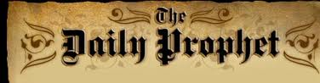

They have replaced the Fat Lady for now with a knight in shining armour.

The question is why Gryffindor? Is it because Harry Potter is in Gryffindor?

By Rachel Brooks

On Halloween night Sirius Black attacked the Fat Lady portrait (entrance to the Gryffindor common room).

All students had to sleep in the Great Hall. No one knows how he did it, there are lots of enchantments, spells and dementors outside the castle. Teachers were searching all night but found nothing.

Thirteen years ago Sirius Black killed 13 people, 12 wizards and one muggle with one curse.

The Fat Lady was found in the portrait of the Map of Argyle.

The Fat Lady before the attack

The Destroyed Portrait of the Fat Lady

**Hogwarts Fat Lady Attaceked!**

1st November 1999 1939 3Knuts