Sunnyside Primary School Improvement Plan (19-20) feedback and actions.
Following our feedback on our proposed school improvement plans we received 11 responses, with the survey closing on 28th June 2019.
What you said:
Literacy
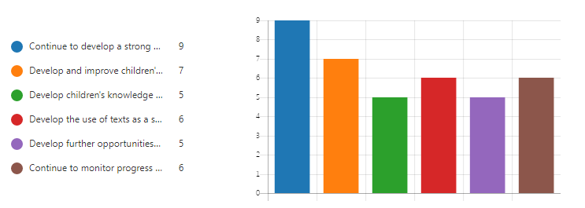
When reviewing our Literacy priorities you agreed that we need to continue to develop a strong reading ethos across the school, and promote reading for enjoyment. You stated that you agreed with our focus on developing pupils understanding and the use of texts to stimulate written pieces.
You also stated that we should continue to monitor progress across all areas of literacy and develop further opportunities for parents to support learning around literacy.
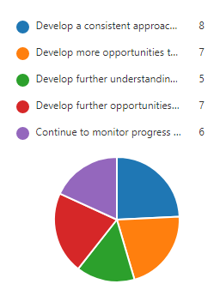
Numeracy and Maths
When reviewing our proposed activities to raise attainment in Numeracy (Maths) you stated that development of a consistent approach to core numeracy strategies was of the greatest importance.
You felt that we should develop further opportunities for children to apply and demonstrate understanding in numeracy, as well as promote further opportunities that support parent’s engagement in numeracy learning.

Health and Wellbeing
Respondents stated that they felt we should prioritise a furthering of understanding of emotions, triggers and behaviours with pupils. Over 75% of respondents also felt that we should continue to promote healthy eating, continue to embed readiness for learning and promote a growth mindset.
What we will do:
Our School Improvement Plan has been tailored to reflect your views, we will prioritise the aspects identified as of key importance above, including:
- Focus on emotional literacy through the introduction of “Emotion Works”.
- Continue to promote reading for enjoyment and understanding in line with the Clackmannanshire Equitable Literacy Project.
- Work in partnership with other schools to ensure consistency in the approach to Numeracy across our cluster and in our school.

