Nursery Newsletter
October 2019

Hello / Bonjour,
We would like to welcome all our new children and families who have started in Sunnyside nursery since August.

Superstar Assembly
Our next superstar assembly will take place on Friday 25th October Your child’s key person will give you a letter inviting you along to celebrate with your child if they are chosen. Your child will be unaware they are receiving a certificate so please can we ask you to keep it a surprise.

Literacy
We have introduced 15 core books to our library with links to story props, puppets etc. Next term each group will begin their monthly visits to the library and Parents are welcome to join us.

Mrs Williamson set up our Lending Library in September and this has been a great success. Our children have really enjoyed taking different books home each day. The children can change their books at the end of each session.

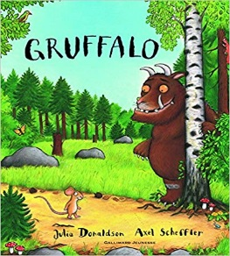

Learning journals
Miss Higgins is our new Learning Journal Champion for Sunnyside nursery. Miss Higgins, Miss Ross or your keyworker is always available if you require assistance with the Learning journals.

Makaton

Our Makaton signs of the moment are:

Ask your children to show you their makaton signs they have been learning.

Stay and Play Days
Our stay and play dates are up in the cloakroom. We look forward to welcoming as many parents as possible to come along and join in with our learning.

PEEP Sessions
Thank you to all our parents who have been attending our PEEP sessions. I hope you all have had as much fun as Miss Rae. Miss McLure will continue the sessions after the October break every Tuesday between 9.30am-10.30am / 12.45pm-1.45pm.

Gym Sessions every Wednesday
Please can we ask that you bring your child to nursery with a change of shoes (e.g. black gym shoes) as they will be unable to participate in our gym sessions if wearing outdoor shoes. We would also like to ask that any children who have piercings are either taped over or removed on a Wednesday.

LIFT - We have recently been audited and have received our silver award for our visual environment supporting children’s speech and language development.

October Holiday: The nursery is closed Monday 14th - Friday 18th October, Hope you all have a lovely break.

Yours sincerely,

Denise Penman
Headteacher

