What is a Nurture group?
A Nurture group is a small group of pupils who come together from across the school to learn in a calm and quiet environment called “The Pod”. It is similar to your classroom.
The Nurture group teaches pupils the skills they need to do well at school, make friends and deal with any issues. This is just like what you do in your class, but in a smaller group.
The Nurture group helps pupils to form trusting relationships with other pupils and teachers. We expect all pupils to show positive behaviour toward one another.
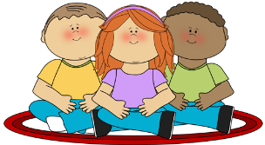

Why is the Pod Needed?
The Pod can improve your wellbeing in a range of areas.
Improved Wellbeing | Improved Achievement
 | 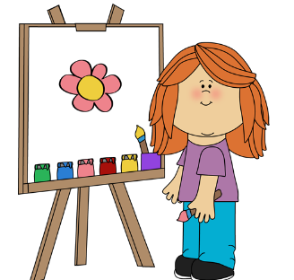
I can work positively in groups.  I can make friends.  I am happier. | I know that it's ok to make mistakes, that's how we learn.
Improved Behaviour | Improved Teaching
 | 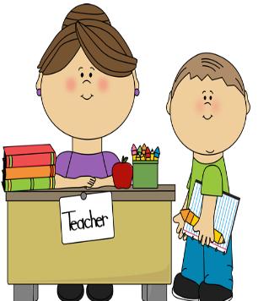
I can bounce back when things go wrong.  I can discuss my feelings.  My classmates and teachers are happy. | I like coming to school.  I can talk to my teachers about my worries and they will help me.
What do we do in the Pod?
 | 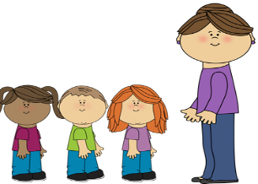
Pupils come into school and begin their day in their own class. | Pupils will be picked up by the Nurture teachers to be taken to the Pod..
We have a morning/afternoon meeting to talk about our feelings and our day. | If something upsetting has happened we talk about ways to fix it and make us feel better.
We share a snack together and have discussions. This is the main difference between the Pod and a classroom. | After we have washed our dishes and cleaned up, we complete our learning tasks.
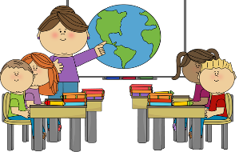

Our tasks come from our personal learning targets and our class teachers. | Then we complete group tasks or games to develop our social skills and relationships.
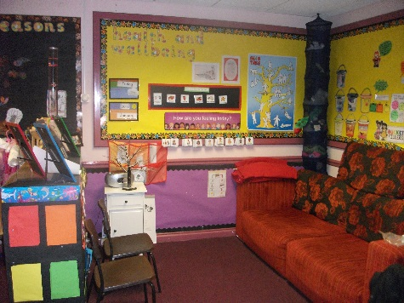
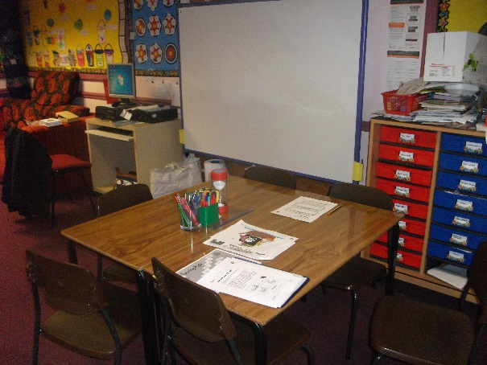
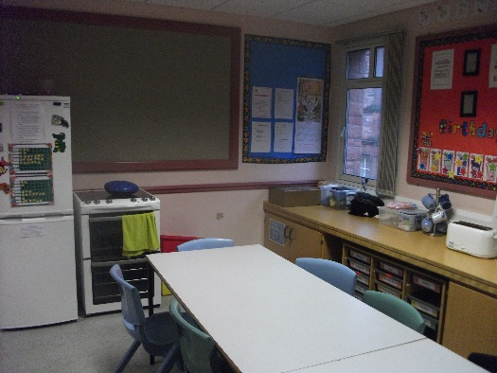
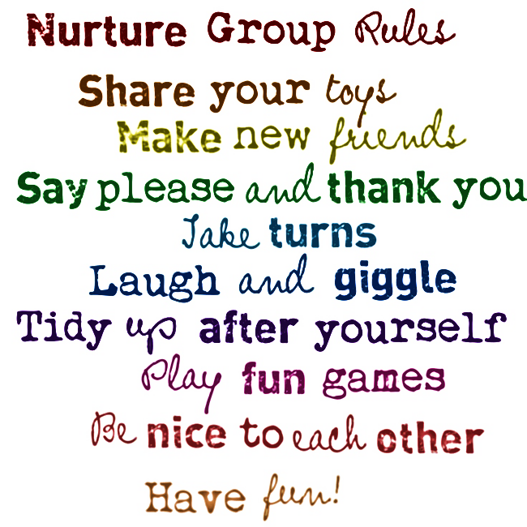
………………………………………………………………………………………………………………………………………………………………………………………………………………………………………………………………………………………………………………………………………………………………………………………………………………………………………………………………………………………………………………………………………………………………………………………………………………………………………………………………………………………………………………………………………………………………………………………………………………………………………………………………………………………………………………………………………………………………………………………………………………………………………………………………………………………………………………………………………………………………………………………………………………………………………………………………………………………………………………………………………………………………………………………………………………………………………………………………………………………………………………………………………………………………………………………………………………………………………………………………………………………………………………………………………………………………………………………………………………………………………………………………………………………………………………………………………………………………………………………………………………………………………………………………………………………………………………………………………………………………………………………………………………………………………………………………………………………………………………………………………………………………………………………………………………………………………………………………………………………………………………………………………………………………………………………………………………………………………………………………………………………………………………………………………………………………………………………………………………………………………………………………………………………………………………………………………………………………………………………………………………………………………………………………………………………………………………………………………………………………………………………………………………………………………………………………………………………………………………………………………………………………………………………………………………………………………………………………………………………………………………………………………………………………………………………………………………………………………………………………………………………………………………………………………………………………………………………………………………………………………………………………………………………………………………………………………………………………………………………………………………………………………………………………………………………………………………………………………………………………………………………………………………………………………………………………………………………………………………………………………………………………………………………………
Our welcome meeting and check-in area. It is set up to look like a sitting room.
This is the learning area where we complete our tasks.
This is our home and kitchen area where we share snacks and bake.
“The Pod”

at

Nurture

