Sunnyside Primary School

Standards and Qualities Report
2017/18
Summary for Parents

Please follow us on Twitter: @Sunnyside_PS
www.blogs.glowscotland.org.uk/cl/sunnysideprimary
Vision
At Sunnyside Primary School, we believe in inclusion and that everyone is equal. We believe that every child should have the opportunity to learn, to try new things, to make mistakes, to be able to learn from them and to be successful.

We should be respectful to each other.
We should try to keep healthy and fit.

Everyone has a voice and our opinions should be respected and heard.

We have the right to feel safe at school and should be able to ask for help and know that we will receive it. Bullying, of any kind, is not allowed and will have consequences.

We believe in good sportsmanship and being good ambassadors for the school.

Our Values
- Respect,
- Equality and Inclusion
- Honesty and Manners
- Kindness and Helpfulness
- Learning and Hard Work
- Resilience, Confidence
- And … Fun!

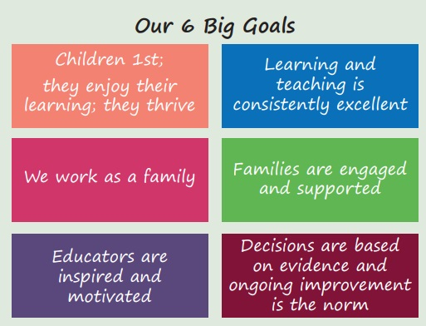

School Improvement Priorities 2017/18

Priority 1: LIFT (Learning is Fun Together) – Nursery
This is the first year of a three year project (funded through PEF) working with Speech and Language colleagues to:
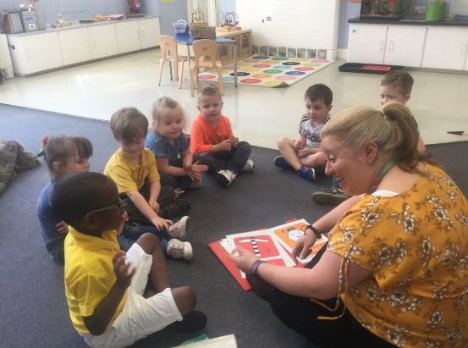
- Improve the spoken language skills for all children regardless of their socio-economic background
- Develop an excellent visual environment within the nursery
- Improve the skills and confidence of nursery educators in using evidence based interventions to improve spoken language skills including children with specific communication needs
- Improve skills, knowledge and confidence of parents and carers in improving the spoken language skills of their children
Staff have received training and the quality of interactions with children are improving.

Priority 2: Developing the Young Workforce
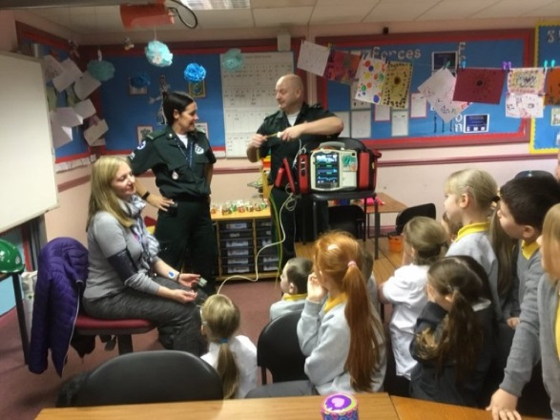
The World of Work continues to be a major focus for learning at Sunnyside Primary School to create ambition and aspiration within children for the future. Children have engaged with STEM ambassadors, parents who showcased their occupations and websites relating to the World of Work and are now able to identify a greater number of roles and occupations.

Clear programmes of work were developed to ensure effective progression across skills relating to the World of Work and Digital Literacy. Significant IT resources (funded through PEF) were purchased to enhance this learning. Social media and internet safety continues to be of concern however although children are aware of the risks, there continues to be incidents where they do not follow the safety rules.

Priority 3: Improve Reading Attainment
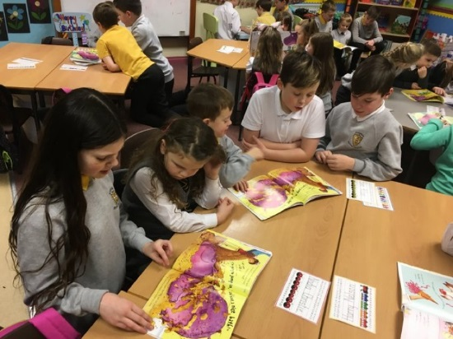
This session the school has participated in an authority-wide initiate in consultation with Professor Sue Ellis from Glasgow University to raise the profile of reading and the skills children need to develop to become competent and confident readers. The school library has been developed (funded through PEF) and enhanced and class libraries are now more inviting. Children regularly share their ‘favourite’ books through book blessings, and through class novels.

Paired reading has been introduced across stages to raise the profile of picture books and has helped to develop children’s reading skills, improve their questioning skills and have encouraged reciprocal teaching/modelling of expression and understanding.

Read, Write Inc. has been rolled out across primaries 1 – 3 to ensure consistency of phonics teaching and to allow children’s progress to be monitored carefully. Where necessary additional 1:1 tutoring sessions were provided to ensure that they make the best possible progress. Children from deciles 1 & 2 were prioritised for additional support by a PEF funded learning assistant, but not to the exclusion of other children who were experiencing difficulty.

There is a need for further clarity and consistency across the whole school to ensure that attainment increases and that children reach their full potential.

Priority 4: Improve Numeracy Attainment
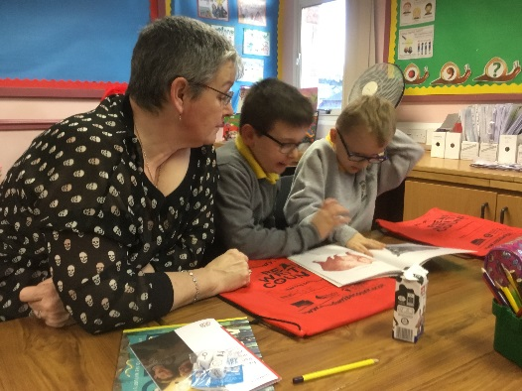
In order to further improve class teachers’ confidence in the numeracy and mathematics curriculum, they have received training in ‘what an excellent numeracy lesson looks like’, pace, challenge, growth mindset and maths recovery.

Maths and numeracy is now taught more often with children receiving daily lessons of at least 60 minutes and the development of whole school planning and tracking documents has ensured a more comprehensive and consistent approach across the whole school. Significant, high quality resources and class sets of iPads have been purchased (funded through PEF) have enhanced children’s learning experiences.

All these initiatives have led to staff becoming more confident and children have a greater opportunity to learn new skills and concepts and to reinforce and practise existing ones. There is now a greater focus upon pace and challenge. Attainment data highlights an improving picture.

Priority 5: Playground Development
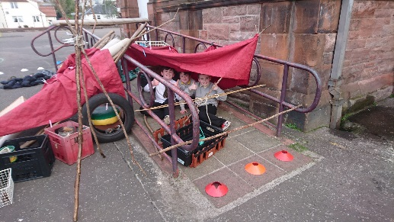
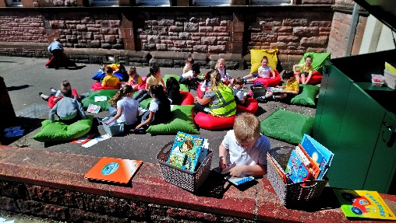

Significant improvements have been made to the playground this session to support children’s readiness for learning. Loose Parts Play, climbing boulders, mud kitchens, gymnastics areas and quiet areas were installed (PEF funded). There are now significantly less incidents where children’s learning has to be redirected and has resulted in children returning to class after their breaks, ready to learn.

Priority 6: R4L (Readiness for Learning)
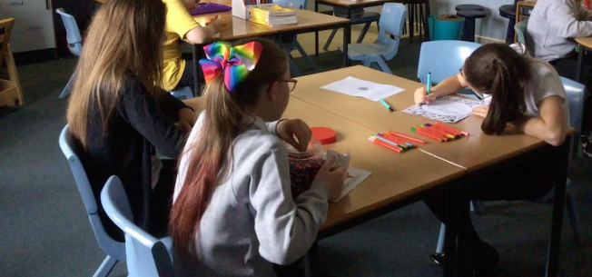
All teaching staff took part in training around NME (neuro-sequential model of education) and implemented strategies within classes to support children to regulate their behaviours. Observations highlight that children are beginning to use these strategies and resources to self-regulate and enter a state of ‘readiness to learn’. This work will be further developed next session.

Children were identified for counselling by class teachers and parental requests (priority given to children in SIMD1 & 2 and those in receipt of Free School Meals). A counsellor was employed (PEF funded) and worked with 9 pupils in total through the session. The impact of this initiative was not significant and therefore this will not be continued next session.

Priority 7: Attendance, Pupil and Parental Engagement
A support worker was employed to tackle Sunnyside Primary School’s low attendance and high late-coming statistics through engagement with parents and carers. Unfortunately there was a delay in the recruitment process and the worker started with the school in January. In this time, there has been a 49% improvement in those children whose attendance is less than 95% and a reduction of 34% compared to baseline data of those children who are late.

Children were identified through review meetings and teacher feedback to receive targeted individual and group work to help them better manage their emotions, to develop resilience skills and enhance their readiness for learning. Pupil engagement has been mixed and the programmes have been adapted to suit pupil preferences. This has resulted in less disruptions in classes.

School Improvement Priorities 2018/19

The following priorities will be addressed through cluster working:
- Clackmannanshire Reading Project – this is the second year of this initiative in consultation with Professor Sue Ellis from Glasgow University
- LIFT (Learning is Fun Together) – second year of a three year initiative for the nursery
- Improving Pedagogy and Equity – an authority wide initiative linked with Professor Dylan Williams and Tapestry
- Moderation – engagement with Education Scotland Moderation Cycle to ensure that the standards within a Curriculum for Excellence experiences and outcomes are regularly used and that the Benchmarks are used to moderate learners’ progress

The following priorities will be addressed within school:
- Developing the Young Workforce – further develop skills for learning, life and work and children’s aspirations for their future
- R4L (readiness for learning) – including further playground development; further roll-out of NME (neuro-sequential model of education); attendance, late-coming and parental engagement; and introduction of resources to develop children’s ability to verbalise their emotions and build resilience skills.

Pupil Equity Funding will support these initiatives through the employment of a Depute Head Teacher to ensure high quality learning experiences for all children and to support consistency in the quality of learning, teaching and assessment across the whole school. A learning assistant will be employed to support attainment in literacy and numeracy and a support worker will continue to be employed to increase attendance, improve late-coming and enhance parental engagement and family learning.

