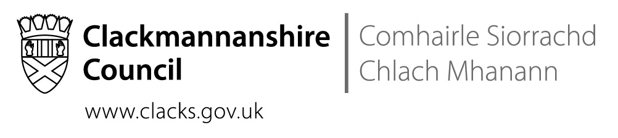
School Name St Bernadette’s RC PS
Address The Orchard, Tullibody, FK10 2SD
Tel No 01259 723973

 | Date: | 13th December 2018

Dear Parents and Carers,

Thank you so much for your incredible generosity in terms of the Christmas Fayre and Raffle. Thanks also to the Parent Council and the volunteers who worked so hard. So far, the amount raised is in the region of £2400! That is an amazing figure for a wee school. Thank you all so much.
Please note that there are changes to the newsletter emailed out on Friday.
Have a wonderful Christmas and New Year!
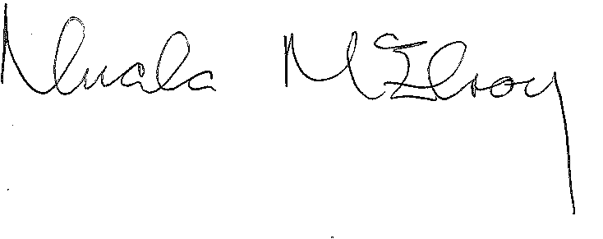

Raffle Tickets:
Please return unsold tickets as soon as possible as several parents are looking for more to sell. It’s also very important that the Parent Council can account for every ticket. Your help with this is very much appreciated. The raffle will be drawn on the morning of the 20th of December. The winners will be Tweeted and posted on Facebook by the Parent Council. They will also be phoning winners directly.

Playground & Relationships Consultation:
Last year, our Parents as Partners meetings helped us to decide on the setting up of the House System and the purchase of playground equipment. This year, we would love to have family members come along to support our Pupil Council as they discuss maximising children’s enjoyment of the playground and the creation of a relationships policy. If you can come along to have a cup of tea and a biscuit while sharing your views, our children would be very grateful. This meeting is at 2.15pm on the 9th of January.

Catholic Schools Admissions Policy Public Consultation:
Education Scotland are visiting the school on the 9th of January to discuss the consultation with staff, parents and children. It is very important that we have parents at the meeting. If you can spare time at 10.00 am, I would be very grateful. It will be a short meeting.

Money:
In the new term, the school will be moving to Parent Pay, a cashless system for paying for all school-related costs eg milk money, breakfast club, lunch, school trips. Active Schools are not participating in this initiative so the money for afterschool clubs will still be handled by the office staff. Letters should be coming out soon with further details.
Thank you so much to all the families who settled their school lunch accounts after our appeal last week. We really do understand how easy it can be to fall behind – we’re all so busy!

Sacrament of Reconciliation:
The P3 and P4 children who are Catholic will be making the Sacrament of Reconciliation on the 14th of December at 9.30am in the church. Please keep them in your prayers.

St Modan’s Community Concert:
Congratulations to our fabulous young people for their wonderful singing and remarkable behaviour. They were, as always, a credit to their families and their school.

Christmas:
Our Christmas celebration will be Mass at 9.30am on the 19th of December in the church. The Primary Ones will perform the Nativity with Primary Twos narrating. Those Primary Threes who are not making the Sacrament of Reconciliation will be helping the wee ones to perform the story. Our remaining children will be singing their hearts out.

Christmas Jumpers:
On the 14th of December, if children wish to wear a Christmas jumper, t-shirt or hat, we will accept donations for Save The Children. If your child doesn’t have a Christmas jumper, please send them in in their school sweatshirt. This is not a non-uniform day. We are not asking parents to go out and buy Christmas jumpers.

Christmas Parties:
Our Christmas parties will be on the 18th of December in the afternoon. The Parent Council, thanks to your generosity, will provide the refreshments for the children. Children can wear their party clothes to school in the morning or can go home at lunchtime to change.

Christmas Surprise:
After her fundraising evening, Mrs Burney has donated money to the school to pay for a Christmas Surprise that will be happening on the 20th. She also donated money that will pay for the pantomime in January.

Our Jams and Apple Sauce:
We are so grateful to Mrs Aitchison for all of her hard work in creating foods with P5 that they could sell to raise funds for school activities. I would like to remind you of the advice that she gave as she sold the jars of jam and apple sauce:
- the jars can be stored unopened for 6 months ie April 2019
- once opened, the contents must be consumed within 3 weeks.

.Dates for Diary
These dates are provisional and may change with circumstances.
14th December | Sacrament of Reconciliation in the church @9.30am
18th December | Christmas parties 1-3pm
19th December | Advent Mass and Nativity @ 9.30am
20th December | Mrs Burney’s Christmas Surprise
21st December | School closes at 1pm
24th December –  4th January | CHRISTMAS HOLIDAYS
9th January | Education Scotland meeting parents @ 10.00am. Please note this time has changed.
9th January | Parents & Pupils As Partners meeting @ 2.15pm. Please come along for tea and a chat with the Pupil Council about the playground & relationships.
16th January | Dick Whittington – paid for by Mrs Burney’s fundraising evening

