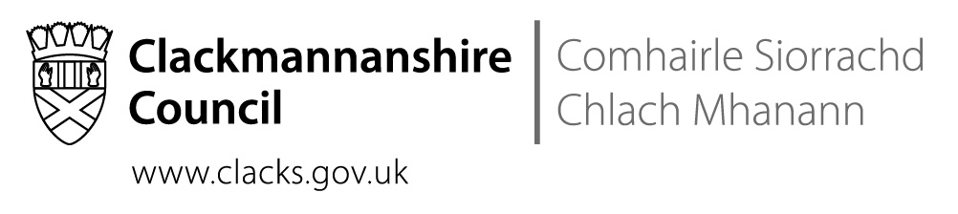
School Name St Bernadette’s RC PS
Address The Orchard, Tullibody, FK10 2SD
Tel No 01259 723973

 | Date: | 19th November 2018

Dear Parents and Carers,

This week, schools all over Scotland are celebrating the Centenary of Catholic Education in Scotland. We will be going to Mass on Wednesday to celebrate in our parish church with our incredibly supportive parish priest and school chaplain, Fr Mike.
On the door to our school, we have posted the Charter for Catholic Schools In Scotland. It is on the door because we want to be explicit about who we are and what we aspire to being.

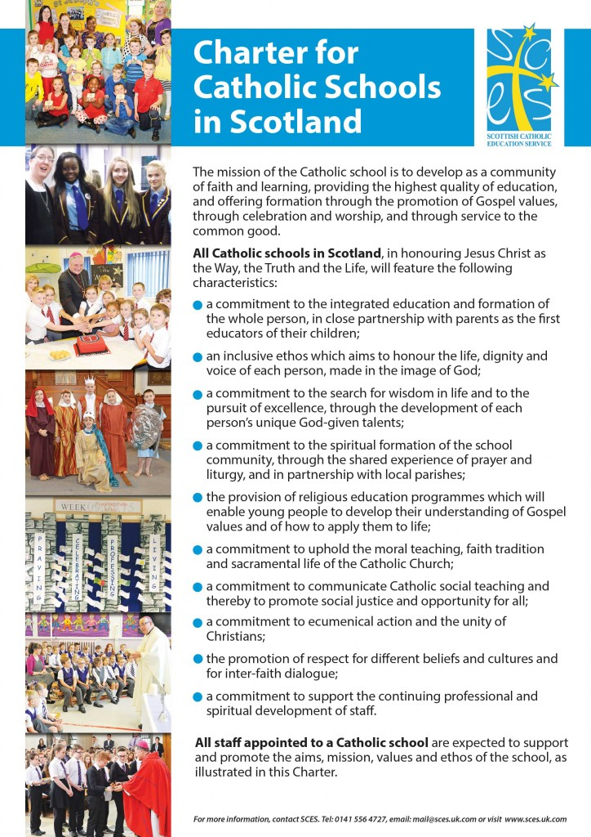

When we make decisions, they are shaped by our Catholic Identity and Catholic Social Teaching and there are practical implications:
- at Christmas, we have a Nativity in our parish church;
- our end of year celebration is in our parish church;
- Mass, prayer and sacramental preparation are central in our curriculum rationale and an important parts of our school life;
- our charitable fundraising activities, address the experience and outcomes of the curriculum as well as driving our Lenten Alms-giving and so we don’t take part in all the worthy and important fundraising drives that occur throughout the year;
- our Health and Relationships Education is taught through God’s Loving Plan;
- our House Groups are named after Saints;
- our School Values are Gospel Values;
- our leadership programme is the Pope Francis Faith Award;
- we always strive to reduce costs of activities for all parents. We know that many parents can afford to pay ‘full price’ but we are determined that no child is denied opportunities at school because their family is struggling financially;
- we work with Saint Vincent de Paul to assist families in need.

All staff in education have chosen this work because they want to support children and young people. The extra dimension in a Catholic school is that we believe we are called by God to love and serve our children and community. It is a huge responsibility to try to ensure that we live up to the demands of the Charter. The expectations are high! It is through working together that we will deliver the best possible outcomes for all of our children. As parents in our school, your support is vital and is appreciated in all the ways that it is expressed – most recently in our Parents’ Evening and completed Snapshot Jotter evaluations.
Thank you for your continued support.

Letter from Parent Council:
St Bernadette's RC Primary school will be holding their Christmas Fayre on the 1st Dec 2018 at noon until 2.30pm. Entrance is £2 Adult, £1 Child, Children will also be able to visit Santa, and receive a present for £2.
If anyone would like to help by donating items for the Fayre, we are looking for Tombola prizes, good clean soft toys, good clean books and home baking. We have a few stalls still available at £20 a table.
Just a reminder that this will be our last Christmas Fayre in our current building, We would love to see as many of you all as possible. Come along and support our little school.
Funds raised will be put towards activities for all of St Bernadette's Children.
There will be raffle tickets being sent home in schoolbags this week; 1st prize Xbox one, 2nd prize Amazon Echo, 3rd prize drink hamper. One ticket = £1 , one book = £10. We are hoping the books should arrive this week, Unsold ticket should be returned ASAP (so they can be passed on to others who want them) and sold ticket ASAP but no later than 14th December. We'll have them on sale at the Christmas Fayre too. The raffle will be drawn on the 19th of December.
Thank you very much, Hope to see you at the Christmas Fayre. Lindsay McCann. Vice Chair, St Bernadette Parent Council.
Catholic Schools Admissions Policy Public Consultation:
Clackmannanshire Council is consulting on amending the schools admission policy to change the policy for denominational primary schools. It is proposed that the admissions policy is changed, so that pupils who can demonstrate affiliation to the Roman Catholic Church by means of a baptismal certificate, would remain entitled to enrol at their catchment denominational school, but that all other pupils would be required to submit a placing request.
Children who are already attending the school will not be required to submit a placing request nor will siblings of children attending the school
The consultation is also available on line at the following link, paper copies of the consultation form are available in schools. https://clackmannanshire.citizenspace.com/education/proposal-for-a-change-in-the-schools-admissions-po/
A public meeting to discuss the consultation will be held at 7pm on 20 November in St Bernadette’s RCPS to which all parents are invited. Officers from the Council will also be attending the next meeting of the Parent Councils as will a representative from Education Scotland.

The Cost of the School Day Initiative:
‘School costs which are difficult or impossible to meet can affect children’s participation at school and the shame surrounding poverty can mean that they feel excluded or embarrassed. Missing out on opportunities and feeling different makes it more difficult for children to learn, to achieve and to be happy at school.’ (CPAG website)
The Scottish Government and Clackmannanshire Council are increasingly focusing in on reducing the cost of the school day as a way of reducing the poverty-related attainment gap. As a Catholic school, we have always worked to ensure that all children enjoy the same opportunities regardless of their families’ financial circumstances. However, there is always more that can be done.
The council’s Principal Teacher for Health and Wellbeing is looking to gather parents’ views on this subject. If you could possibly pop in at 9am on Monday the ^{3rd} of December, it would be greatly appreciated. All views are welcome.

Period Poverty:
The parents of P6 and P7 should have received letters informing them of the provision of free sanitary products for both term-time and holidays. This is a government initiative.

Money:
In the new year, the school will be moving to Parent Pay, a cashless system for paying for all school-related costs eg milk money, breakfast club, lunch, sports events, school trips. The office will not accept cash. There will be more details in the next newsletter.

Advent:
We will be going to Mass on Wednesday mornings throughout Advent as preparation for Christmas. We would greatly appreciate having additional adults to walk to and from Mass with us.

Christmas:
Our Christmas celebration will be Mass at 9.30am on the 19th of December in the church. The Primary Ones will perform the Nativity with Primary Twos narrating. Our remaining children will be singing their hearts out.

Christmas Parties:
Our Christmas parties will be on the 18th of December in the afternoon. The Parent Council, thanks to your generosity, will provide the refreshments for the children. Children can wear their party clothes to school in the morning or can go home at lunchtime to change.

Christmas Surprise:
After her fundraising evening, Mrs Burney has donated money to the school to pay for a Christmas Surprise that will be happening on the 20th. She also donated money that will go towards a live theatre performance in the school – details of the theatre show will follow as the arrangements are made.

St Modan’s Community Concert:
Mrs Morgan is working very hard with our Primary Sixes and Sevens to make sure that they have a wonderful experience performing at the St Modan’s Concert on the 11th of December. This was a very successful evening last year and we encourage all of our children to participate.

Our Jams and Apple Sauce:
We are so grateful to Mrs Aitchison for all of her hard work in creating foods with P5 that they could sell to raise funds for school activities. I would like to remind you of the advice that she gave as she sold the jars of jam and apple sauce:
- the jars can be stored unopened for 6 months ie April 2019
- once opened, the contents must be consumed within 3 weeks.

Sacrament of Reconciliation:
Parents in P3 and P4 should have received letters asking for confirmation of their desire to have their child undertake Sacramental Preparation. If you have not done so, please contact the school.

Inservice Days:
Please note these are the 29th and 30th not the 28th-29th.
Dates for Diary

These dates are provisional and may change with circumstances.
20th November | Consultation on Schools Admissions Policy @ 7pm
21st November | Centenary of Catholic Education In Scotland Mass @ 9.30am
22nd November | Tullibody South – Robertsons Reporters
26th November | Cost of the School Day – please join us if you can for a short chat
29th-30th November | INSERVICE DAYS (School closed to children)
1st December | Parent Council School Fayre 12 – 2.30pm
3rd December | Cost of the School Day Consultation – please join us if you can @ 9am
5th December | Advent Mass @ 9.30am
6th December | Parent Council Meeting @ 6.30pm. Please attend if you can.
11th December | St Modan’s Community Concert – details to follow
12th December | Advent Mass @ 9.30am
14th December | Last day to return raffle tickets
18th December | Christmas parties 1-3pm
19th December | Advent Mass and Nativity @ 9.30am
19th December | Raffle drawn and prize winners informed
20th December | Mrs Burney’s Christmas Surprise
21st December | School closes at 1pm
24th December – 4th January | CHRISTMAS HOLIDAYS

