SUNNYSIDE PRIMARY SCHOOL NEWSLETTER
August 2023

Dear Parents/ Carers,

We hope our families have had an enjoyable break from routine and managed to catch some pleasant weather. The staff team are rested, rejuvenated and ready for a new school year.

Our Staff Development Days were positive and purposeful and we have begun to plan an exciting and productive year for all.

Meet The Teacher

Parents and Carers will have the opportunity to meet the new class teacher/s on 5.9.23 from 2pm-2.45pm. This informal event will allow you to see the children’s classroom and have a wee blether with the teacher, parents and children. We look forward to seeing you all then.

School Excursion Fundraising

This year, in order to allow all classes to enjoy a school trip we intend to start fundraising straight away. Therefore every last Friday of the month we will have a Dress Down Day. We suggest that children bring a donation of £1 for this. We have made this available on ParentPay to make this easier for families.

Parent Council

The next meeting is on 18.9.23 at 6pm at the school. Your support would really be appreciated in any way.

Class Dojo

Class Dojo has been successfully introduced to improve and streamline communication. Please get in touch if you haven’t already connected. If you have any concerns or questions, please contact your child’s teacher in the first instance. If your child is going to be absent you can also communicate this through class dojo. Please contact Mrs Hill or Miss Jed directly. Please note that school staff will only respond to dojo messages in working hours and that urgent messages should be made by phone call to the school office. We advise that you check the class dojo daily to ensure you are up to speed with what is happening in school.

School Expectations

We have started the new school year with some simple and clear expectations. These will replace large numbers of rules which can be confusing. The children have been learning what this means across different environments across the school. e.g class, dinner hall etc.

Sunnyside’s Expectations are-

READY
RESPECTFUL
SAFE

All adults will support children in their understanding of these and in enacting them.

PE Kit

This year we are encouraging children to wear PE kit. Children in P1-P3 will get changed in the classroom. P4-P7 will get changed in the changing rooms. Please get in touch if you need any help with PE kit. A reminder that football strips are not permitted.

Road Safety

It is frustrating and upsetting that our children’s safety continues to be put at risk daily through unsafe parking. Motorists are parking on double yellow lines, zig zag “keep clear” lines, stopping on junctions and obstructing residents’ driveways. We are working in partnership with the police who will ticket motorists for these offences. I urge drivers to consider that their parking choices do have the potential to cause a serious accident or injury.

Wet Play Times

We have been very lucky in recent weeks that there has not been too much rain. The children will be outside as much as possible so please make sure that on rainy days your child is suitably dressed. Being active in the fresh air has a huge impact on the children’s engagement and learning in class. We have spare jackets and wellies if children have come to school in items that will result in them getting wet. We are always happy to take donations of welly boots and waterproof jackets.

Dogs in the Playground

As with all schools in Clackmannanshire dogs should not be in the playground. Many of our children are frightened of dogs and this can cause some distress. Thank you for your support with this.

Staffing Update

- Mr Qadir remains with us 4 days a week and will cover various classes.
- Mrs Munro successfully completed her probationary year with us and will be doing supply work within Clackmannanshire schools. We are sad to see her go.
- Mrs Perez has been appointed as a permanent member of staff at Sunnyside. We are very happy to have her here and wish her and her P5 class a successful year.
- Gordon Ross has been appointed as our new janitor. We are delighted to have him here. He has already established himself as a valued member of the Sunnyside Team.

As always, should you have any comments, queries or suggestions, please do not hesitate to contact me.

Yours sincerely,

Lynne Goodwin
Headteacher

Dates for the Diary

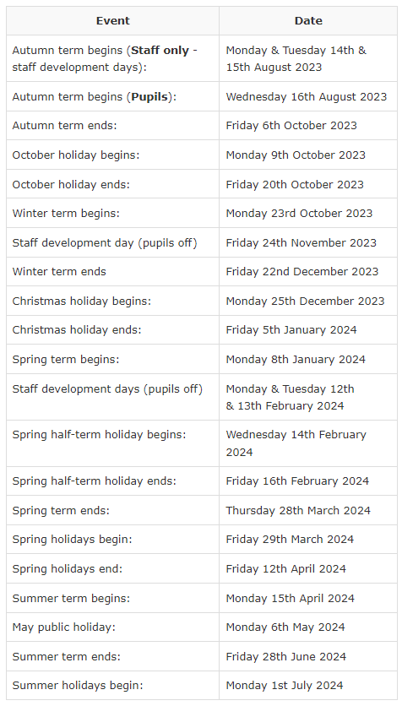

- 25.9.23 Maths Week Scotland
- 31.10.23 School Photos
- 14.11.23 and 16.11.23 Parents Evenings

