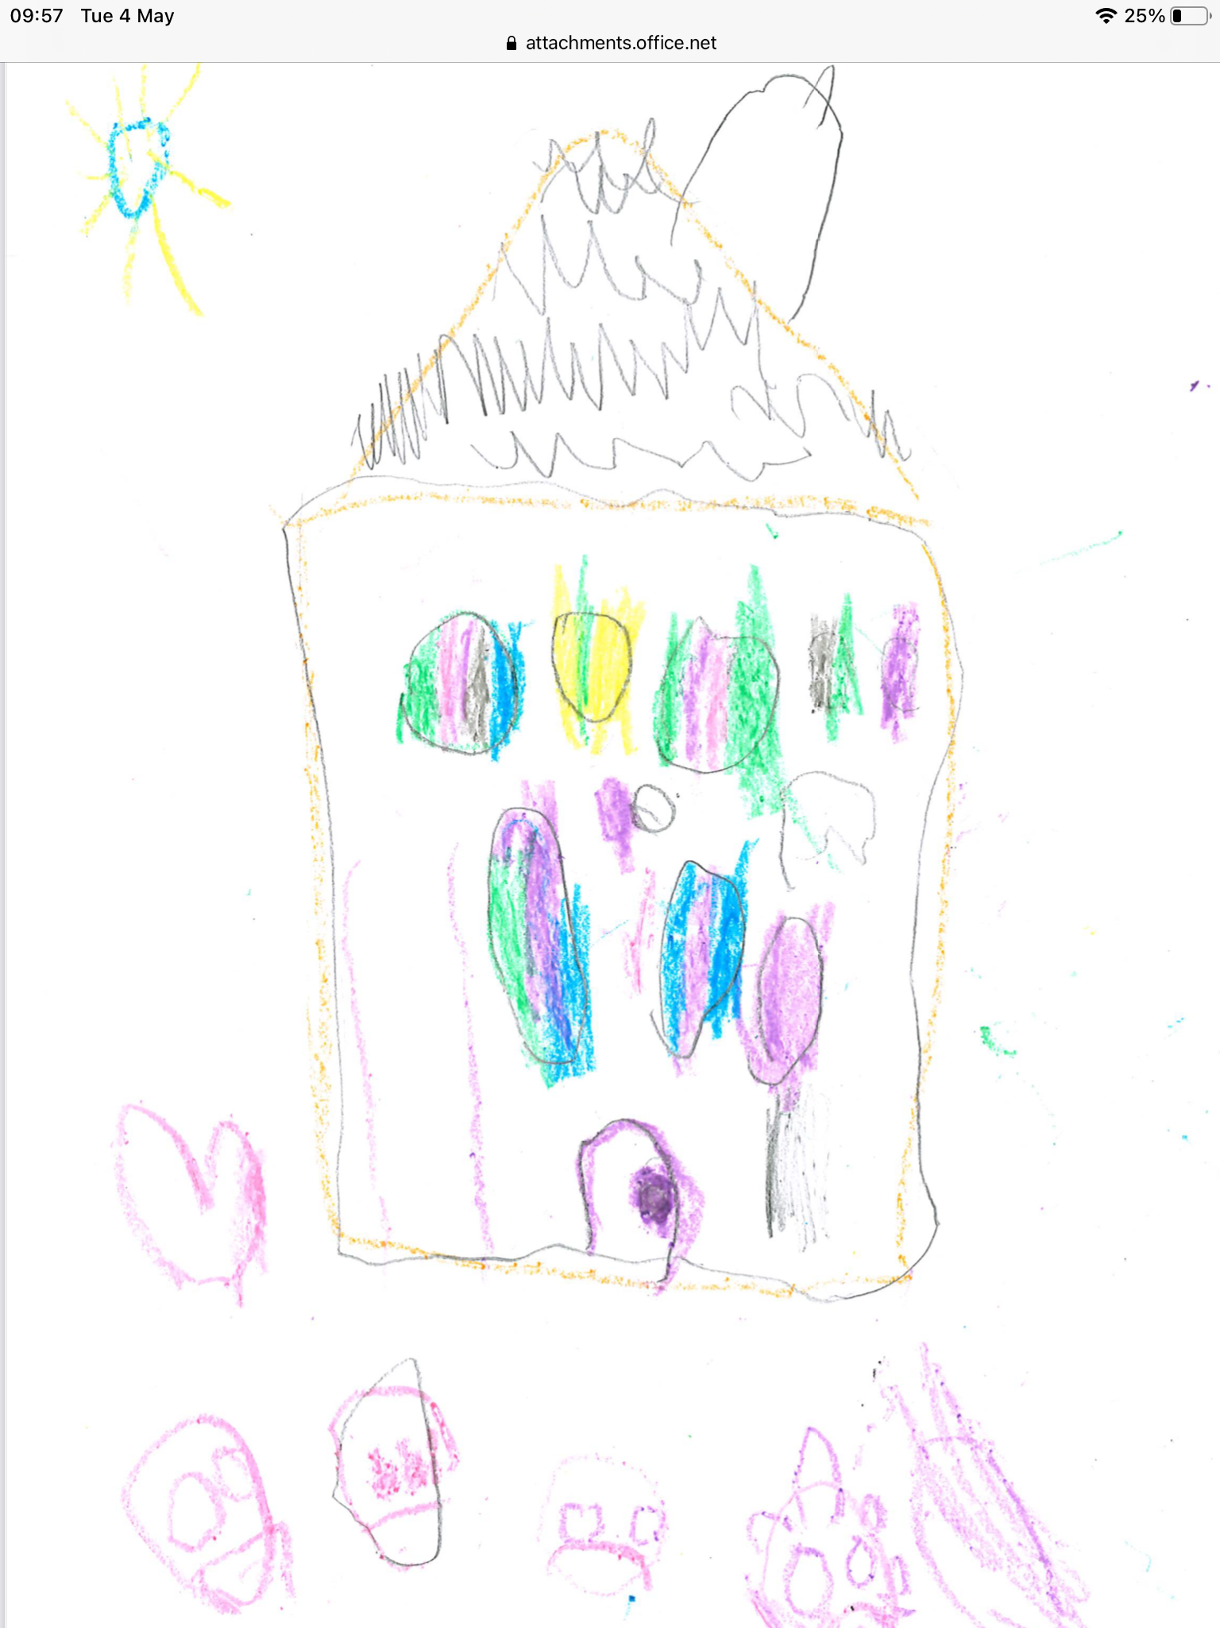

Welcome to Sunnyside ELC
2021 / 2022

Sunnyside ELC
Erskine Street
Alloa
FK10 2AT

Tel: 01259 452319 (option 2 for ELC)
E-mail: sunnyside@edu.clacks.gov.uk
Website: blogs.glowscotland.org.uk/cl/sunnysideprimary
Twitter: sunnyside_ps

Contents Page

Introduction 2
ELC Times 2
Meet the team 3
Aims and Values 4
Well-Being 4
Child Protection 5
Transitions 5
ELC Procedures 6
- Lateness and Absences 7
- Change in Personal Information 7
- Cloakroom Peg 7
Child Led Planning 8
Pre-birth to Three 9
Curriculum for Excellence 9
Outdoor Learning 10
Learning Journals 10
Child’s Voice 11
LIFT 12
Parental Engagement and Family Learning 13
- Communication with Parents 13
Parent Council 14
Self-Evaluation through Self Improvement 15
Health and Wellbeing 16
Literacy 17
Numeracy 18
Holidays and Staff In-service Days 19

Introduction
Welcome to Sunnyside Primary School and ELC. We offer a nurturing, stimulating, and creative learning environment for all children, aged from 2 to 5 years old. We have 2 Cohorts that are split into 4 groups. These groups are:
Daisy, Poppy, Lily and Rose.

We hope that both you and your child enjoy your time at Sunnyside ELC as we embark on a learning adventure.

Should you have any questions or queries, please ask any member of staff who will be happy to help you.

ELC Times

Sunnyside ELC’s session times are from 8:40am – 2:40pm.

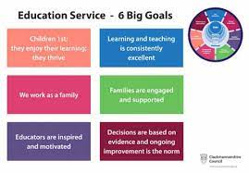

Meet the Team

Senior Management
Miss Angie Ross – Senior ELCE
Miss Lauren Barclay - Childhood Pedagogue
Cohort 1
Mrs Claire Chatburn – ELCE – Daisy Group
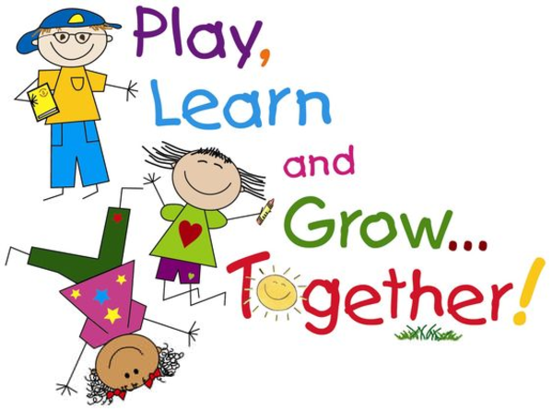
Miss Kirstin Goddard – Trainee ELCE – Daisy Group
Mrs Linda Foley – ELCE – Daisy Group
Mrs Katy Murphy – ELCE – Poppy Group
Mrs Julie Williamson – ELCE – Poppy Group
Miss Lisa Graham – ELCE – Poppy Group
Cohort 2
Mrs Gail Taylor – ELEC – Lily Group
Miss Shirley Rae – ELCE - Lily Group
Mrs Jean Adams – ELCE - Rose Group
Mrs Donna Chalmers – ELCE – Rose Group
Mrs Helen McCulloch – ELCE – Rose Group
Mrs Lindsay Henry – Lunchtime Assistant
* ELCE – Early Learning Childcare/Educator

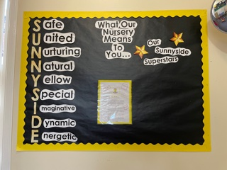
Aims and Values
Our aims at Sunnyside are:
- To provide a safe, happy and stimulating learning environment where everyone in our ELC community is included, valued and respected.
- To offer an early year’s curriculum- based education which provides each child with active, enjoyable and challenging learning experiences to enable them to develop as successful learners, confident individuals, effective contributors and responsible citizens.
- To provide effective learning and teaching which meets children’s needs and supports them to achieve their full potential.
- To work in partnership with parents, outside agencies and the wider community to support children’s learning and promote equality and fairness.
- Values; Respect, Inclusion, Integrity, Resilience, Effort and Fun!

Wellbeing (SHANARRI)
The Getting it right for every child (GIRFEC) approach supports children and young people so that they can grow up feeling loved, safe and respected and can realise their full potential. At home, in school or the wider community, every child and young person should be. There are wellbeing indicators which help make it easier for children and families and the people working with them to discuss how a child or young person is developing and progressing in their education. These 8 factors are often referred to by their initial letters – SHANARRI.

- Safe
- Healthy
- Achieving
- Nurtured
- Active
- Respected
- Responsible
- Included

Child Protection
The safety and welfare of children and young people are of paramount
concern to schools. All staff and volunteers working with children and
young people (in and out of the school building) are checked through
Protecting Vulnerable Groups (PVG) Scheme for offences that would make them unsuitable for such work. The school also has close working links with a wide range of other services and agencies that can help support children and young people in need.

Each school has a named coordinator responsible for all issues relating to child protection. In our school this person is Denise Penman, Head Teacher. Full details of the council guidelines and procedures for child protection can be seen in the school on request.

The council requires all staff to inform the coordinator if any allegation or suspicion of abuse arises. Such information cannot be kept confidential. The coordinator must pass the matter to social services and ensure that parents/carers are informed. Other members of school staff will be informed only if they have a direct role in supporting the child or young person.

Social services staff will pursue the allegation. Sometimes this will be as part of a joint team with the police and a member of the health team if appropriate.

The school actively supports children and young people develop their knowledge and skills about personal safety and to be confident in expressing any anxieties about their own wellbeing.

Transitions

Vertical transitions involve major changes for families, this occurs when the child moves into ELC and again into school. The five C’s we promote with children and families as a positive transition are:
Child-centred
Consistency
Communication
Communication

Collaboration
Culture

ELC Procedures
Procedure for arriving/picking up at ELC – Bubble 1
ELC parents and children in Bubble 1 (Daisy and Poppy Group) will wait at the car park every morning. A senior member of staff and keyworkers from Bubble 1, will greet you before your child’s keyworker takes him/her into the ELC, through the garden, to hang up his/her jacket/bag.
At the end of the day, 2:40pm, please return to the car park, where your child’s keyworker will hand your child back over to you. Following health and safety procedures, staff are only able to take two children out through the gate at one time.
Procedure for arriving/picking up at ELC – Bubble 2
ELC parents and children in Bubble 2 (Lily and Rose Group) will wait at the badminton court, located in front of the bike shelter, in the school playground. A senior member of staff and keyworkers from Bubble 2 will greet you before taking your child into the ELC, through the School door, to hang up his/her jacket/bag.
At the end of the day, 2:40pm, please return to the badminton court, where your child’s keyworker will hand your child back over to you. Following health and safety procedures, staff are only able to take two children out through the gate at one time.
Following procedures, it is important that you let staff know exactly who will be collecting your child at the end of the day.
We understand that plans may change, or emergency situations can arise during the time your child is in ELC which could affect who will be collecting your child. If this happens you must ensure that a phone call is made to the ELC immediately, to inform us who will be collecting your child. We are not permitted to release your child from our care to anyone that has not been authorised by yourself. If you have not given us the correct information, we would then have to contact you/emergency contact for permission.
Unfortunately no parents are allowed to enter the building.

Lateness and Absences
If you are running late and miss the ELC drop off/collection times, you are required to take your child to the school office and a member of ELC staff from the ELC will come and collect your child.
If your child is unable to attend ELC, please phone the ELC, before 9:00am on the day of absence or if you know in advance your child will be absent please inform a member of staff. If we have not been informed of your child’s absence, you will receive a phone call from your child’s keyworker that morning, enquiring their absence.
If you child is unwell, please see the link below which follow government guidelines on illnesses.
https://www.nhs.uk/live-well/healthy-body/is-my-child-too-ill-for-school/
Change in Personal Information
Should you change your contact details, such as phone number or address, you must let staff know to ensure we have up to date information in case we need to contact you for any reason involving your child at ELC.

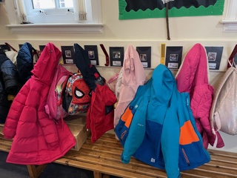
Cloakroom peg
Your child will be allocated a peg with the colour of their group which will have their name and picture on it. It would be greatly appreciated if all items of your child’s belongings are clearly labelled with their name on them e.g. jacket, jumpers, shoes etc.
Resources to include in your child’s bag
- Spare set of clothes e.g. pants, socks, trousers, jumper, t-shirt etc, in the event your child will need to be changed during the session.
- Packet of wipes and nappy sack bags to put their clothes into if they have been changed.
- If your child wears a nappy/pull-up, please provide nappies/pull-ups, wipes and nappy sacks.

Responsive Planning
At Sunnyside ELC, we respond to planning through the child’s interests and allow the children to take the lead on their individual learning. Children learn and develop at different rates personal to themselves. They are continually trying to make sense of the world around them. Children learn best when they are active, busy learners. It could be said that they are learning all the time from all their experiences. These intentions must be supported by the interactions and experiences surrounding the child in affording outdoor and indoor spaces.

On a Friday, the ELC blog is published to your child’s e-learning journal. This sums up what the ELC has been learning that week, alongside a few activities to try at home relating to the children’s interests.

Please take the time to look at your child’s E- Learning journal and ELC website for more in depth information around the child led planning approach that we offer.
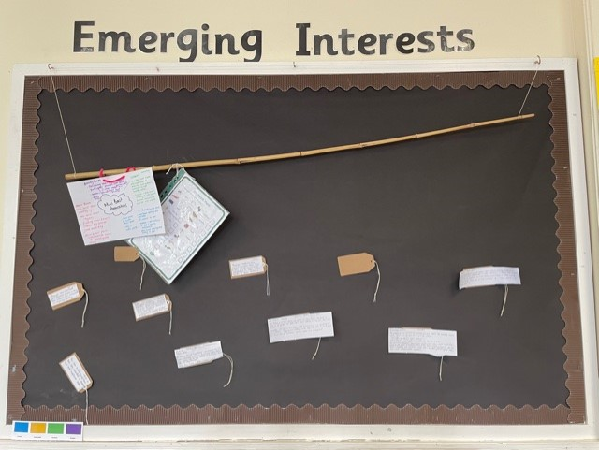
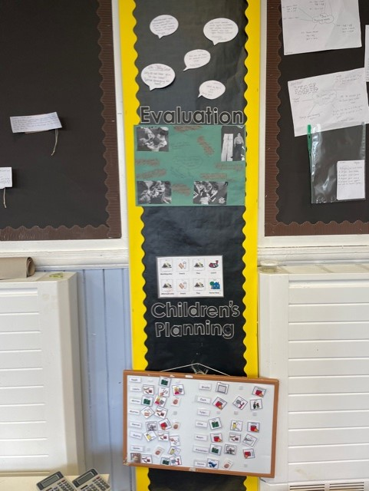

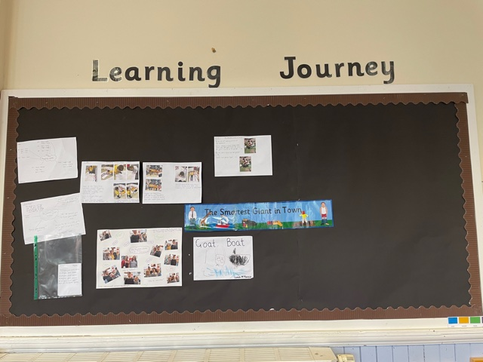

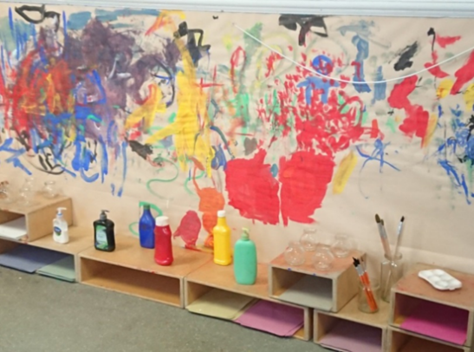
Pre Birth to Three
Pre-birth to three guidance aims to improve and enhance evidence-based practice by building on our knowledge of current research and our work with babies, young children, and their families. It also lays a sound foundation for children’s learning and development and will ensure a smooth and coherent transition for all children as they begin to engage with Curriculum for Excellence 3–18.
Four Key Principles:
- Rights of the Child
- Relationships
- Responsive Care
- Respect.

Curriculum for Excellence
As part of your child’s learning journey, they are entitled to experience a coherent curriculum from 3 to 18, in order that they have opportunities to develop the knowledge, skills and attributes they need to adapt, think critically and flourish in today’s world.
Curriculum for Excellence places learners at the heart of education. At its centre are four fundamental capacities. These capacities reflect and recognise the lifelong nature of education and learning. The four capacities are aimed at helping children and young people to become:
- Successful Learners
- Confident individuals
- Effective Contributors
- Responsible Citizens

Outdoor Learning
Outdoor learning and play is highly beneficial for our children. The outdoor environment enhances areas such as social development, wellbeing and mental health. All learning and development which takes place indoors can be transferred and achieved outdoors. Our children are offered free-flow between the indoor and outdoor environments enabling them to make their own choices.
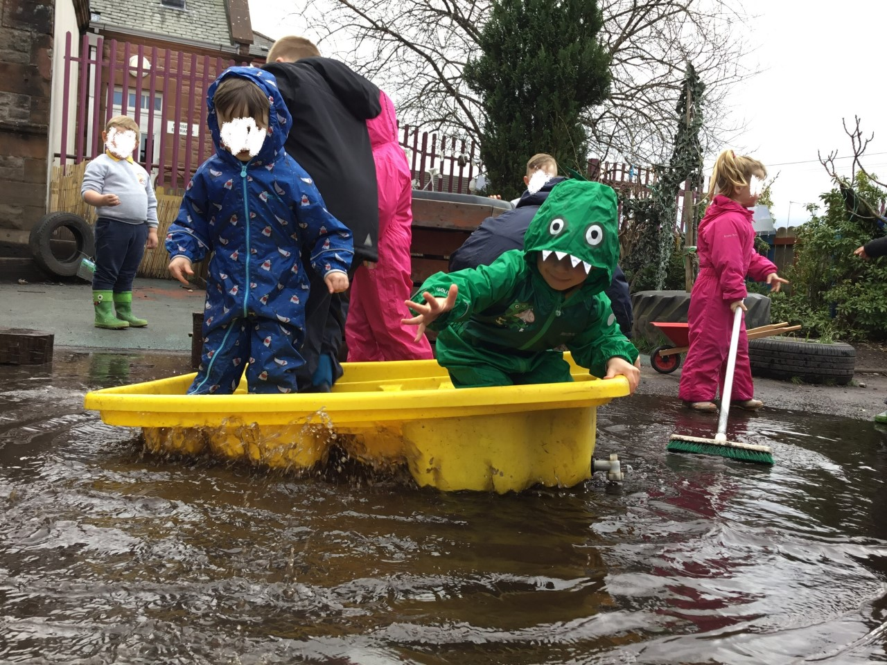
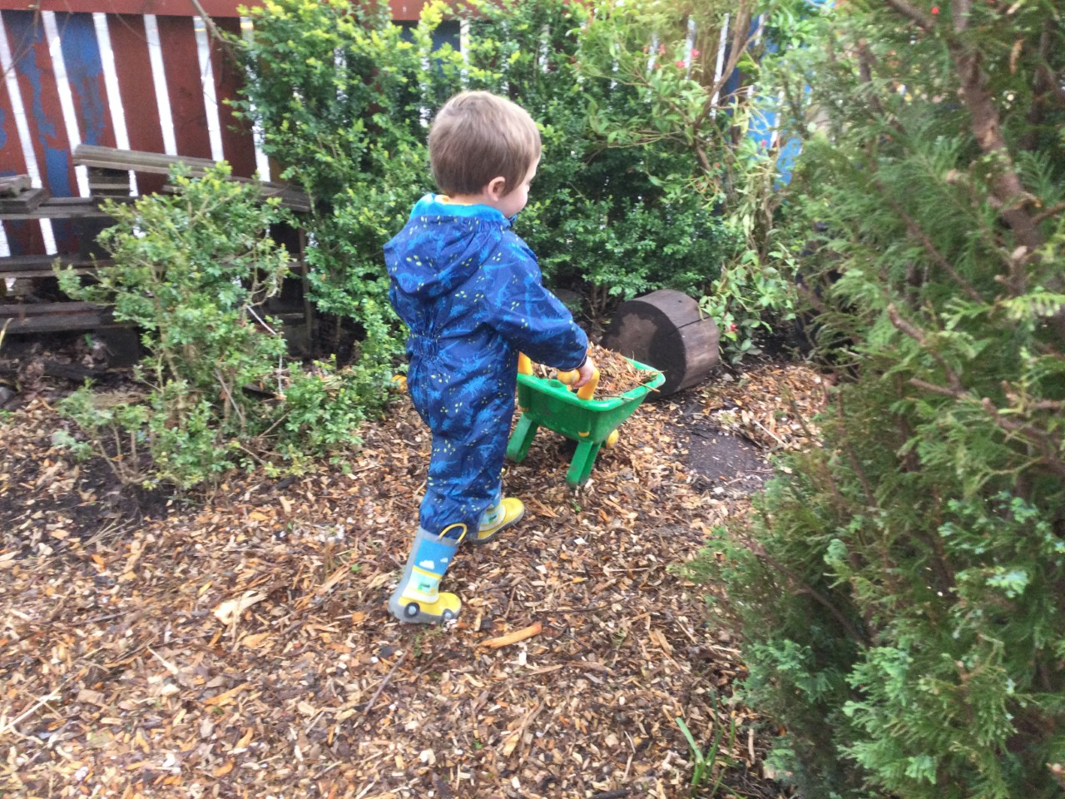

Learning Journals
At Sunnyside, we use Learning Journals to record your child’s learning while attending the ELC. Learning journals are a secure online reporting system that can be readily accessed by parents and carers from home.

As an ELC establishment, we believe that it is important for you as parents and carers to be involved within your child’s learning and using Learning Journals, allows you to immediately see what your child has achieved. Learning Journals allow you to respond to your child’s learning or add any learning or achievements from home. This can be done through comments or photographs.

In order to get your child’s Learning Journal set up an email address is required when your child starts. If you have any further questions, please speak to Miss Lauren Barclay.

Child’s Voice

Sunnyside ELC aims to empower children as independent learners in an environment which promotes choice, responsibility and respecting the rights of the child. We fully value and respect the thoughts and ideas of our young learners and their voice is at the centre of everything we do. Please read what one of our parents and child’s responses to being at Sunnyside ELC:

“”””””2F“I “I LIKE NEW BOOKS”
AS – 4YEARS
LIKE NEW BOOKS”
AS – 4YEARS
D”R“”” LIKEI LIK

“I LIKE TO PLAY ON THE SMART BOARD AND WATCH THE SMARTEST GIANT IN TOWN”
NB
“I LIKE NEW BOOKS IN THE ELC”
AS

"I like the ladies and playing with my friend"
AP

GGGGGV [Grab your reader’s attention with a great quote from the document or use this space to emphasize a key point. To place this text box anywhere on the page, just drag it.]
GZSGTTAFDG

"Playing Tig"
ON
“A SNACK” AB

"The teachers. Miss Ross and the toys"
CD
"I like it because I can make playdough and play with my friends"
CB
"Climbing trees and seeing my brother and sister"
EH

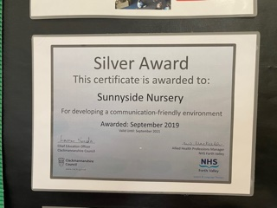
LIFT

At Sunnyside we have an ongoing commitment to LIFT, Language is Fun Together, part of the Speech and Language (S&L) Forth Valley Project. A whole Authority/ ELC approach that focuses on working collaboratively with S&L on earlier identification of children with speech, language, and communication needs.
LIFT aims are on providing quality ACI (adult child interaction), with all children. Promoting language on things that the children are interested in to increase their confidence in communication. This includes the ELC communication environment, being inclusive, accessible and full of enriching language for all learners.
We want to work in partnership with parents to increase engagement, knowledge and empower parents to support their children.
Through training and our awareness of the benefits of LIFT, we strive to deliver the best outcomes for children and families.
Good communication skills are essential for children’s learning, friendships, and wellbeing. The quality of spoken dialogue in ELC and school can significantly improve children’s attainment.

Sunnyside Primary and ELC has their own designated Speech & Language therapist Hannah Wong who visits weekly.
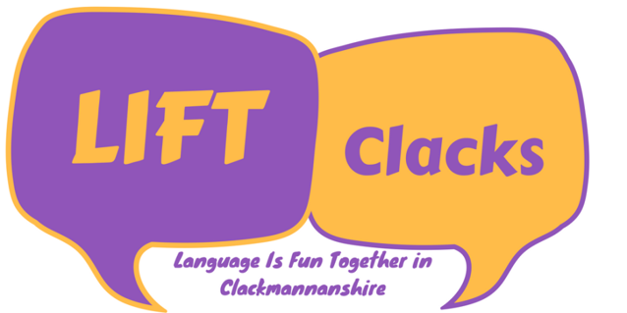

Parental Engagement and Family Learning
Family learning encourages family members to learn together, with a focus on intergenerational learning. Family learning activities can also be specifically designed to enable parents to learn how to support their children’s learning.
- E-Learning Journals – active activities uploaded weekly for parents to participate in over the weekend.
- PEEP Group (Virtual) – weekly curricular activities provided for parents/carers to join in with your child.
- Cooking Group (Virtual) – join your child in preparing nutritious favourite foods. Staff will upload a video, preparing the recipe chosen for that week.
Communication with Parents
An ELC newsletter is published on a monthly basis and can be found on the school website, twitter and E-Learning Journals. Our ELC Blog is published every Friday on the E-Learning Journals.
Parents Feedback
- “My daughter really struggled starting nursery with separation anxiety and would only stay for an hour at first, within no time she was staying the whole day! That’s all thanks to the nursery staff at Sunnyside! They are brilliant with her and really helped her confidence grow. I like how the nursery post regular updates on the learning journal for the parents to see what they have been doing that week. Sunnyside is a great nursery and I highly recommend it!!” (AP)
- “I would 100% recommend Sunnyside nursery to anyone! Staff are amazing at what they do and are brilliant with the kids. Massive Thankyou to Miss Ross and the gang at the nursery your truly amazing staff” (AB)
- “The nursery is welcoming, friendly and has a great atmosphere. All nursery staff are brilliant and they go above and beyond with support. Over the last two years my child has built excellent relationships with nursery teachers. My child loves everything about nursery” (SN)

Parent Council
Hi and welcome to our school from Sunnyside Parent Council,

We are a group of parents and carers who meet about once every 6-8 weeks.
At present it’s a zoom meeting but fingers crossed we can all meet up together again soon.

The parent council come from all walks of life we are a welcoming and open group.
We meet to discuss what’s happening in our school community, how we as parents can influence and get involved in decisions making in the school.

We discuss non child specific issues from uniform, homework, lunch, school funding and the school improvement plan to reporting formats. Anything and everything that you think you would like to know about your child’s school life we can ask.

We have a lot of fun when we are raising funds to improve the children’s learning environment from discos to sponsor walks to the school fayre. All parents and carers (yes even dads) are welcomed to roll their sleeves up and get involved. If you have an hour spare we can fill it for you.

I joined the parent council for a couple of reasons I wanted to know more about the school and what happens in it. I also wanted to meet parents of kids in my child’s classes and thought this would be the ideal way.

So if you want to get involved or even just find out more we have our own fb page just drop us a message and say Hello.

Leeann Currie
(Sunnyside Primary School & ELC Parent Council)

Self-Evaluation for Self-Improvement
At Sunnyside self-evaluation remains at the heart of our practice. In line with Education Scotland's How Good Is Our Early Learning Childcare (HGIOELC) document we use self-evaluation to explore our progress, development and practice to identify what has improved and what still needs to improve. The three familiar questions that support our effective self-evaluation and improvement are:
- How are we doing?
- How do we know?
- What are we going to do now?
We value and respect parent/carer’s views and suggestions to support our ELC self-evaluation. There are a variety of ways you can have your voice heard such as:
- Parent/Carer evaluation group (Not Available during Covid)
- Parent/Carer observations (Not available during covid)
- Parent/Carer questionnaires
- Add your feedback to the self-evaluation wall in the cloakroom (Not available during Covid)
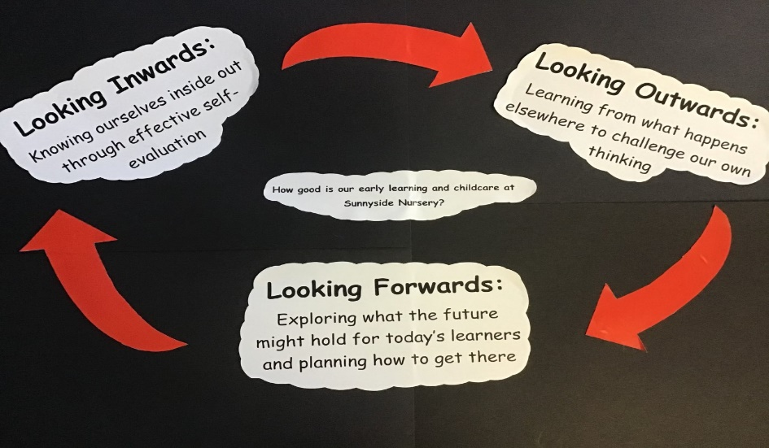

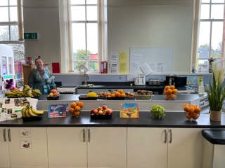
Health & Wellbeing
At Sunnyside ELC we provide a variety of healthy snacks, available to all children throughout the day. We follow Setting the Table – a nutritional guidance and food standards for early years childcare providers in Scotland. Children are encouraged to help prepare snack and follow good hygiene practices when doing so.

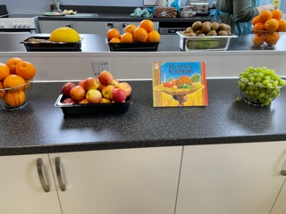
Over the past year we have focused on supporting the children to transition back into ELC life. We have had a huge focus on wellbeing, supporting the children to identify their feelings and provide them with the tools to build resilience and problem solve.
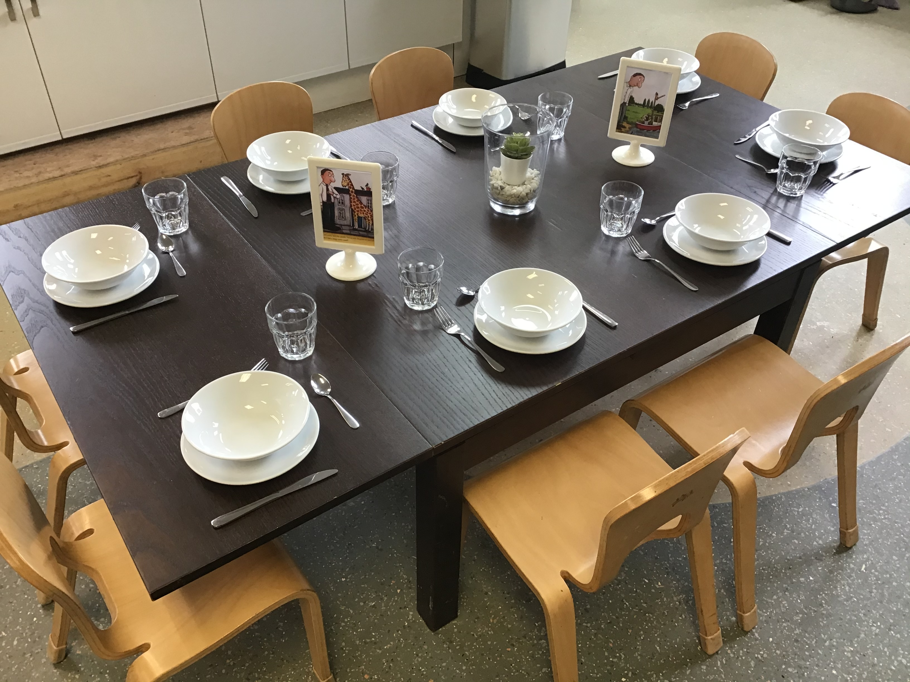
In October Sunnyside ELC successfully completed the Natural Health Award from the Health Improvement Team (NHS). The children completed a number of challenges linked to wellbeing. The Curriculum of Excellence benchmarks we use to measure the impact are:
- I am aware of & able to express my feelings and I’m developing the ability to talk about them. (HWB 0-01a)
- I know that we all experience a variety of thoughts & emotions that affect how we feel & behave and I am learning ways to manage them. (HWB 0-03a)
- I understand the importance of mental wellbeing & this can be fostered and strengthen through personal coping skills & positive relationship. (HWB 0-06a)

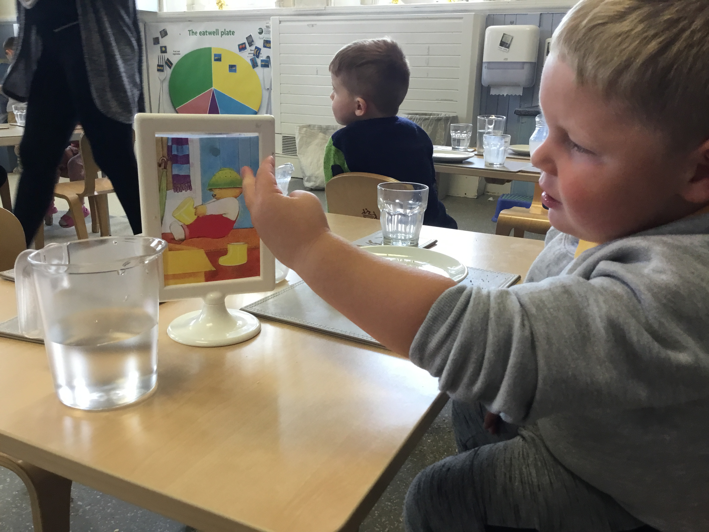
Literacy
At Sunnyside ELC we strive to increase Attainment within Literacy. We have carefully selected 15 core books which will remain out on our bookshelf for the entire year. This allows children to become familiar with the different characters and events in stories, and begin to use what they have learned in different ways.
After consulting with the children, we focus on a book for four weeks and explore the context. Staff choose three words for the children to focus on within the book – developing their language and understanding skills. Table provocations are used to promote discussions around meal times, as well as discussing the chosen story. As an ELC, we promote child led responsive planning so the children take control of their own learning. All activities linked to the 15 core books come from the children.
Alongside reading, we also strive to develop children’s writing skills. Children are able to participate in an initiative called “Helicopter Stories” which allows to the children to use their imagination to create their own stories and act them out. As An ELC, we encourage children to respect one another while engaging in their own play. Helicopter stories enables children to take turns, observe and be part of an audience.
15 Core Texts
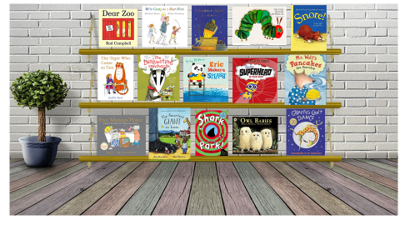

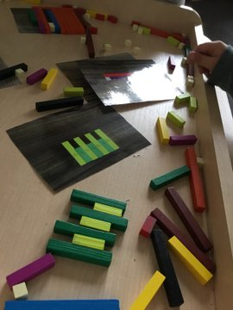
Numeracy
From a young age, children see and hear numbers wherever they go. At Sunnyside ELC, numbers are only a small fraction of what numeracy experiences that we offer. In order to raise numeracy attainment, Sunnyside ELC take into consideration the 7 different areas of numeracy which include; counting forwards, backwards, number identification, number sequencing, number structure – spatial, number structure – fingers and number counting.

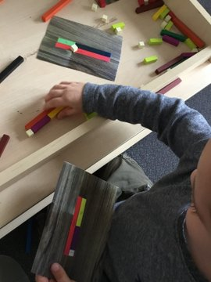
Some of the experiences on offer include;
- FoNS bags (The Foundational Number Sense) are available to children to promote a different which are designed for staff to work closely with children 1:1 or in small groups to support or challenge individual children. These bags enable children to develop a secure understanding of the concepts and processes of mathematics including; number recognition, systematic counting, the relationship between number and quantity, quality discrimination, representation of numbers, estimation, simple arithmetic competence and number patterns.

- Active Number groups where children learn and develop essential numeracy skills, through develop and challenging play experiences.

- Cuisenaire rods are mathematics learning aids for students that provide an interactive, hands-on way to explore mathematics and learn mathematical concepts. Children learn the skills of addition and subtraction, measurement, counting and grouping together.

Holidays and Staff In-service Days 2021-2022

Event | Date
Autumn term begins (Staff only - staff development days): | Monday & Tuesday 16th & 17th August 2021
Autumn term begins (Pupils): | Wednesday 18th August 2021
Autumn term ends: | Friday 8th October 2021
October holiday begins: | Monday 11th October 2021
October holiday ends: | Friday 15thOctober 2021
Winter term begins | Monday 18th October 2021
Staff development day (pupils off) | Friday 26th November 2021
Christmas holiday begins: | Wednesday 22nd December 2021
Christmas holiday ends: | Tuesday 4th January 2022
Spring term begins: | Wednesday 5th January 2022
Staff development days (pupils off) | Monday & Tuesday 14th & 15th February 2022
Spring half-term holiday begins: | Wednesday 16th February 2022
Spring half-term holiday ends: | Friday 18th February 2022
Spring term ends: | Friday 1st April 2022
Easter holidays begin | Monday 4th April 2022
Easter holidays end: | Monday 18th April 2022 (Easter Monday)
Summer term begins: | Tuesday 19th April 2022
May public holiday: | Monday 2nd May 2022
Summer term ends: | Friday 24th June 2022

