Sunnyside Primary School
Transition Activities 2021
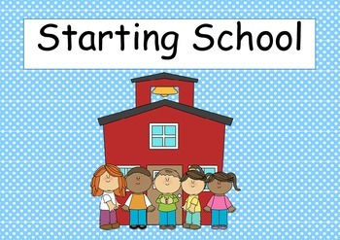

Dear Parent/Carer,
Welcome to our Sunnyside Primary 1 Transition Newsletter! As we are now navigating through different times we are having to be more creative than ever as we approach our transition this year.

We understand that, for many this is an anxious time, however we want to make it as enjoyable and easy for our new pupils as possible.

We hope that you find the information contained in this newsletter useful and that it provides you with an idea of our exciting transition activities we have planned for your child before he/she starts our school in August.

Why have Transition?
“It has always been recognised that the transition from pre-school to primary school is a critical time of change for children, parents and practitioners – which is full of opportunity and potential.”
(Curriculum for Excellence Pre-School to Primary Transitions)
We know that the impact of transitions in the early years can strongly influence a child’s future progress and development, and when supported well, transitions can provide opportunities for:
- Meaningful and challenging learning experiences
- New positive identities
- Broadening horizons
- Collaborative working
- Strong relationships to be formed
- Families to be meaningfully involved
- Children to develop both emotionally and socially.

Primary 1 Information Event:
A Primary 1 information Event is usually held at the beginning of June. Unfortunately due to guidelines we will be unable to organise this event. However, please be assured that we will keep you updated as much as we can via the school website and/or your child’s learning journal.

Transition Book Study with Primary 1
In order to enhance the transition of learning we would like to carry out a book study with all children moving to Primary 1. This work will then be continued
with their new Primary 1 teachers once the children begin in August.
The plan is that everyone will hear the same story and then each day for a week there will be different learning activities linked to the story. The story will be read by either your child’s keyworker, Primary 1 teacher or Early Intervention Worker. The learning will be uploaded to learning journals alongside the learning activity. It would be great if you could upload photos and videos of your children completing the activities to their learning journal. The book study will start week beginning Monday 17.05.21 so look out for the post.
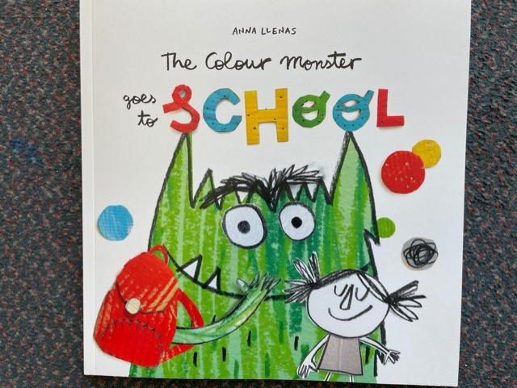

Virtual Tour
We have a virtual tour of our school on the website. The video will show you around the school, visiting the classrooms, PE hall, dinner and packed lunch hall, playgrounds, school lunch hall etc. This will be uploaded to our Transition page on the Nursery Website, which is part of our school website. You can sit down and share this video with your child as many times as you would like and discuss it with them.

School Website:
If you are new to Sunnyside Primary School please have a look at our website. Click on the link below:
https://blogs.glowscotland.org.uk/cl/sunnysideprimary/
There is a separate ELC tab on the Webpage. Click on this and then access the Transition Page. Here we will keep you updated with any information about transition into Primary 1.
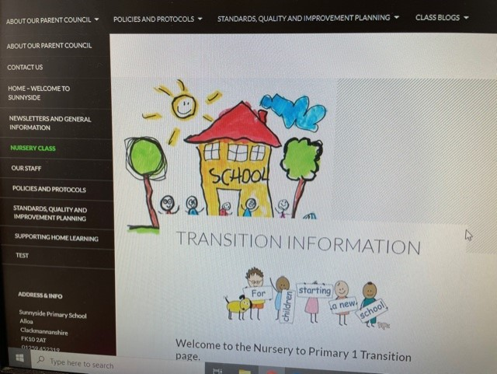
Transition Table 2021
Week Beginning | Transition Activity
17th May | - The Colour Monster Goes to School ‘Book Study’  - Video – Tour of the school on the website
24th May | - Primary 1 teachers spending time in the nursery/reading ‘The Colour Monster Goes to School’
31st May | - Video – Tour of Primary 1 classrooms - Website  - Video – Primary 1 teacher introductions - Website
7th June | - Welcome Pack will be sent out, which includes a booklet primary 1 children have made for their new primary 1 friends.
14th June | - Video – Linda King (Early Intervention Worker) reading ‘The Colour Monster Goes to School’ - Website
21st June | - Surprise Summer Transition Activity sent out

Mrs Denise Penman

Headteacher Sunnyside Primary School

