SUNNYSIDE PRIMARY SCHOOL NEWSLETTER
November/ December 2020

Dear Parents/ Carers,

We are now well into term 2 of this session and looking forward to our Christmas celebrations. These will obviously look very different this year to ensure that children and staff remain safe in light of COVID 19.

I am determined however that when planning learning and activities that we encompass our value of ‘FUN’ as much as possible.

The school will close for the Christmas Holidays on Wednesday 23rd December at 1.00pm and will re-open on Thursday 7th January 2021.

Christmas Parties:
Normally the Christmas Parties would have classes across each stage joining together. This is not possible as we need to ensure that children remain in their class bubbles at all times. We will however be able to hold class parties in our gym hall ensuring that the area is cleaned thoroughly before the next party takes place.

Children are encouraged to come to school dressed in their

party clothes, or alternatively bring their clothes so that they can get changed at school as they should not go home at lunchtime to get changed.

The dates are as follows:

Monday 7th December – P6M
Tuesday 8th December – P5/6
Wednesday 9th December – P5A
Thursday 10th December – P4M
Friday 11th December – P4S
Monday 14th December – P3Y
Tuesday 15th December – P2/3
Wednesday 16th December – P2
Thursday 17th December – P1/2
Friday 18th December – P1D
Monday 21st December – P7D
Tuesday 22nd December – P7B
Wednesday 23rd December – Nursery (8.30am – 12.45pm)

It is hoped that Santa will visit the Primary 1, Primary 1/2, and Nursery parties at some point during the celebrations.

Nativity Performances/ Coffee & Carol Shows
Obviously in light of current restrictions it will not be possible to invite parents and carers into the school to join in with our celebrations and to watch our children perform. This is obviously extremely disappointing as I know how much the children love to share their learning with you.

We have therefore decided to go digital with our performances this year, ‘Sunnyside’s Christmas Spectacular’ and our Primary 1/2 Christmas Show ‘The Night Before Christmas’ and our Primary 1 Christmas Show, ‘The Christmas Story’, will be filmed and posted onto Google Classroom for you all to see. The link to these will be posted onto our website, Tweeted and also shared through Groupcall once the videos are completed.

Christmas Extravaganza
On Monday 21st December children from all classes will be able to participate in an outdoor Christmas Festival. They will be able to take part in a variety of Christmas Themed activities which will be led by Primary 7B as part of their Enterprise Project. Children will participate in quizzes, artwork, scavenger hunts and building challenges all geared to help them develop their engineering habits of mind. I’m sure that this will be great fun for all!

Santa Storytime & Christmas Coorie Doon
As many of you know, we have worked with Fergus McNicol from Macastory for a couple of years to develop our storytelling skills here at Sunnyside.

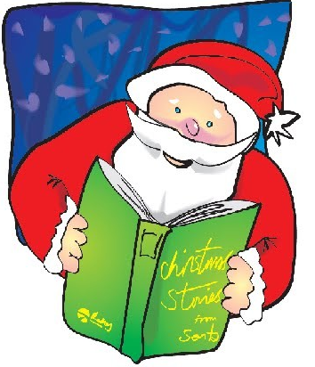
This year, instead of their normal Christmas show, they will be performing ‘Santa Storytime’ for children in nursery to Primary 2 and ‘Christmas Coorie Doon’ for children in Primary 3 to Primary 7.

I am delighted that our children will be able to experience these shows digitally in their class bubbles at some point during December.

Social Distancing and COVID-19:
We appreciate your assistance and consideration regarding social distancing. We understand that this can be particularly challenging around pick up and drop off times, however it is very important that families stay 2m apart and face masks worn at these times.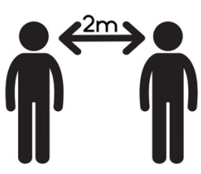

If you have a child that is P2 or P3, you are welcome to wait on the marked spots behind the trim trail.

We would however ask that families whose children are P4 and above meet them away from the school, if possible, in order to support social distancing.

Parking and Road Traffic
You may have noticed that we have recently had our zig-zag lines repainted, it is imperative that these areas are left clear to provide children and families with a safe space to cross. Stopping on these lines can result in a fine and penalty points and more importantly put children in significant danger as they try to cross the road.

We continue to work with local agencies, and our Junior Road Safety Officers have been surveying traffic around the school in partnership with local Police. This remains a high priority.

By parking a short distance (approximately 10 minutes) away and walking to school, pupils are able to earn their WoW badges.

Uniform
As you know, in light of COVID we have temporarily relaxed our Uniform Policy, we would however ask that children are suitably dressed with a school t-shirt, jumper or blazer. Hoodies are not part of school uniform, and we ask that these are not worn.

With winter well and truly on its way, could we also remind all families that children must bring a warm, waterproof coat.

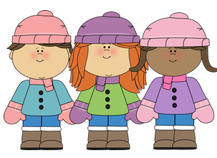
Young Leaders of Learning
We are very excited that our Pupil Council will be working with Education Scotland to become “Young Leaders of Learning”.

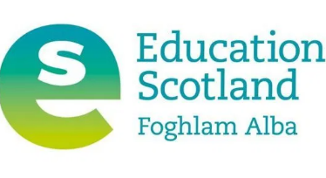
This programme helps children and young people to be more actively involved in helping to improve their schools, developing confidence, communication skills and other organisational abilities.

I hope that you’ve found this newsletter informative, however, as always, should you have any comments or questions, please do not hesitate to contact me.

Thank you all for your continued support.

Denise Penman
Head Teacher

