Sunnyside ELC Newsletter
August 2020

Dear Parents/Carers,

We would like to welcome back all of our children and families after a challenging few months. It was lovely to see how resilient our children have been coming back into Sunnyside.

Transitions
It was fantastic to see so many of our new children and families attend our transition visits to our garden. Each child will have an individual transition plan as some children will take longer than others to settle into their new ELC routine.

To ensure a positive transition we have also:
- Sent a Transition letter last term.
- Added a virtual tour of our ELC which is on the website/twitter.
- Sunnyside ELC brochure uploaded to the website.

Staffing update
- Angie Ross has moved from the Childhood Pedagogue to become the Senior Early Learning and Childcare Educator.
- Melanie Higgins is now the Childhood Pedagogue.
- Julie Williamson is our new Early Learning and Childcare Educator for the Poppy Group.
- Jean Adams is now our full time Early Learning and Childcare Educator for the Rose Group.
- Donna Chalmers is our new Early Learning and Childcare Educator for the Daisy Group.
- Louise Anderson is our new Trainee Early Learning and Childcare Educator.
- Kirstin Goddard is our new Trainee Early Learning and Childcare Educator.

Health & Wellbeing
Our main focus for August is your child’s health & wellbeing as the last few months will have had an impact on how your children are feeling. We will be encouraging the children to explore their feelings using a variety of methods such as board maker signs, yoga and using our feelings box.

Learning Journals
All Learning Journals have been set up with our new parents, and should have been sent login details. Please check your email for these details. Learning Journals will be updated on a monthly basis as a minimum.

Website
We are so excited to let you know we have been busy giving the nursery section of the school website a total revamp. The nursery team have left a message for you all. We hope you like the new look and any feedback would be welcome.

Literacy
Our focus this term is introducing our 15 core books. Each month we will ask the children to choose a story and focus on activities relating to them. To extend the children’s learning we will use story stones, story spoons, sequence cards to retell the story and smartboard.
The more that you read,
The more things you will know,
The more that you learn,
The more places you’ll go.
---Dr. Seuss
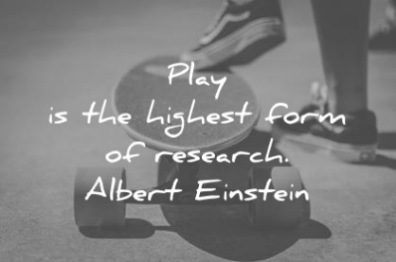

We are looking forward to seeing how our learners play and creations evolve over the coming weeks. Look out for our weekly tweets on @sunnyside_ps twitter page.

PEEP Sessions
PEEP is a play based session between parents and their children to encourage bond/attachment and learning together. Hopefully we will see as many parents as possible coming along to have fun and learn new things.

We are hoping to launch our virtual PEEP sessions after the October holidays so you can continue learning together at home.

Gym Sessions with Mr Foley every Thursday & Friday
We would like to ask that any children who have piercings are either taped over or removed on a Thursday & Friday.

If there is anything you would like to discuss further or any questions please do not hesitate in speaking to either Miss Ross or Miss Higgins.

Yours sincerely,

Denise Penman
Headteacher

