Welcome to Sunnyside Primary School Nursery Class

Sunnyside Nursery
Erskine Street
Alloa
FK10 2AT

Tel: 01259 452319 (option 2 for nursery)
E-mail: sunnyside@edu.clacks.gov.uk
Website: blogs.glowscotland.org.uk/cl/sunnysideprimary
Twitter: sunnyside_ps

Contents Page
Introduction 2
Nursery Times 2
Meet the team 2
Aims and Values 3
Well-Being 3
Child Protection 4
Transitions 4
Nursery Procedures 5
- Lateness and Absences 6
- Change in Personal Information 6
- Cloakroom Peg 6
Child Led Planning 7
Pre Birth to Three 8
Curriculum for Excellence 8
Learning Journals 9
Child’s Voice 9
LIFT 10
Parental Engagement and Family Learning 11
- Communication with Parents 11
Self-Evaluation through Self Improvement 12
Health Promoting Nursery 13
Holidays and Staff Inservice Days 14

Introduction
Welcome to Sunnyside Primary School and Nursery Class. We offer a nurturing, stimulating, and creative learning environment for children aged 2 to 5 years old. We hope you and your child enjoy your time at Sunnyside Nursery. Should you have any questions or queries, please ask any member of staff who will be happy to help you.

Nursery Times

Our session times are 8:45am – 2:45pm or 9:15am – 3:15pm. You will already be allocated a time. Please check with your Keyworker if you are unsure.

Meet the Team!
Miss Angie Ross – Senior ELCE
Miss Melanie Higgins – Childhood Pedagogue
Mrs Linda Foley – ELCE - Lily Group
Mrs Shirley Rae – ELCE - Lily Group
Mrs Claire Chatburn – ELCE - Rose Group
Mrs Jean Adams – ELCE - Rose Group
Mrs Fiona Haughton – ELCE - Daisy Group
Mrs Donna Chalmers – ELCE – Daisy Group
Mrs Helen McCulloch – ELCE – Poppy Group
Mrs Julie Williamson – ELCE – Poppy Group
Mrs Lindsay Henry – ELCA
Ms Louise Anderson – ELC Trainee
Ms Kirstin Goddard – ELC Trainee
* ELC/E – Early Learning Childcare/Educator
* ELCA – Early Learning Childcare Assistant

Aims and Values

Our aims at Sunnyside are:
- To provide a safe, happy and stimulating learning environment where everyone in our Nursery community is included, valued and respected.
- To offer an early year’s curriculum- based education which provides each child with active, enjoyable and challenging learning experiences to enable them to develop as successful learners, confident individuals, effective contributors and responsible citizens.
- To provide effective learning and teaching which meets children’s needs and supports them to achieve their full potential.
- To work in partnership with parents, outside agencies and the wider community to support children’s learning and promote equality and fairness.
- Values; Respect, Inclusion, Integrity, Resilience, Effort and Fun!

Wellbeing (SHANARRI)
The Getting it right for every child (GIRFEC) approach supports children and young people so that they can grow up feeling loved, safe and respected and can realise their full potential. At home, in school or the wider community, every child and young person should be. There are wellbeing indicators which help make it easier for children and families and the people working with them to discuss how a child or young person is developing and progressing in their education. These 8 factors are often referred to by their initial letters – SHANARRI.

- Safe
- Healthy
- Achieving
- Nurtured
- Active
- Respected
- Responsible
- Included

Child Protection
The safety and welfare of children and young people are of paramount
concern to schools. All staff and volunteers working with children and
young people (in and out of the school building) are checked through
Protecting Vulnerable Groups (PVG) Scheme for offences that would make them unsuitable for such work. The school also has close working links with a wide range of other services and agencies that can help support children and young people in need.

Each school has a named coordinator responsible for all issues relating to child protection. In our school this person is Denise Penman, Head Teacher. Full details of the council guidelines and procedures for child protection can be seen in the school on request.

The council requires all staff to inform the coordinator if any allegation or suspicion of abuse arises. Such information cannot be kept confidential. The coordinator must pass the matter to social services and ensure that parents/carers are informed. Other members of school staff will be informed only if they have a direct role in supporting the child or young person.

Social services staff will pursue the allegation. Sometimes this will be as part of a joint team with the police and a member of the health team if appropriate.

The school actively supports children and young people develop their knowledge and skills about personal safety and to be confident in expressing any anxieties about their own wellbeing.

Transitions

Vertical transitions involve major changes for families, this occurs when the child moves into nursery and again into school. The five C’s we promote with children and families as a positive transition are:
Consistency
Communication
Communication

Child-centred

Collaboration
Culture

Nursery Procedures
Procedure for arriving at nursery ELC
Nursery parents and children will wait at the car park every morning. A senior member of staff will greet you and sign your child in before your child’s keyworker takes him/her into the nursery to hang up his/her jacket/bag.
Following procedures, it is important that you let staff know exactly who will be collecting your child at the end of the day.
We understand that plans may change, or emergency situations can arise during the time your child is in nursery which could affect who will be collecting your child. If this happens you must phone the nursery immediately to inform us who will be collecting your child. We are not permitted to release your child from our care to anyone that has not been authorised by you, whilst signing your child in that day. If you have not given us the correct information, we would then have to contact you/emergency contact for permission.
Unfortunately no parents are allowed to enter the building.

Lateness and Absences
If you are running late and miss the nursery drop off/collection times, you are required to take your child to the school office and a member of nursery staff from the nursery will come and collect your child.
If your child is unable to attend nursery, please phone the nursery before 8.50am on the day of absence or if you know in advance your child will be absent please inform a member of staff. If we have not been informed of your child’s absence, you will receive a Group call message stating that your child is absent and requesting that you phone the school immediately with the reason for absence.
If you child is unwell, please see the link below which follow government guidelines on illnesses.
https://www.nhs.uk/live-well/healthy-body/is-my-child-too-ill-for-school/

Change in Personal Information
Should you change your contact details, such as phone number or address, you must let staff know to ensure we have up to date information in case we need to contact you for any reason involving your child at nursery.

Cloakroom peg
Your child will be allocated a peg with the colour of their group which will have their name and picture on it. It would be greatly appreciated if all items of your child’s belongings are clearly labelled with their name on them e.g. jacket, jumpers, shoes etc.
Resources to include in your child’s bag
- Spare set of clothes e.g. pants, socks, trousers, jumper, t-shirt etc, in the event your child will need to be changed during the session.
- Packet of wipes and nappy sack bags to put their clothes into if they have been changed.
- If your child wears a nappy/pull-up, please provide nappies/pull-ups, wipes and nappy sacks.

Child Led Planning
At Sunnyside, we respond to planning through the child’s interests and allow the children to take the lead on their individual learning. Children learn and develop at different rates personal to themselves. They are continually trying to make sense of the world around them. Children learn best when they are active, busy learners. It could be said that they are learning all the time from all their experiences. These intentions must be supported by the interactions and experiences surrounding the child in affording outdoor and indoor spaces. Whilst you are in the nursery, please take the time to have a look at our planning walls, floor books, your child’s E- Learning journal and nursery website for more in depth information around the child led planning approach that we offer.
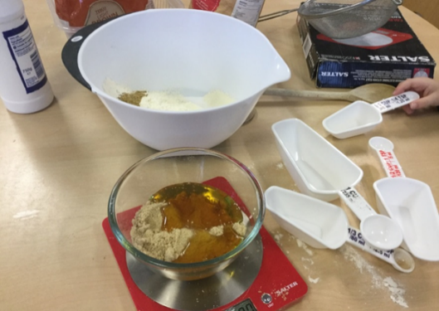
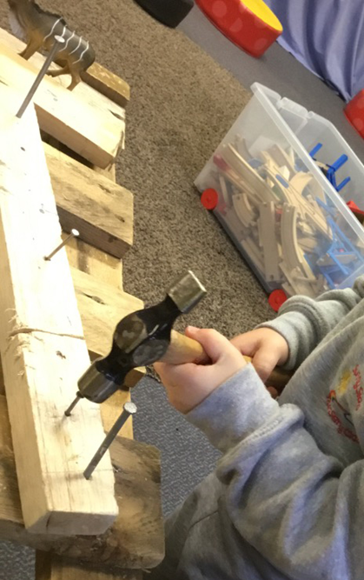

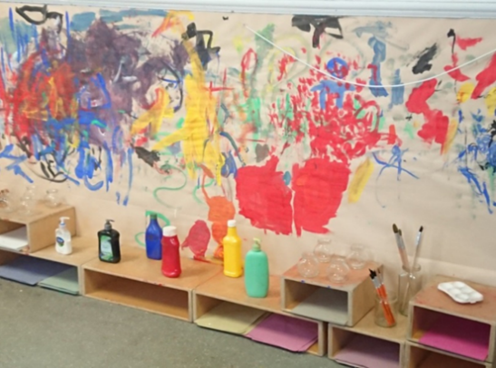

Pre Birth to Three
Pre-birth to three guidance aims to improve and enhance evidence-based practice by building on our knowledge of current research and our work with babies, young children, and their families. It also lays a sound foundation for children’s learning and development and will ensure a smooth and coherent transition for all children as they begin to engage with Curriculum for Excellence 3–18.
Four Key Principles:
- Rights of the Child
- Relationships
- Responsive Care
- Respect.

Curriculum for Excellence
As part of your child’s learning journey, they are entitled to experience a coherent curriculum from 3 to 18, in order that they have opportunities to develop the knowledge, skills and attributes they need to adapt, think critically and flourish in today’s world.
Curriculum for Excellence places learners at the heart of education. At its centre are four fundamental capacities. These capacities reflect and recognise the lifelong nature of education and learning. The four capacities are aimed at helping children and young people to become:
- Successful Learners
- Confident individuals
- Effective Contributors
- Responsible Citizens

Learning Journals
At Sunnyside, we use Learning Journals to record your child’s learning while at nursery. Learning journals are a secure online reporting system that can be readily accessed by parents and carers from home.

We as a nursery believe that it is important for you as parents and carers to be involved within your child’s learning and using Learning Journals, allows you to immediately see what your child has achieved. Learning Journals allow you to respond to your child’s learning or add any learning or achievements from home. This can be done through comments or photographs.

In order to get your child’s Learning Journal set up an email address is required when your child starts. If you have any further questions, please speak to Miss Higgins.

Child’s Voice

Sunnyside Nursery aims to empower children as independent learners in an environment which promotes choice, responsibility and respecting the rights of the child. We fully value and respect the thoughts and ideas of our young learners and their voice is at the centre of everything we do. Please read what one of our parents and child’s responses to being at Sunnyside Nursery:

Sunnyside nursery is a safe, happy and enjoyable place to be. Full of great children and amazing staff and they do everything they can to educate children and help their families with anything they can, always understanding.
I like going to nursery too see my friends, I like to do peep and I enjoy helping the ladies prepare snack

I like nursery because I can play with my friends and I like the sand, Lego, story time and assemblies

LIFT

At Sunnyside we have an ongoing commitment to LIFT, Language is Fun Together, part of the Speech and Language Forth Valley Project. A whole Authority/ Nursery approach that focuses on working collaboratively with S&L on earlier identification of children with speech, language, and communication needs.
LIFT aims are on providing quality ACI (adult child interaction), with all children. Promoting language on things that the children are interested in to increase their confidence in communication. This includes the nursery communication environment, being inclusive, accessible and full of enriching language for all learners.
We want to work in partnership with parents to increase engagement, knowledge and empower parents to support their children.
Through training and our awareness of the benefits of LIFT, we strive to deliver the best outcomes for children and families.
Good communication skills are essential for children’s learning, friendships, and wellbeing. The quality of spoken dialogue in nursery and school can significantly improve children’s attainment.

As a nursery, we were awarded our Silver Award in September 2019. We are now working towards our Gold Award.
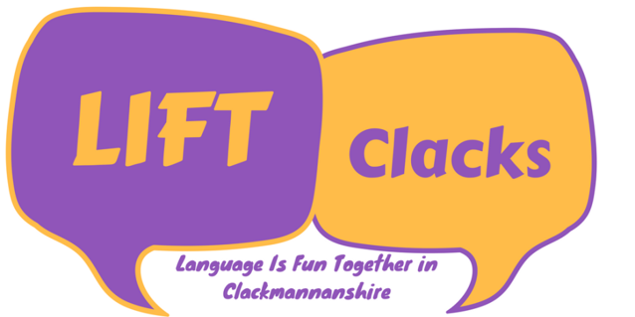

Parental Engagement and Family Learning
Family learning encourages family members to learn together, with a focus on intergenerational learning. Family learning activities can also be specifically designed to enable parents to learn how to support their children’s learning.
- Lending Library - Help your child choose a book to read at home from our selection of books in the lending library. The lending library is manned daily by a member of staff at the end of the day. All we ask is that you complete the folder with the date, your child’s name and name of book. Once you return the book, just tick the end box. There is a book feedback form which we would be grateful if you and your child could complete and post in the box.
- E-Learning Journals – active activities uploaded weekly for parents to participate in over the weekend.
- SHANARRI Dolls - Sunnyside Nursery have a doll and a teddy bear both named SHANARRI and at some point, during your child’s time at nursery they will take one home for a night.
- PEEP Group – weekly curricular activities provided for parents/carers to join in with your child.
- Cooking Group – join your child in preparing nutritious favourite foods, you will be given the recipe to take away so you can practise together at home.
- French Group – join your child in taking the first vital steps into learning a second language. Learn basic French words through play-based activities which will support their learning of French through school.
Communication with Parents
We update the noticeboard on a Monday for the upcoming week. It is important for you to check this regularly, so you are aware of the variety of learning opportunities within the nursery. Take a screen shot of the notice board with your phone, so you always know what is going on within the nursery on a weekly basis.
A nursery newsletter is published on a monthly basis and can be found on the school website, twitter, E-Learning Journals and nursery cloakroom.

Self-Evaluation for Self-Improvement
At Sunnyside self-evaluation remains at the heart of our practice. In line with Education Scotland's How Good Is Our Early Learning Childcare (HGIOELC) document we use self-evaluation to explore our progress, development and practice to identify what has improved and what still needs to improve. The three familiar questions that support our effective self-evaluation and improvement are:
- How are we doing?
- How do we know?
- What are we going to do now?
We value and respect parent/carer’s views and suggestions to support our nursery self-evaluation. There are a variety of ways you can have your voice heard such as:
- Parent/Carer evaluation group
- Parent/Carer observations
- Parent/Carer questionnaires
- Add your feedback to the self-evaluation wall in the cloakroom
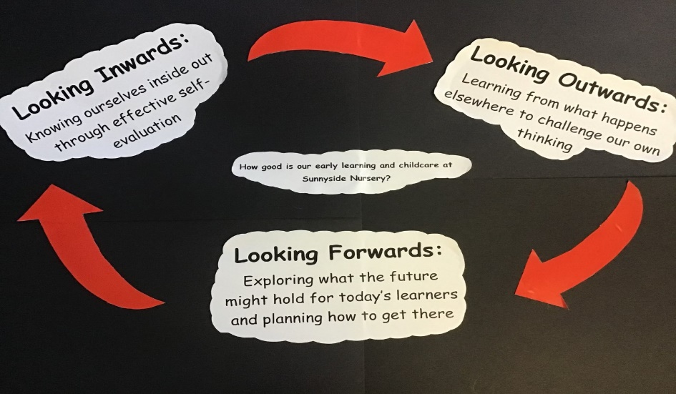

Health Promoting Nursery

- Sunnyside is a health promoting nursery therefore at the end of each session there is a selection of fruit available for the children to take home, all we ask is a small donation. The children will be running this stall as a social enterprise project and all donations will go towards nursery funds.

- At Sunnyside Nursery we provide a variety of healthy snacks, available to all children throughout the day. We follow Setting the Table – a nutritional guidance and food standards for early years childcare providers in Scotland. Children are encouraged to help prepare snack and follow good hygiene practices when doing so.

- Children are able to attend PE with Mr Foley once a week if they wish to do so. This takes place in either the school gym or lunch hall. Mr Foley will focus on developing hand/eye co-ordination and large physical development.

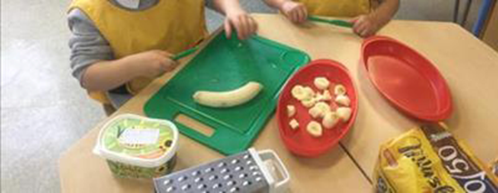
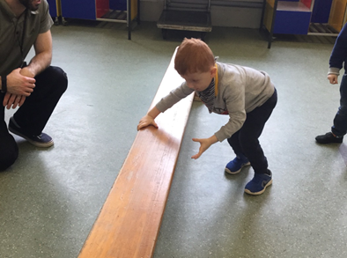
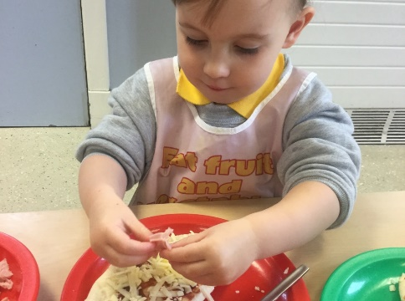

Holidays and Staff Inservice Days

Event | Date
Autumn term begins (Staff only - staff development days): | Monday & Tuesday 17th & 18th August 2020
Autumn term begins (Pupils): | Wednesday 19th August 2020
Autumn term ends: | Friday 9th October 2020
October holiday begins: | Monday 12th October 2020
October holiday ends: | Friday 23rd October 2020
Staff development day (pupils off) | Monday 19th October 2020
Winter term begins | Tuesday 20th October 2020
Winter term ends | Wednesday 23rd December 2020
Christmas holiday begins: | Thursday 24th December 2020
Christmas holiday ends: | Wednesday 6 January 2021
Spring term begins: | Thursday, 7th January 202
Staff development days (pupils off) | Monday & Tuesday 15th & 16th February 2021
Spring half-term holiday begins: | Wednesday 17th February 2021
Spring half-term holiday ends: | Friday 19th February 2021
Spring term ends: | Thursday 1st April 2021
Easter holidays begin | Friday 2nd April 2021 (Good Friday)
Easter holidays end: | Friday 16th April 2021
Summer term begins: | Monday 19th April 2021
May public holiday: | Monday 3rd May 2021
Summer term ends: | Friday 25th June 2021

