Sunnyside Primary School: Numeracy & Mathematics Policy

August 2020

Sunnyside Maths Policy
August 2020
Purpose
As with all areas of the curriculum, it is important to ensure consistency in approach in order to provide our children with the best possible learning experiences. Children need to be able to build upon previous learning in order to progress.
It has become apparent that we have a problem in Scotland with regard to maths with too many people feeling it is acceptable to label themselves as “no good with numbers”. Our challenge is to change the mindset of our young people as well as many adults.
In a recent survey carried out by “The Making Maths Count Group” they discovered the following challenges:
“The first is to convince everyone, whatever their circumstances in life, that they have the ability to become proficient at maths. The second is to convince them of the benefit of doing so.
The strongest messages we received to address these challenges were to make maths more relevant in real life work and more enjoyable. Making maths more inspiring will help to create greater enthusiasm, encourage greater participation and raise attainment.”
There are many ways that we aim to tackle this within Sunnyside.
Aims
We aim to build conceptual understanding by teaching a range of strategies using the concrete, pictorial, abstract (CPA) approach.
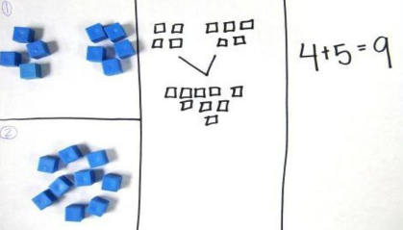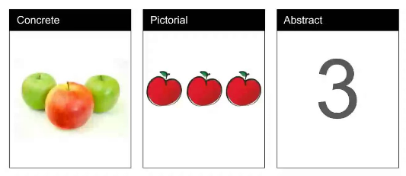
By equipping our learners with a range of strategies, incorporating the CPA approach, they can then choose which one works for them. The strategy which they choose may differ depending on what is being asked, particularly when it comes to problem solving. We discovered through a children’s questionnaire that a lot of our learners needed to know where to go when one strategy was not working for them. For so many learners, calculations can be solved when presented in a simple form but when put into a word problem they may struggle.
Within Maths, learners need to have the opportunity to problem solve and be involved in their learning in order to fully understand it. This includes learners getting things wrong and being able to discuss where they went wrong. Talking through strategies is an important part of every Maths lessons whether it is learners sharing it with a partner, the entire class or with an adult.

We aim to:
- develop problem solving, reasoning and fluency
- create mathematical mindsets
- engage in Maths talks
- meet the needs of all learners’
We involve all stakeholders in our children’s learning. This includes in school and in authority training for teachers and learning assistants.
We recognise the need for feedback in order to improve the quality of our teaching and learning and do this through questionnaires completed by children, staff and parents.

Planning

In terms of planning we follow Clackmannanshire’s Progression Pathways. These show a clear progression in all areas of Maths from Early Years to P7, over 8 phases.

In a very busy and demanding curriculum we recognise the need and benefit for teaching Maths in context. We therefore look for links within Maths and also across different curricular areas. We encourage teachers to plan for these opportunities throughout the year e.g. consider which areas of Maths may be part of IDL topics or contexts of learning being covered that year.
We are inspired by the spiral approach which is endorsed by Clackmannanshire Council. We recognise that children need the opportunity to revisit learning throughout the year.
In order to support all of the above we adapted the pathways and they were converted into tracker form. Below shows an example of how a tracker may be used, every term having a corresponding colour.
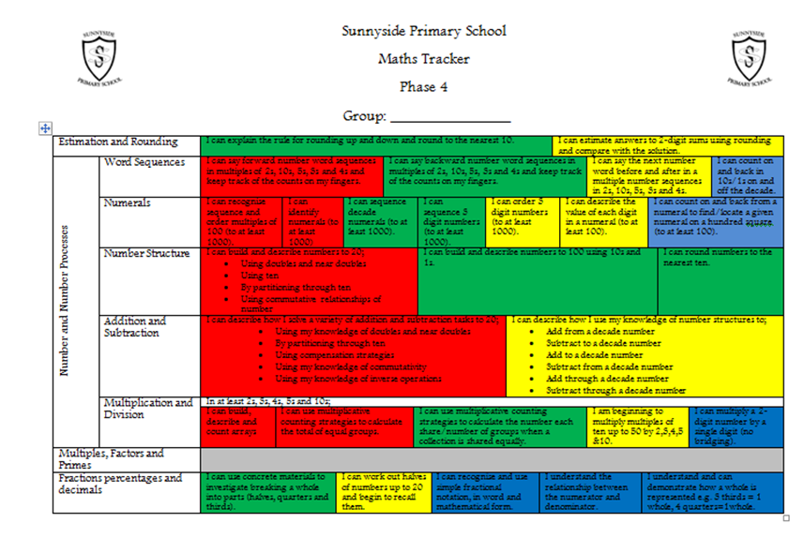

Each group within the class will have a tracker. Teachers are encouraged to display these trackers on their wall. The original format is also available in Forward Plan folders.
In order to keep track of how learners are coping with different areas of Maths, teachers use Evaluations. This is an opportunity to note down important information which they may require e.g a child who found something difficult or equally something an area whereby a child required challenge. Red, Amber and Green colours can be used to show progress in each area.
Teachers should have an evaluation for each group:

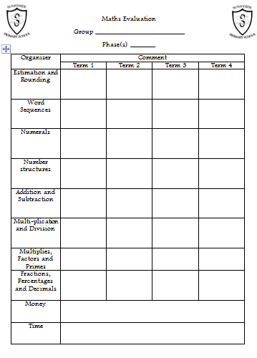
Trackers and evaluations are available on the shared drive under Q:\Curriculum\Numeracy, Maths\Trackers
Transitions
Trackers and evaluations are passed on to the next teacher as part of the transition process. Teachers may choose to transfer the tracker information on to their own copies of the trackers.

Teaching and Learning
As Clackmannanshire move towards creating Maths Fundamentals the teachers of Sunnyside gave the following feedback in the teaching and learning of Maths.
Classroom  Displays and resources organisation  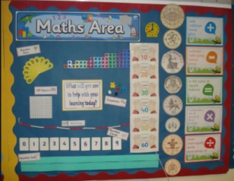 | Displays should include:  Number lines and number squares. Interactive hundred squares preferable, particularly in early years.  Strategies that are being taught. Preferable that posters are created by children.  Part, part whole display.  Maths vocabulary particularly to support with problem solving.  Pupil work.  Clock with time intervals.  Months of the year, days of the week, seasons.  Calendars.  Daily timetable – date and time in context.  Resources:  Should be clearly labelled to encourage children to take ownership.  Every class should have a Maths box (COVID individual packs) which includes a variety of resources stage appropriate. It will includes resources such as tens frames, counting materials, playing cards, dice etc.
On the table  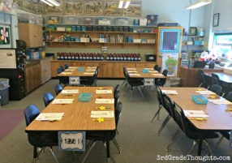 | Learners should have access to:  Manipulatives – cubes, diennes materials, place value counters, cuisinaire rods,  Number lines, rekenrek, double sided counters, ten frames, numicon  Whiteboards and pens – draw pictorial representations/ bar models  Part, part whole boards  Counting sticks.  Active games.  2D and 3D Shapes.  Topical maths resources.
Access to manipulative | On tables for all learners to access.  Clearly labelled areas within the classroom.  Accessible from P1-P7.
Textbooks  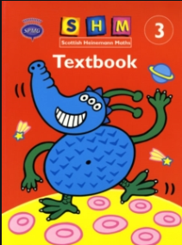 | Within Sunnyside we use Heinemann SPMG.  All teachers have access to relevant teaching files to support active Maths.  Previously we had Workbooks in P1. Prefer now to use active approach e.g use of tough trays.  From end of first level textbooks used for abstract once children have a thorough understanding. Elements selected. Not completing page after page. Teachers selecting particular questions which may be relevant.  TeeJay Maths textbooks also accessible.  (Textbooks should be left for 72 hours between groups and classes - COVID)
Online resources | Used within rotations.  Used as a teaching tool.  Recommended websites include:  Education city  Mathbot – manipulatives online/online starters  doorway online for formation  Top marks  Teaching 5 - starter activities  Hit the button.  Which one doesn’t belong – good for a starter activity.  NRich  BBC Bitesize  National 5 Maths – Primary teacher resources  https://www.national5maths.co.uk/free-primary-teacher-resources/
SHM Teaching Files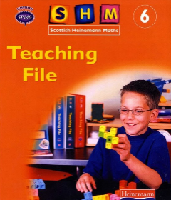 | Each stage will have access a SHM Teaching file which is appropriate to your stage.  Teaching Files contain suggested lessons and activities suited your stage.

Counting
We value the need for counting in Sunnyside and encourage this to be a part of every maths lesson from P1-P7. One tool which we use to support this is the counting stick. One of which can be found in all of our classrooms.
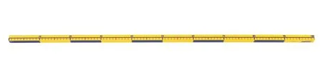
Details of what counting should be taking place at each stage is clearly detailed in our Maths Trackers/Plans. For example, in primary 1 counting forward and backwards to 10 can be reinforced daily with the use of a counting stick. As we move to Primary 7, the counting stick can be utilised to revise times table facts or count in fractions.
Effective methods whilst using a counting stick include whole class chanting, labelling points on the counting stick with suitable increments through effective questioning and removing these labels when the learners become confident in their recital. In addition to this, labels can be ‘missed’ and learners asked what would go here/how did you work this out?
As well as colleagues sharing good practice with the use of this tool there are also many useful links on Youtube, for example ‘Jill Mansergh – Tables with a number stick’ which provides an insight into effective questioning when using the counting stick to teach times tables.

Concrete, Pictorial and Abstract
We do not state when a child should move from one element of concrete material to the next as this will vary from child to child and will be decided by the teacher. However, this is a guide of when and how children may progress. Some learners may move on earlier or later than this.
Progression | Concrete | Stage
 | Items  Cubes  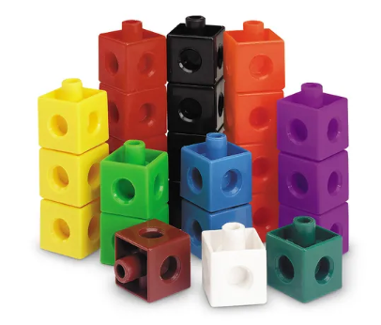  Diennes Materials  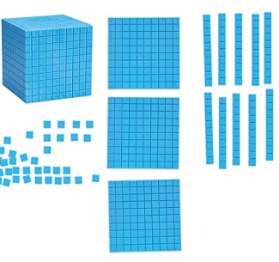  Place value counters  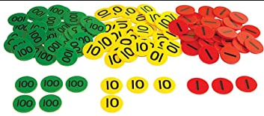 | Early Level  Nursery-P1  Early Level  P1  First Level  P2-P3  First Level  P3-P4  Second Level  P5-P7

As previously mentioned we teach concepts using a range of strategies. Strategies which children have been taught should be clearly displayed on Maths wall displays.

Strategies for addition and subtraction
Use of concrete materials
Open/empty number line.
Partitioning
Algorithm
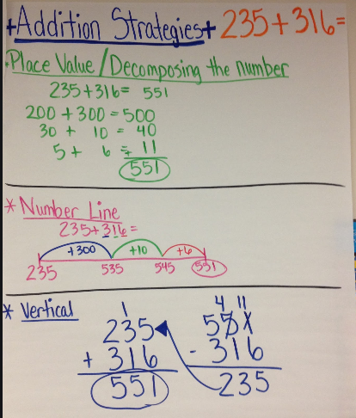
Strategies for multiplication and division
Use of concrete materials
Arrays
Open/empty number line
Repeated addition/subtraction
Algorithim
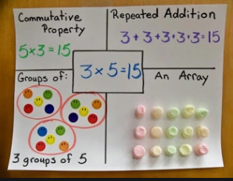
As children begin to work with two digit numbers and beyond:
Partitioning Grid Method
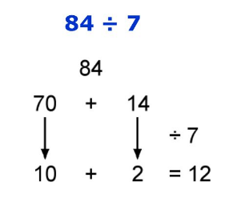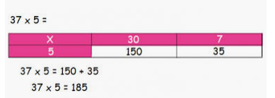

Subitising
From P1 we teach Subitising. Subitising is the ability to identify a quantity quickly without thinking.
Children begin subitising using their fingers which builds upon bunny ears which will have been taught in Nursery. The progression is then use of subitising flashcards which teachers in P1-P3 have within their Maths boxes.
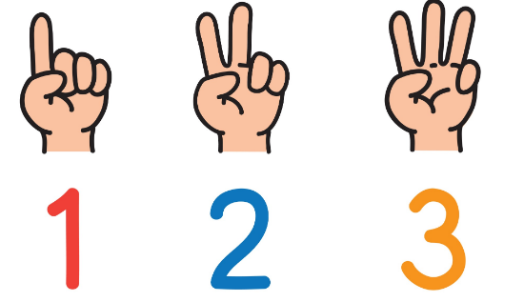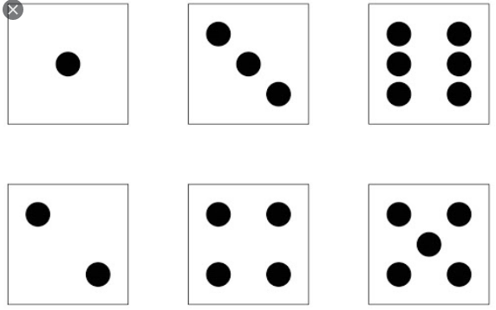
Children are also taught with the use of Tens frames to develop their number sense as well as addition and subtraction.
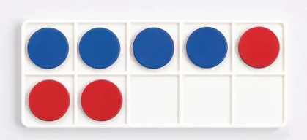
Part, part whole
The Part-whole reasoning or model is the concept of how numbers can be split into parts. Children using this model will see the relationship between the whole number and the component parts, this helps learners make the connections between addition and subtraction.
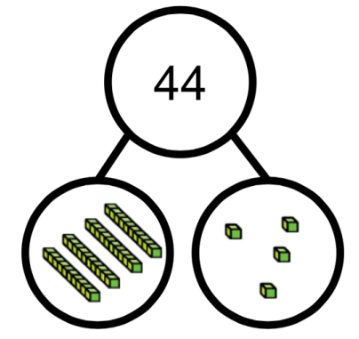
Part, part whole can be taught using concrete, pictorial and abstract. All used in conjunction with one another. Children should be encouraged to experiment with different ways in which a number can be split.
Bar Model
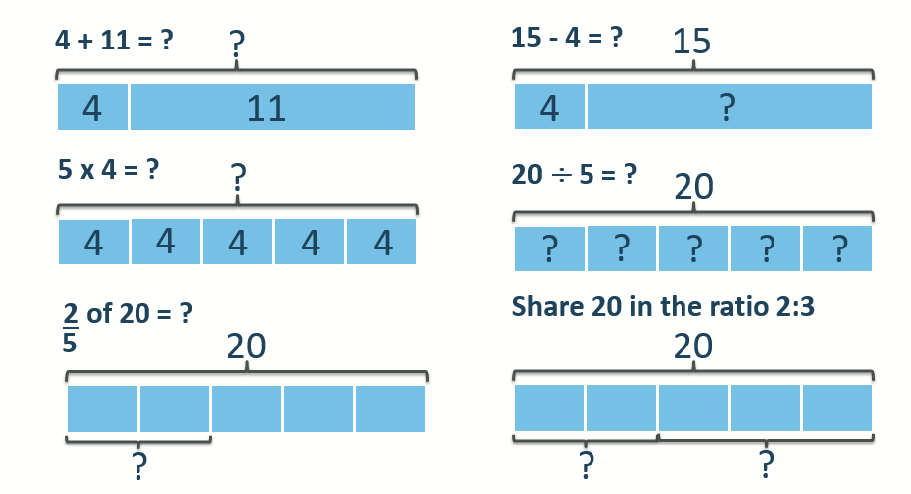
A bar model is a pictorial representation of a mathematical problem where bars or boxes are used to represent the known and unknown quantities. Bar models can be used to solve an array of different mathematical problems and can prove particularly useful when the type of calculation is unknown, for example in word problems.
Bar models should be encouraged only when a child shows clear understanding of the mathematical concept through the use of concrete materials.
Rotations
Rotations do not have to form part of every maths lesson, however every group should have direct teaching during the lesson, in addition to the whole class starter and plenary. Rotations can be very good in order to direct new learning, consolidate prior knowledge and revising.
A suggested rotational lesson is outlined below. This is suggested and should be adapted to suit the needs and interests of your class.
Whole class Starter – could be chilli challenge/counting strategy/starter from a suitable website
Whole class Revision – related to main lesson
Group 1 | Group 2 | Group 3
Independent Learning  Follow up | Teaching input | Game/IT
Game/IT | Independent Learning  Follow up | Teaching input
Teaching input | Game/IT | Independent Learning  Follow up
Whole Class Plenary - 5mins

Chilli Challenge/Self Differentiation
Every child should have the opportunity to choose the level of challenge. This may be presented through a chilli “challenge”.
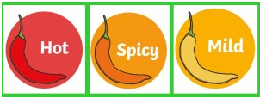
A chilli challenge offers the learners three options ranging in difficulty. These are typically labelled Mild, Spicy and Hot; with each child invited to select an option to allow for self-differentiation. This facilitates personalisation and choice and allows a level of challenge.

Outdoor Learning Resources
It is important maths has meaning and is relevant to children, therefore outdoor and real life experiences are encouraged within Sunnyside Primary School to promote the embedding of mathematical concepts. Suggested lesson ideas can be found on Staff share under Curriculum > Outdoor Learning > Numeracy. Additionally, online resources can offer inspiration and ideas by accessing the websites below:
https://www.ltl.org.uk/free-resources/
https://sites.google.com/cl.glow.scot/outdoorlearning/home

Assessment and Monitoring
Within P1, P4 and P7 our children complete SNSAs in line with government guidance.
All children, P1-P7 complete a MALT assessment in March. This assessment gives a standardised score as well as a Maths age for all learners. This information allows us to track learner’s progress
At the beginning of P1 we use SEAL assessments as a baseline for all of our children.
All assessments are used to inform future planning for individuals as well as at whole school level. This information along with class teacher’s professional judgement is used to inform tracking and monitoring.
We also use the Scottish governments Benchmarks as a tool to plan assessments and to identify where our children are in their learning.

Engaging family and community in Numeracy and Mathematics
Within Sunnyside we have involved our parents and carers in a number of ways and have a plan about how we can do this further in the future.
We have started by creating short videos which parents can access on our school website. These videos share some of the strategies which we teach in class.
Through a parent/carer questionnaire we established the need to present parental workshops in order to share strategies now taught within school.
Throughout the curriculum we encourage children to be taught the key skills. We encourage opportunities to work with the local community and for members of the local community to share their experiences with children. This includes the relevance of Maths in the world of work.

