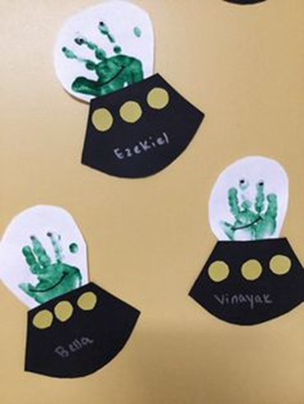
Make your own Alien
- Using your handprint to create alien

- Add googly eyes (however many you choose)

- Use a different colour of paper or paint for the base for the spaceship and decorate it how you want.

- Stick them both together and you have your own alien and spaceship!

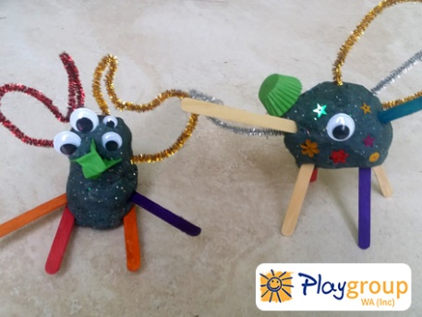
Make your own playdough

Watch the video attached to make your own playdough.
See if you can make your own planet, rocket or even alien!

https://www.youtube.com/watch?time_continue=3&v=oAIAm6BF0fs&feature=emb_logo

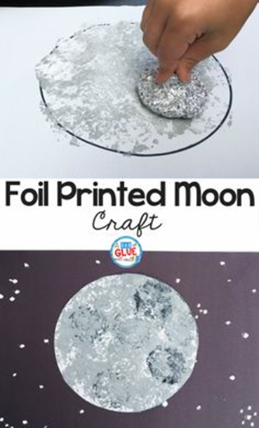
Foil Printed Moon

1.Use scrunched up foil dipped in paint to create an effect for the moon, and all the other planets.

2. Cut out circle, half circle, crescent shape – the different shapes of the moon.

3.Cover in foil/paint to create the different phases of the moon.

