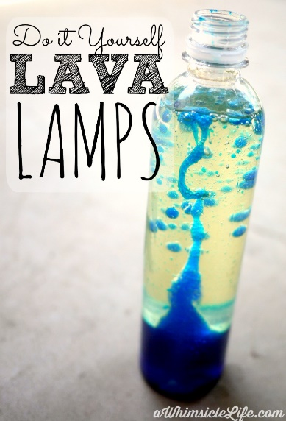
Create your own Lava Lamp
- Fill a plastic bottle up 2/3 with vegetable oil.
- Fill the rest up with water, leaving a bit of space at the top.
- Now add drops of food colouring and watch what happens!

Build your own space rocket!
https://www.youtube.com/watch?v=kp7ExAZL8i0

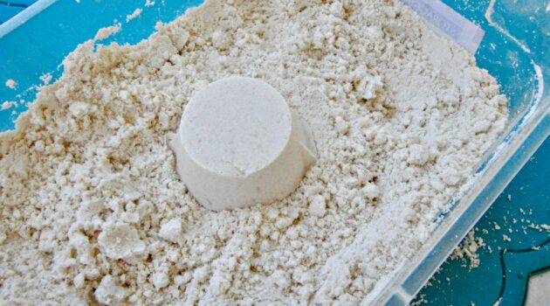
Moon Sand!
Ingredients:
- 8 cups of all-purpose flour
- 1 cup of oil
Method:
- Put all ingredients into a large mixing bowl.
- Mix the flour and oil together (This takes a while, roughly 8-10 minutes for everything completely incorporated)
- Add drops of food colouring if you like, and you are finished!
- You can put measuring cups, spoons, straws and other items into the bin for an even more sensory experience

