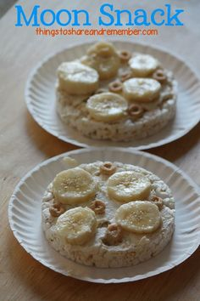
Moon Snack
- Try making a moon snack. You will need three ingredients.
- 1 Pancake/Rice cake
- 1 Banana (add more toppings if you wish to do so)
- Spread (butter or cheese)
- First spread your pancake/rice cake with either butter or cheese.
- Next, cut up a banana and place on top of your pancake/rice cake.
- Enjoy your yummy moon snack!

---------------------------------------------------------------------------------------------------------------------------

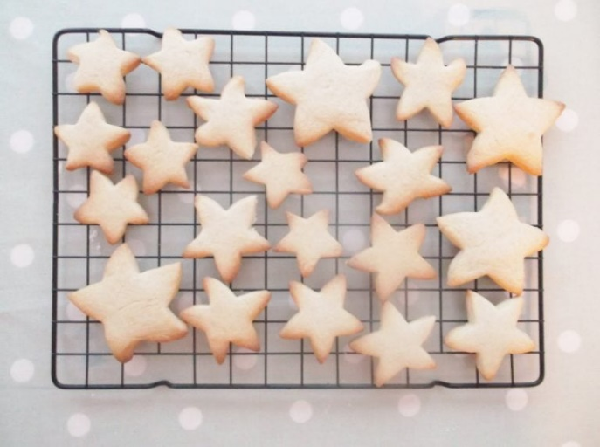
Star Biscuits
Ingredients:
- 100g Butter
- 50g Caster Sugar (you can also use icing sugar)
- 175g of Plain flour
- Vanilla extract
- Star cutter
Method:
- Mix the butter and sugar together.
- Add the flour and mix with your hands.
- Once the mixture is stuck together roll out onto a floured surface with a rolling pin and cut out into star shapes using a star cutter.
- Place on a greased oven tray and put in the oven at 180 degrees for 15 minutes until golden brown.

