The Flying Dragon

Flying Dragon Craft
Materials Needed:
- empty cardboard tube
- coloured craft paper
- wool or string
- pens
- googly eyes
- scissors
- glue
Decide what color you want your dragon to be, your child can make their cardboard tube dragon whatever colour they choose. They can even make it multi-coloured.
Measure the length of your cardboard tube and cut a strip of craft paper that wide so it will cover the tube. Glue this around the tube. You could also use clear tape to hold it in place.
Fold a piece of craft paper in half and draw a wing shape on the paper, with the folded edge being where the wing would meet the dragon’s body. Cut out the wing shape so that when you unfold it, you have two wings that are connected.
Glue the wings to the cardboard tube.
Use craft paper to create a tail and a head for the dragon. Your child may choose to just cut a circle shape or get even more creative.
Attach the wiggly eyes to the head and use markers to complete the dragon’s face.
Glue the tail and head to the cardboard tube.
Let the glue dry completely before doing the next part.
Cut 50 to 60 inches of wool or string and hang it over a door handle or from a hook, so an equal amount hangs on both sides.
Thread the loose ends of the yarn through the top of the tube, so they stick out the bottom.
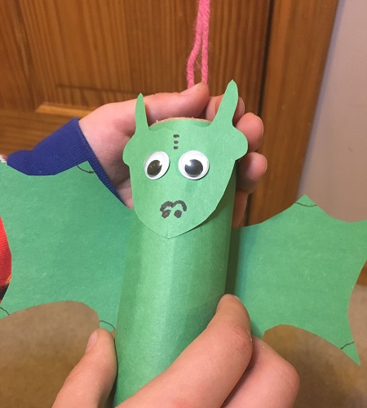
To make the dragon fly, hold the two ends of the wool, one in each hand, and pull your hands apart to separate the wool.
