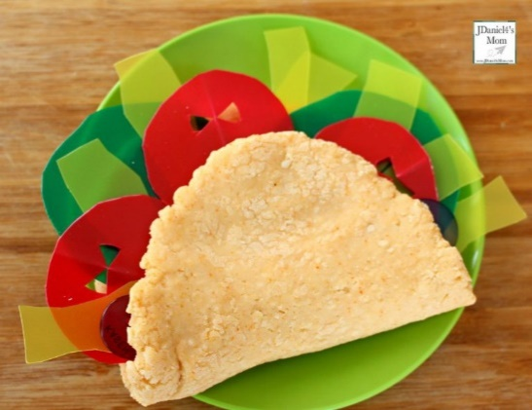
A Dragon Taco

Ingredients
- 1 Wrap/Taco
- 1 Tomato/Cucumber (Sliced)
- Handful of lettuce
- Cheese (grated)

Method:
- Slice your tomato/cucumber
- Grate cheese and place aside in separate bowl
- Fold your wrap (so it is a half-circle shape) (If using a taco this is already pre-made)
- Add a handful of lettuce inside the folded wrap
- Place the tomato/cucumber slices inside, at the top of the wrap
- Add the cheese either to the side of the wrap/taco (for fire breathing out of the dragon’s mouth) OR inside the wrap/taco (as displayed in the photo)
- Enjoy! but, be careful, as dragons love food and might come for a nibble

