What do you think will be scary in P1?
Your new teachers can help you not feel scared!
The dragon was not scary!
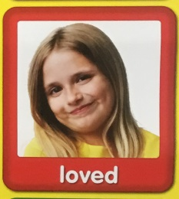
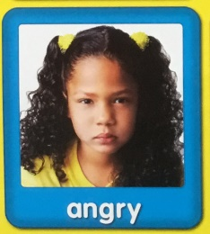
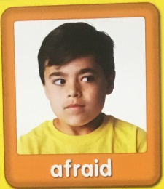
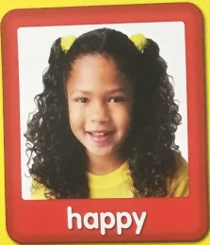
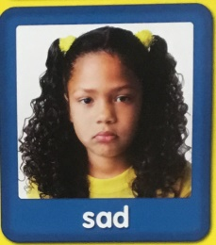

(Images from poster and cards in nursery)

- Parent/ Carer can talk about feelings – describing and labelling emotions; Sad, Happy, Scared/ Afraid, Loved, to helping children manage their feelings give examples of what these emotions are like.

- Try being a role model – talking with children about your own feelings what makes you scared, shows them that these emotions are a part of life and can be learning opportunities for everyone. Talk about the teacher, how they might be scared meeting all the new children, but how they can help the teacher with a smile or just saying hello. The teacher is excited to meet you and will help you enjoy P1.

- Children could draw a picture of what makes them scared and what makes them happy. Make a card for the new teacher with a picture of them so the teacher will not be so scared to meet them.

