**Dragon Crafts**

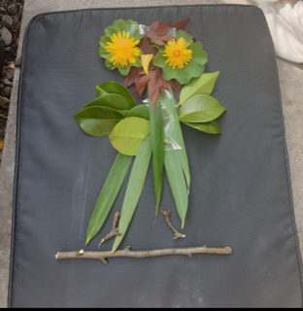

Loose Parts Owl, could you do a dragon?