Google Classroom Protocol (Updated 01/05/20)

Introduction
In line with Clackmannanshire Council contingency plans, following the ongoing control measures around the spread of COVID-19, Sunnyside is developing distance learning opportunities using Google Classrooms as a platform.
Please be aware that this is a working document and further guidance may follow.

What is Google Classrooms?
Google classrooms is an online learning platform, accessible through GLOW, and facilitates discussion and file sharing between learners and teachers. For further information regarding google classrooms please see: https://teachercenter.withgoogle.com/

How do I access Google Classrooms?
Google Classrooms are accessed through Glow (https://glow.rmunify.com/). One you have logged into Glow you will need to click on the little house, taking you to the Sunnyside Launchpad:
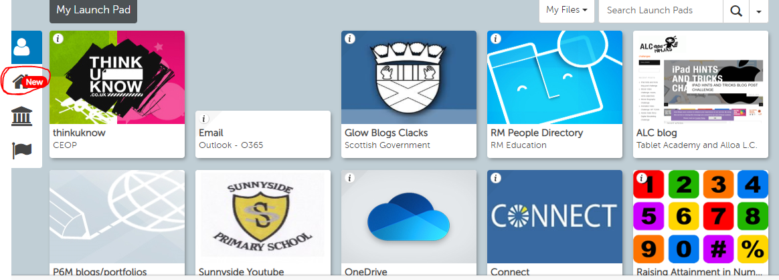
The Google Classroom tile be appear on the top row of the Sunnyside Launchpad. Please click this tile:
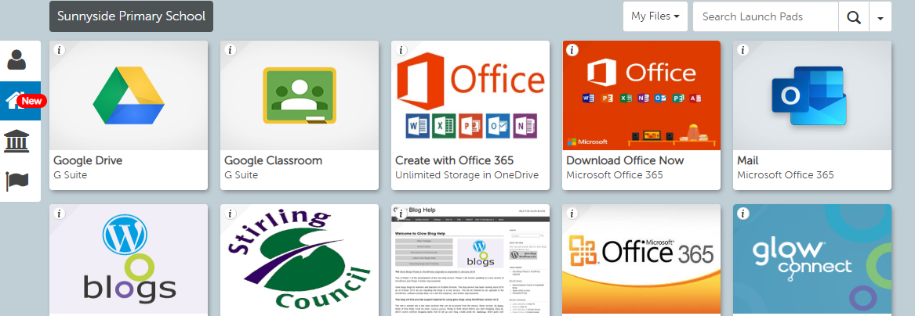
Classroom access can be arranged through inviting teachers/practitioners into classes and through the use of class codes. Any concerns regarding access to Google Classrooms should be addressed to the in-school digital leader.

Organising Learning Content:
Assignments:
There should be 3 assignments per day set by class teachers, however check-ins, travel tracker, daily stories, PE or German are not included in this number. The 3 assignments should consist of:
- 1 Numeracy
- 1 Literacy – only one aspect of Literacy per day (phonics, spelling, writing, punctuation or grammar etc, however tasks within those assignments may incorporate additional elements e.g. phonics with a writing follow up).
- 1 other curricular area - please ensure there is a balance of the curriculum evident across the week.
As part of Equitable Literacy, Daily Stories/Class Novel should be implemented in each class. You can choose, if you would prefer, to record yourself reading a story and upload it or there are other online links you could use, e.g. https://www.storylineonline.net, https://www.scottishbooktrust.com, https://www.bbc.co.uk/cbeebies/stories .
Links to video clips and online resources should be posted within each assignment along with the task so pupils and parents have easy access to these. Example photos:
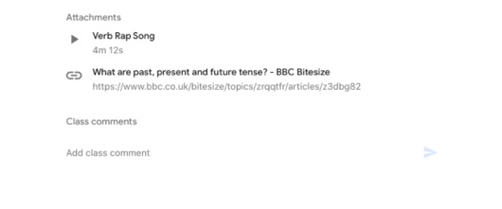

All assignments posted should include Learning Intention and Success Criteria, and concise, numbered steps should be evident to explain what to do.
To ensure consistency across all google classrooms, daily assignments should be posted under the same topic heading, set out as individual days and named clearly e.g. Wednesday 29.04.20.
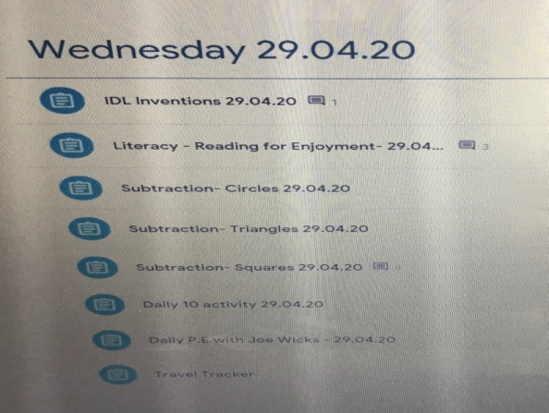
Assignments should be set on the day for that day and no due date or grading to be set.

What am I doing today topic/Daily Overview:
There is now no need for a daily overview as all the assignments for the specific day will be under the day and date heading and assignments will be clearly titled with the curricular area, date and group (if not for whole class).

IDL and Skills for Life:
Some IDL focuses are coming to an end therefore Learning Outcomes and IDL skills should be shared with the children in order for them to have a say on learning contexts and styles. Pupil Voice should be evident in the planning of new IDL’s with consideration of E&O’s not yet covered. An element of personalisation and choice should also be evident within assignments and IDL learning. This allows us to progress learning into term 4.

Skills for Life should also be considered when creating assignments and the importance of skills for life should be recognised as part of wider/home learning.

What can or should be posted as an assignment?
Whilst the work may be very specific – i.e. revising a particular spelling pattern, sound, maths strategy. Some of will be open ended – I.E IDL, it is still important that the pupils recognise the importance of the learning and the skills that are being covered.
Below are some examples to guide your assignment structure, these are suggested formats. Work must be directive with specific resources, as we cannot expect parents to decide the structure of learning.

Learning Intentions and Success Criteria should be included on the assignment notes.

Literacy:
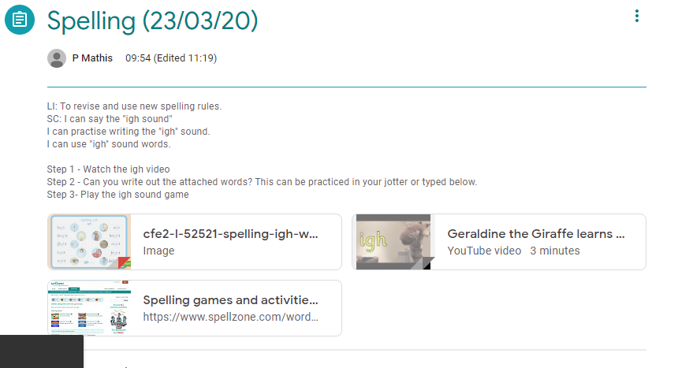

Maths and Numeracy:
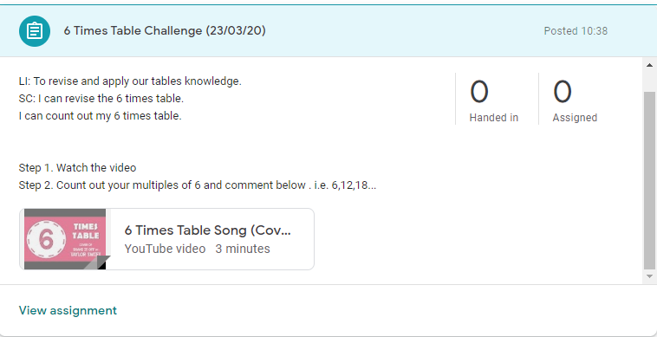

IDL:
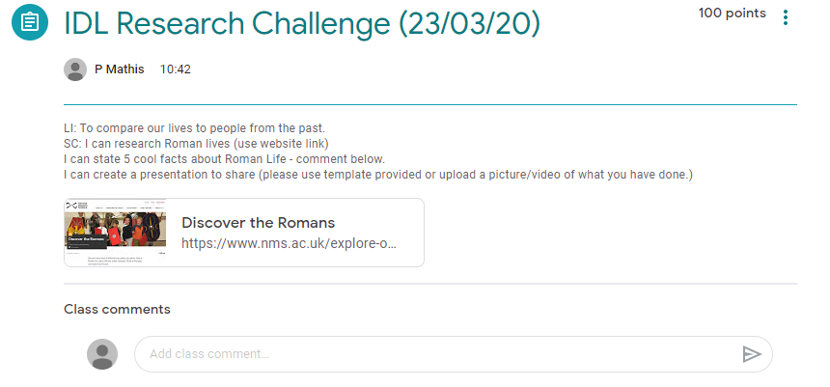
HWB:
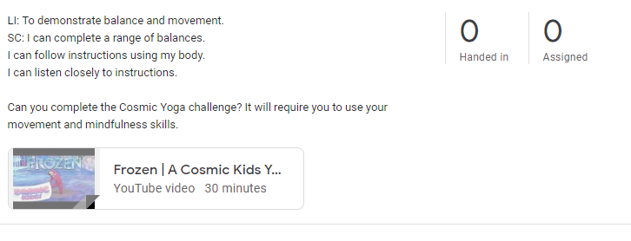
ICT:
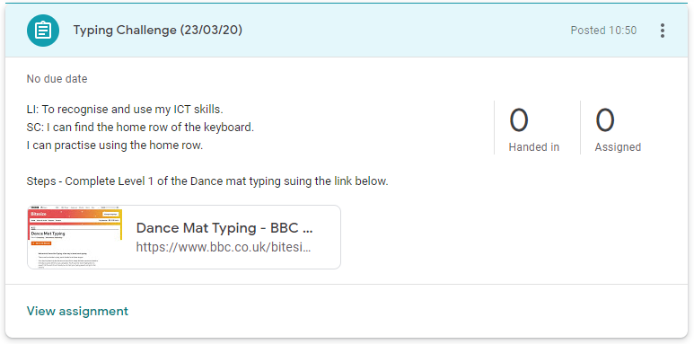

Assigning Work and Differentiation:
Some learning activities/assignments may be whole class, although others will be targeted at groups – an example of this being Maths and Literacy where children will be working at different levels and on different learning outcomes.
Assigning work can be tailored during the assignment creation stage, by clicking on the “For” tile, and selecting all students or choosing individuals by name.
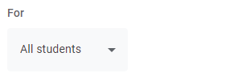
As our knowledge of pupil progress alters over time differentiation should be apparent through the use of levelled challenges (Chilli Challenge) that pupils can then self-differentiate with.
A level of differentiation is expected and should be apparent.

Gradings
Do not assign gradings to assignments, as this could create a significant workload issue at this point. It is best that open tasks are utilised.

Feedback
Feedback can be monitored to help streamline workload through the people and marks pages, when work has received feedback and has been returned this will show as a tick.

Communication
Communication within the classroom will take place, mainly through the class stream and comments. It is vital that pupils understand that communication should be learning centred, this is not a social media channel. Any inappropriate or irrelevant comments may be deleted by a member of the teaching team.
If you have any concerns regarding what is posted please notify a member of the senior management team ASAP.
If a pupil is asking questions or comments regarding learning, please respond as appropriate.
Assignments should be posted to the classroom and the stream should be used for communication between class teachers and pupils and can be used for pastoral check-ins. To ensure classwork is separate and not getting mixed up or lost within communication, can you follow the instructions below which will turn ensure assignments are posted in the classwork section and are not listed in the stream.
- Click on the settings button on your stream - circled yellow in photo 1 below.
- Under the general section you will see ‘classwork on the stream’ – circled yellow in photo 2 below and click on hide notifications.
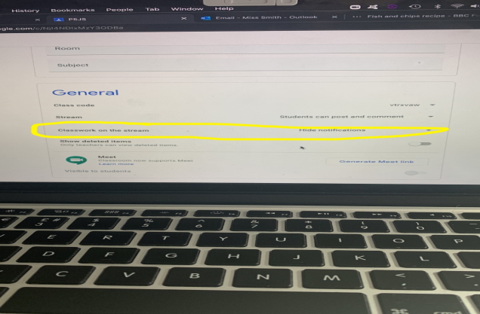
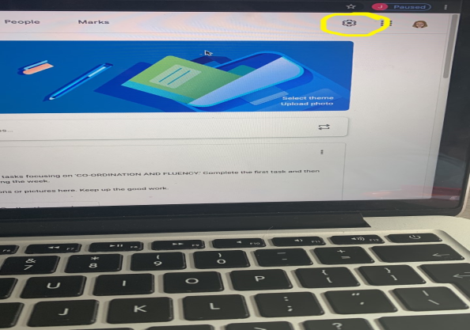

Profiles
Pupil’s may change their online avatar, as this is a secure learning space it is important that pupils feel they have ownership, however if inappropriate images are used please report this to your in-school digital leader (Phill Mathis) and it will be addressed.

Managing Workload and Time:
Whilst it is important that tasks are posted and CTs are available periodically to reply to comments, breaks away from Google Classroom are vital. Time should be spent on own CLPL and ensuring that you get fresh air and exercise.
Notifications can be turned on and tailored to allow teachers to see when pupils are submitting or commenting, avoiding needing to sit at the computer for longer than necessary.
There is the facility to remove notifications for classes that you are part of, but do not teach:
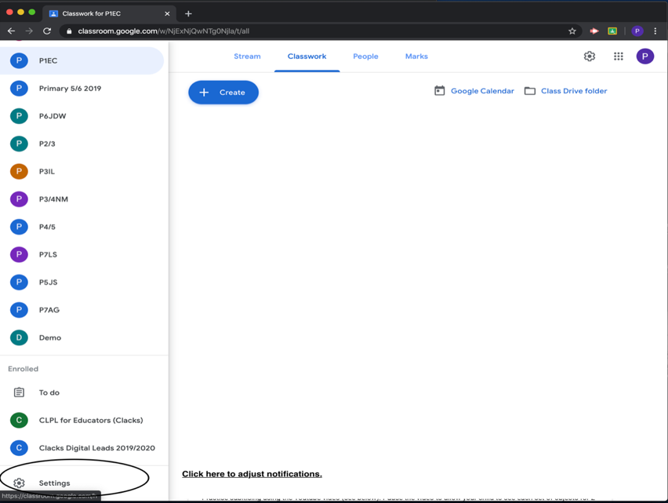
Click here to alter notification settings.

Questions:
Please report any issues with Google Classrooms to your in-school digital leader (Phillip Mathis). We will strive to assist ASAP.

