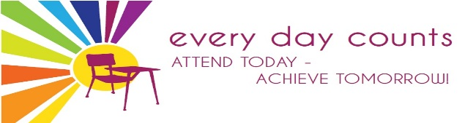

SUNNYSIDE PRIMARY SCHOOL NEWSLETTER
January 2020

Dear Parents/ Carers,

Happy New Year to you all! I hope that you had a wonderful festive break. It was great to see many of you at our events in December and I thank you for taking the time to come along to support the school and the children.

Fergus McNichol – Storyteller
This week we were visited once again by Fergus McNichol, Storyteller. Fergus spent time in Nursery to Primary 6 telling stories, singing songs and teaching the children the skills of storytelling.

Most children remembered these sessions from last year and were extremely excited to see Fergus in school. The feedback for this year continues to be very positive and I hope that with continued Parent Council support we can further develop this area of the curriculum over the next few years.

Not only did Fergus work with the children, he led a training session with class teachers and nursery staff to upskill them in using stories to enhance the curriculum.

Scottish Opera
Children in primary 6 and primary 7 have been working hard over the past few weeks on their upcoming performance of “Warriors! The Emperor’s Incredible Army”

The first workshop with Scottish Opera performers took place on Thursday 9th January and it sounded amazing!
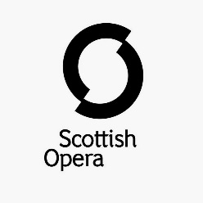
Letters have been sent out giving details of the performance which will take place on Friday 24th January 2.00pm.

We have allocated 2 tickets per family however a waiting list will be organised for those who require more. This will be on a first come, first served basis.

Relationships, Sexual Health & Parenthood Education
Further to our RSHP information event which took place on 6th November 2019, I confirm that all classes will participate in lessons relating to this important part of the curriculum from Monday 10th February.

Full details regarding what your child will be learning can be found on the school website under Newsletters & General Information – Parent & Carer Guides.

Should you require further information, please do not hesitate to contact us.

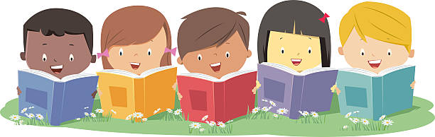
Reading at Sunnyside
At Sunnyside Primary School, as part of our drive to improve attainment in reading and reduce the poverty-related attainment gap, we are working hard to develop a positive reading culture. This work is in partnership with Strathclyde University and Professor Sue Ellis.

How we teach reading has changed and children now have access to a range of different texts to support their learning in different ways:
- Core book – taught in class and is used to develop reading skills and strategies. This book will come home to allow you to reinforce the learning.
- Chill book – generally easier than the core book and is used to encourage children to read independently for enjoyment. This book is chosen by children according to their interests.
- Challenge book – more challenging than the core book and should be shared. This book is also chosen by children according to their interests.

It is important that when children bring their books home, that they are involved in discussions with you about the book. We do this routinely in school, known as “3 Sharings” to support their understanding of the text. Examples of questions you may wish to ask are:
- Was there anything you liked about this book?
- What especially caught your attention?
- What would you have liked more of?
- Was there anything you disliked?
- Were there parts that bored you?
- If you gave up, where did you stop and what stopped you?

- Was there anything that puzzled you or you thought strange?
- Was there anything that took you by surprise?

- Did you notice any patterns in the story?
- Did you make any connections to you and your life?
- Did you make any connections to the wider world?
- Did you make any connections to other stories that you have read?

By working together we can support our children to become confident and to identify themselves as readers.

As always, should you have any comments, queries or suggestions, please do not hesitate to contact me.

Yours sincerely,

Denise Penman
Head Teacher

