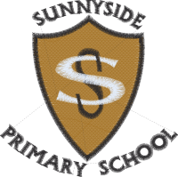 Primary 7 Curriculum Newsletter
October to December, 2019

Dear Parent/Carer,
Below is our focus for this term for different areas of the curriculum. I hope you find this information helpful. Please contact me if you have any questions or if I can be of any further help.
Miss Gillon and Miss Stewart

Context for Learning

- WW2- Who is Hitler? What was the holocaust? How did the war end?
- Health and Wellbeing - Max in the Middle. Looking at how we keep our bodies healthy.

Literacy

- Develop skills in using figurative language (for example: Onomatopoeia, simile, metaphor, alliteration and personification).
- Poetry – Discuss and write different styles of poetry.
- Identify different types of sources and discuss bias.
- Reading with fluency and expression.
- Develop responses to inferential questioning.

Numeracy & Mathematics

- Explore mental addition strategies when dealing with both whole numbers and decimal fractions.
- Explore mental subtraction strategies when dealing with whole numbers.
- Develop multiplication skills when dealing with decimal fractions.
- Develop division skills when dealing with whole numbers.

Health & Wellbeing
PE
- Gymnastics – creating sequences that show imagination, quality and control.

Food and Health
- Apply knowledge and understanding of health eating.
- Use a range of simple food preparation techniques when working with food.
- Trying a diverse range of healthy foods.

