Family Learning Consultation and Feedback (2019).
Our family learning survey was open for a period of 2 weeks, closing on Wednesday 3rd October 2019. It had over 68 responses from P1-7 parents, the majority of these responses were from P1-3 parents.
What you said:
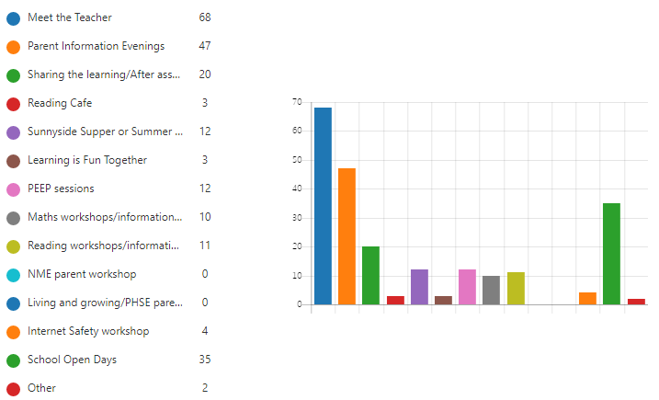
When asked about attendance at our family learning and information events the majority of you stated that you had attended parent information evenings, meet the teacher events, open days and visited classes after assemblies. The fewest responses came from parents attending our reading cafe, internet safety and NME/Health and Wellbeing information events.

When considering the usefulness of our events in supporting learning at home, you gave us an average score of 4.31 out of 5. And when asked how confident you felt supporting your child’s learning at home you provided an average score of 4.57 out of 5.
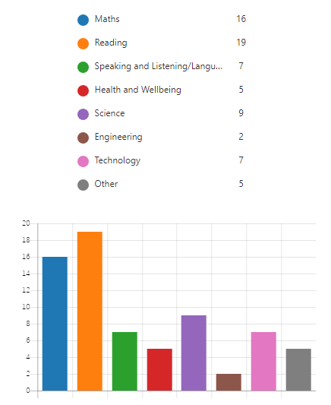
We asked what areas of the curriculum do you feel school should be doing more to help families support learning at home?
You stated that Reading and Maths are the areas you would most like support. Followed by Sciences, Talking and Listening and Technologies.
When asked what times would be most suitable for you to attend workshops and further events 81% stated that the evenings and afterschool were the best times for yourselves.

When asked what else you feel we should be doing, common themes include sharing new teaching/learning methods and more opportunities to join class activities.

When asked if you were aware that our website and twitter offer guidance on supporting learning at home 72% of you stated you were aware. With 56% having used this information to support learning.
When asked for further comment there were some comments regarding the format and quantity of homework, reporting and our use of social media and digital communication.

What we will do:
Thank you for all your feedback, in order to improve our family learning we shall:
- Continue to offer paper and digital communications.
- Utilise all available channels to publicise our events and workshops.
- Renew our focus on supporting literacy and maths at home – considering the implementation of workshops for parents that discuss common strategies and methods used within teaching.
- Continue to host workshops and events afterschool and in the evenings.
- Continue to support learning at home through the publication of materials via our website.
- We have recently revised our home learning policy and would welcome feedback on this via the appropriate channels.
- We have recently revised our social media policy and would welcome feedback on this via the appropriate channels.

